SMART-BIN: AN ESP32-BASED IoT WASTE BIN MONITORING SYSTEM WITH FILL, WEIGHT, AIR-QUALITY AND TAMPER DETECTION
FOR PRIORITY-BASED COLLECTION

WASTE MANAGEMENT AND CLEANLINESS
PROBLEM: Overflowing Garbage Bins and Inefficient Waste Collection Routes

Technological University of the Philippines - Manila
Bachelor of Engineering Technology major in Computer Engineering Technology

Embedded Systems: Final Project
BET-CPET 4A-M, Group 2

Submitted By:
Brian Jay Celeste
Genesis Walter D. Reyes II
Jade C. Gunayan
King Perth G. Pepito
Rodel S. Banogbanog

Submitted To:
Prof. Jonel R. Macalisang

November, 2026
TABLE OF CONTENTS
TITLE PAGE i
TABLE OF CONTENTS ii
LIST OF FIGURES iii
LIST OF TABLES vi
I. INTRODUCTION 1
1.1 Introduction and Problem 1
1.2 Sustainable Development Goal (SDG) Addressed 2
1.3 Review of Related Literature 3
1.4 Objectives 54
1.5 Conceptual Framework 55
1.6 Target Beneficiaries 59
II. PROTOTYPE DESIGN AND DEVELOPMENT 60
2.1 Prototype Design 60
2.2 Block Diagram 61
2.3 System Flowchart 63
2.4 Schematic Design 69
2.5 Component Materials 72
III. TESTING, RESULTS, AND CONCLUSION 83
3.1 Test Cases 83
3.2 Results and Discussion 83
3.3 Conclusion 83
3.4 Recommendations 83
REFERENCES 84
APPENDICES 94
Appendix A: Gantt Chart 95
Appendix B: Bill of Materials of the Smart-Bin Prototype 96
Appendix C: User Interface Screens 97
Appendix D: Source Code 98

LIST OF FIGURES
Figure 1. Sustainable Development Goal 11: Sustainable Cities and Communities 2
Figure 2. Patents Reviewed by Priority Year and Region 6
Figure 3. Remote Status Units Linked to a Central Unit 7
Figure 4. Compacting Ram and Chambers of the Solar Compactor 8
Figure 5. Path of a Full Message From the Compactor Monitor to the Service Provider 9
Figure 6. Trash Can With a Motor-Driven Lid 10
Figure 7. Container With a Bag Between Capacitive Plates 11
Figure 8. Waste Collection System of Containers, Server and Vehicles 12
Figure 9. Refuse Container With Scale, Display and Lights 13
Figure 10. Sensor Device Mounted Under the Lid Behind a Thermal Barrier 14
Figure 11. Gauge Mounted Under the Lid of a Container 15
Figure 12. Smart Garbage Bin With a Lid-Mounted Sensor Device 16
Figure 13. Pay-by-Weight Food Waste Processor With a Load-Cell Hopper 17
Figure 14. Infrared Beam Across a Container 18
Figure 15. Circuit of the Induction Flip Lid With a Settable Sensing Distance 19
Figure 16. Overall Smart Waste Management System 20
Figure 17. Garbage Cans and the Monitoring Center 21
Figure 18. Waste Measurement System With Weighing Devices and Reports 22
Figure 19. Block Diagram of the Capacity-Detecting Bin 23
Figure 20. Electrical Block Diagram of the Bin Intelligent Controller 24
Figure 21. Automatic Alerting System for a Trash Can 25
Figure 22. Network of Waste Bins, Cloud Server and Vehicles 26
Figure 23. Block Diagram of the Smart Waste Management System 29
Figure 24. Circuit Setup of the LoRa Bin Unit 30
Figure 25. Proposed System Architecture for Hospital Waste Monitoring 32
Figure 26. Proposed Network Architecture for Waste Collection in Bukavu 34
Figure 27. Prototype of the Smart Dustbin 35
Figure 28. Block Diagram of the Arduino-Based Smart Dustbin 37
Figure 29. Data Communication Structure of the Smart Waste Management System 38
Figure 30. Prototype of the SmartTrashBin 39
Figure 31. Data Flow of the Garbage Monitoring System 40
Figure 32. Power Chain of the ESP32-CAM Node 44
Figure 33. SWOT Analysis of Smart-Bin 49
Figure 34. Features Found in the 30 Related Studies 52
Figure 35. Input-Process-Output Model of Smart-Bin 55
Figure 36. System Architecture of Smart-Bin 57
Figure 37. Block Diagram of the Smart-Bin System 61
Figure 38. System Flowchart of the Smart-Bin 63
Figure 39. Operator Flowchart of the Smart-Bin Apps 65
Figure 40. Collector Flowchart of the Smart-Bin Apps 67
Figure 41. Schematic Diagram, Sheet 1: Microcontroller 69
Figure 42. Schematic Diagram, Sheet 2: Actuators and Outputs 70
Figure 43. Schematic Diagram, Sheet 3: Sensors and Inputs 71
Figure 44. ESP32 DevKit V1 (38-Pin, ESP32-WROOM-32D) 72
Figure 45. HC-SR04 Ultrasonic Distance Sensor 73
Figure 46. HC-SR501 PIR Motion Sensor 74
Figure 47. BME680 Environmental Sensor 75
Figure 48. BMI160 Six-Axis Inertial Measurement Unit 76
Figure 49. HX711 Load Cell Amplifier and 5kg Load Cell 77
Figure 50. SG90 Micro Servo Motor 78
Figure 51. 2.4-in. TFT Touchscreen (ILI9341 With XPT2046 Touch Controller) 79
Figure 52. KY-016 RGB LED Module 80
Figure 53. Passive Buzzer Module (MH-FMD) 81
Figure 54. 18650-Battery Shields for Bin A (4-Cell) and Bin B (2-Cell) 82
LIST OF TABLES
Table 1. Related Patents, by Priority Year 4
Table 2. Related Studies From 2023 to 2026 27
Table 3. Commercial and Student Systems as Described by Their Own Pages 47
Table 4. Technical Basis of the Main Design Choices 48
Table 5. The Four Closest Patents Compared With Smart-Bin 51
Table 6. The Research Gap by Capability 53

I. INTRODUCTION

1.1 Introduction and Problem
An effective waste management plays a crucial role in creating and sustaining healthy, clean and prosperous communities. With the rising amount of waste that is being generated, it has become a problem for the local government and commercial waste collectors in the Philippines. The Philippines is estimated to be producing a total of 60.76 thousand tons of garbage every day in 2025, according to the Philippine Statistics Authority (PSA, 2026). Despite the significant actions taken by the City of Metro Manila, its garbage is projected to reach 9,498 MT/D in 2020, making it the country's waste capital (World Bank, 2022). This was projected to rise to 10,368 MT per day by 2025 (World Bank, 2022). Hence, a high priority of improving waste management and collection practices in the country. Most garbage collection systems are conducted on a fixed schedule, causing bins to overflow when they are picked up or not to be filled to capacity when collected. Additionally, the smell, pollution levels, temperature, tilting of garbage bins, and unauthorized access should also be monitored as they are important indicators of environmental conditions and the efficiency of garbage management.
The researchers propose the Smart-Bin which is an Internet of Things (IoT) based bin monitoring system based on the ESP32 microcontroller with the aim of improving garbage collection performance. Sensors will be used by Smart-Bin to determine the level of fullness, weight, temperature, humidity, and air quality. It'll also be tracking bins that tilt irregularly, and any unauthorized bin openings, through a web dashboard and mobile application. Smart-Bin includes a touchscreen at the bin for employees to view and acknowledge the collection instructions, as well as to set up PIN codes to select who can access the bin, and to make collection setting changes. The project will include the development of two Smart-Bin prototypes built at the table size that will feature the ESP32 boards, local Wi-Fi, ThingSpeak, web dashboard, Android app, and screen at the bin. Smart-Bin will arrange the list of collection priorities based on fill levels and how long they will take to fill up, with the aim of optimizing garbage collection and fuel consumption rates.

1.2 Sustainable Development Goal (SDG) Addressed
Figure 1
Sustainable Development Goal 11: Sustainable Cities and Communities

The project Smart-Bin is connected to one of the Sustainable Development Goals (SDGs) of the United Nations (Agenda 2030), namely SDG 11: Sustainable Cities and Communities. Smart-Bin is specifically targeting the environmental impact of cities, per capita, with particular attention to air quality and municipal and other waste management (United Nations Department of Economic and Social Affairs [UN DESA], n.d., Target 11.6).
Smart-Bin can contribute to achieve the target of Sustainable Development Goal 11. It is achieved by monitoring and control of waste state with help of sensors installed in smart-bins and collecting information to make timely decision to ensure waste management collection process. As part of the project, a dashboard and application are developed and send a notification to the operator regarding of the bins state (levels, weight, temperatures, humidity, air quality around bins).
This could be helpful when it comes to optimizing the collection process as priority could be given to those bins that contained more trash and should be emptied before the trash overflows. Moreover, it can also be employed to avoid the effects on the environment, e.g., when the temperature or air quality (sign of rot) is not acceptable. This can help to streamline the collection process by prioritizing bins and reducing vehicle and fuel usage.

1.3 Review of Related Literature
This review covers three kinds of sources. Patents show what has already been claimed, in any year. Studies from 2023 onward show what researchers have built lately, and a handful of commercial products show what is already on sale. The patents were found and read on Google Patents which also provided the legal status listed in Table 1. Every research study was followed up with its DOI or its publisher page and each element in the reference list was verified with the research. Each patent and each study has its own entry, and figure (where present) from the source that can be reused, and each one has a comparison with Smart-Bin. The synthesis of those comparisons is made in the synthesis, the SWOT analysis and the research gap at the end of the section.

Prior Art
Review of 20 patents. They are in effect through 2023 and their owners are in the United States, Europe, China and Korea. They are listed in priority year order in Table 1, and their coverage and differences from Smart-Bin are summarized. Google classifies these labels as assumptions and not legal conclusions, it's not until someone checks with the patent office whether their status is Active or Expired, that they should rely on it. Figure 2 puts the twenty into a time line. Most of the activity is recent, as five are priority years before 2012 and fifteen are priority years in 2012 or after.
Each of the patents is discussed individually below, in the order of the table. The numbers for each entry are the first images of the patent released as published on Google Patents, and the text below in each are what the patent claims and how it relates to Smart-Bin. The four closest patents are Kurani (2023), Sait et al. (2025), Shahabdeen (2016) and Yan and Chen (2021) and the synthesis in the end of this section makes a side-to-side comparison of the features of the two Smart-Bins.

Table 1
Related Patents, by Priority Year
No. | Patent | Priority year | Status | What it covers | How Smart-Bin differs
1 | US 5,016,197  (Neumann & Allison, 1991) | 1986 | Expired | Remote status units judge how full compactor containers are from hydraulic pressure or weight, and report over a telephone line to a central unit that calls the hauler. | A phone-line system for hydraulic compactors. It has no gas, tilt, lid, display, wireless link or phone app.
2 | US 7,124,680  (Poss et al., 2006) | 2003 | Expired | A public trash compactor powered by a solar panel and a battery, with a removable bin, so it is emptied less often than an ordinary bin. | It compacts rather than senses. It has no weight, air-quality or tilt sensing, touchscreen, PIN mode or priority list.
3 | US 7,145,450  (Brown, 2006) | 2004 | Expired | A processor reads the pressure on a compactor ram, flags the unit as full after a preset time and emails a work order to a service provider. | Fullness is inferred from pressure only. It has no fill level, weight, gas, lid, local display or app.
4 | US 7,781,995  (Yang & Sandor, 2010) | 2005 | Expired | A trash can whose electric drive opens the lid when a sensor detects an object near the lower part of the can. | The trigger is a foot-level sensor. There is no fill, weight, air-quality, tilt, wireless or collection feature.
5 | EP 2 516 974 B1  (Di Giugno et al., 2016) | 2009 | Not in force | A container that holds a bag has capacitive plates that give several fill levels. Its status goes wirelessly to stations that plan the emptying routes. | The sensing is capacitive around a bag. There is no weight, gas, tilt, powered lid, PIN mode or phone app.
6 | WO 2014/079586 A1  (Kekalainen & Engstrom, 2014) | 2012 | Ceased | Containers with sensors report their status over a wireless network to a server, which plans the collection vehicles and can run bidding for the jobs. | It is a fleet-level planning platform with sensors only. There is no weight, tamper detection, powered lid, PIN mode or on-bin display.
7 | US 9,347,821 B1  (Mullaney, 2016) | 2012 | Expired | The refuse container has a scale on it that indicates the weight of refuse in the container and alerts to a maximum weight. | It is capable to sense weight. Fill level, air quality, tamper alarm, PIR lid, PIN mode and dashboard are not present.
8 | US 9,927,278 B2  (Kekalainen & Engstrom, 2018) | 2013 | Expired | A sensor device fixed under the container lid, behind a thermal barrier, measures the amount of waste and the conditions inside and sends them to a remote location. | Its novelty is the heat-insulated lid mounting of a cellular sensor module. There is no weight, tamper alarm, powered lid, PIN mode or priority list.
9 | US 9,930,429 B2  (Kekäläinen, 2018) | 2014 | Active | A gauge compares the fill rate with limits set by a server and contacts the server only when a limit is crossed, which saves battery. | It is a battery-saving reporting scheme. No motorized lid, tamper alarm, PIN mode, touchscreen or phone app is described.
10 | US 2016/0176630 A1  (Shahabdeen, 2016) | 2014 | Abandoned | A bin carries a lid-mounted range finder or a weight sensor at the base, with optional hydrogen sulfide, ammonia and methane sensing, and a controller that sends the data wirelessly. | It has no tamper detection, powered lid, lock, on-bin display, PIN mode or priority list. Temperature and humidity are not mentioned.
11 | KR 10-1581944 B1  (Shin, 2016) | 2015 | Active | The hopper of a pay-by-weight food waste processor sits on a load cell and rotates to drop the waste into a crushing tank. | It is a weighing and payment machine. There is no fill sensing, gas sensing, tilt sensing, wireless reporting or priority list.
12 | US 11,054,545 B2  (Devitt & Walsh, 2021) | 2016 | Active | Two low-power ways to detect a full container: an infrared beam across the container, or the resting tilt angle of the lid. | The output is only full or not full. There is no weight, gas, temperature, powered lid, PIN mode or tamper alarm.
13 | EP 3 620 405 A1  (Wang, Chen, et al., 2020) | 2017 | Withdrawn | An induction flip-lid can whose infrared sensing distance the user can set, built into a single microcomputer chip. | It only opens the lid. There is no fill, weight, gas, tilt, display or wireless link.
14 | US 11,702,280 B2  (Kurani, 2023) | 2018 | Active | 12 sensors, including those measuring fill level, weight, air quality, temperature, humidity and pressure, along with an accelerometer, are installed on the bin and communicate with a cloud server, which generates statistics and works out collection routes, also notifying mobile apps. | Focuses on litter, biohazard and pathogen sensing, with a sterilizer. There was no PIR servo lid, no remote lock or no PIN collect mode or latched tamper alarm.
15 | CN 109324552 B  (Yan & Chen, 2021) | 2018 | Active | Each can has weight, infrared height, odor and smoke sensors and a positioning unit. A monitoring center decides which cans to visit and builds the truck route. | It plans city-wide truck routes with GPS. No powered lid, tamper detection, PIN mode, on-bin display or phone alert was found.
16 | US 11,788,877 B2  (Balachandran & Talavera, 2023) | 2018 | Active | Load cells under a platform weigh the waste of two or more bins, and cameras with image analysis identify the contents for waste audit reports. | It is a waste audit and reporting service, not a single bin with fill, tilt, lid and lock control, a PIN collect mode and a collection priority list.
17 | CN 210504152 U  (Yang et al., 2020) | 2019 | Expired | A bin with an infrared induction module, an ultrasonic ranging module and a programming module lets users see how much capacity is left. | It is a stand-alone local device. There is no weight, gas, tilt, lid actuator, wireless link or phone app.
18 | CN 111559590 A  (Wang, Zhang, et al., 2020) | 2020 | Withdrawn | A controller for top or side installation measures the distance to the garbage and uploads it to a supervisory platform, which has an early-warning unit. | It comprises of one laser ToF sensor. No weight, gas, temperature, tilt, lid control or touchscreen collect mode or priority list.
19 | US 12,125,361 B2  (Keller et al., 2024) | 2021 | Active | Two calibration setpoints enable a processor to convert distance readouts to a fill percentage and signal a user device when it exceeds a threshold, which varies depending on the can owner. | It uses a single laser time-of-flight sensor. There is no weight, gas, temperature, tilt, lid control, touchscreen collect mode or priority list.
20 | US 12,450,575 B1  (Sait et al., 2025) | 2023 | Active | Each bin has methane, fill level and temperature/humidity sensors that provide data to neural networks which calculate the time required to reach the methane and fill limits; a scheduler creates routes considering the vehicle emissions. | It revolves around the sensing of methane by air quality. There is no load cell, tilt alarm, PIR lid, remote lock or PIN collect mode.
Note. Status is as reported by Google Patents in October 2026. The differences are those found in the patent text read for this review.
Figure 2
Patents Reviewed by Priority Year and Region
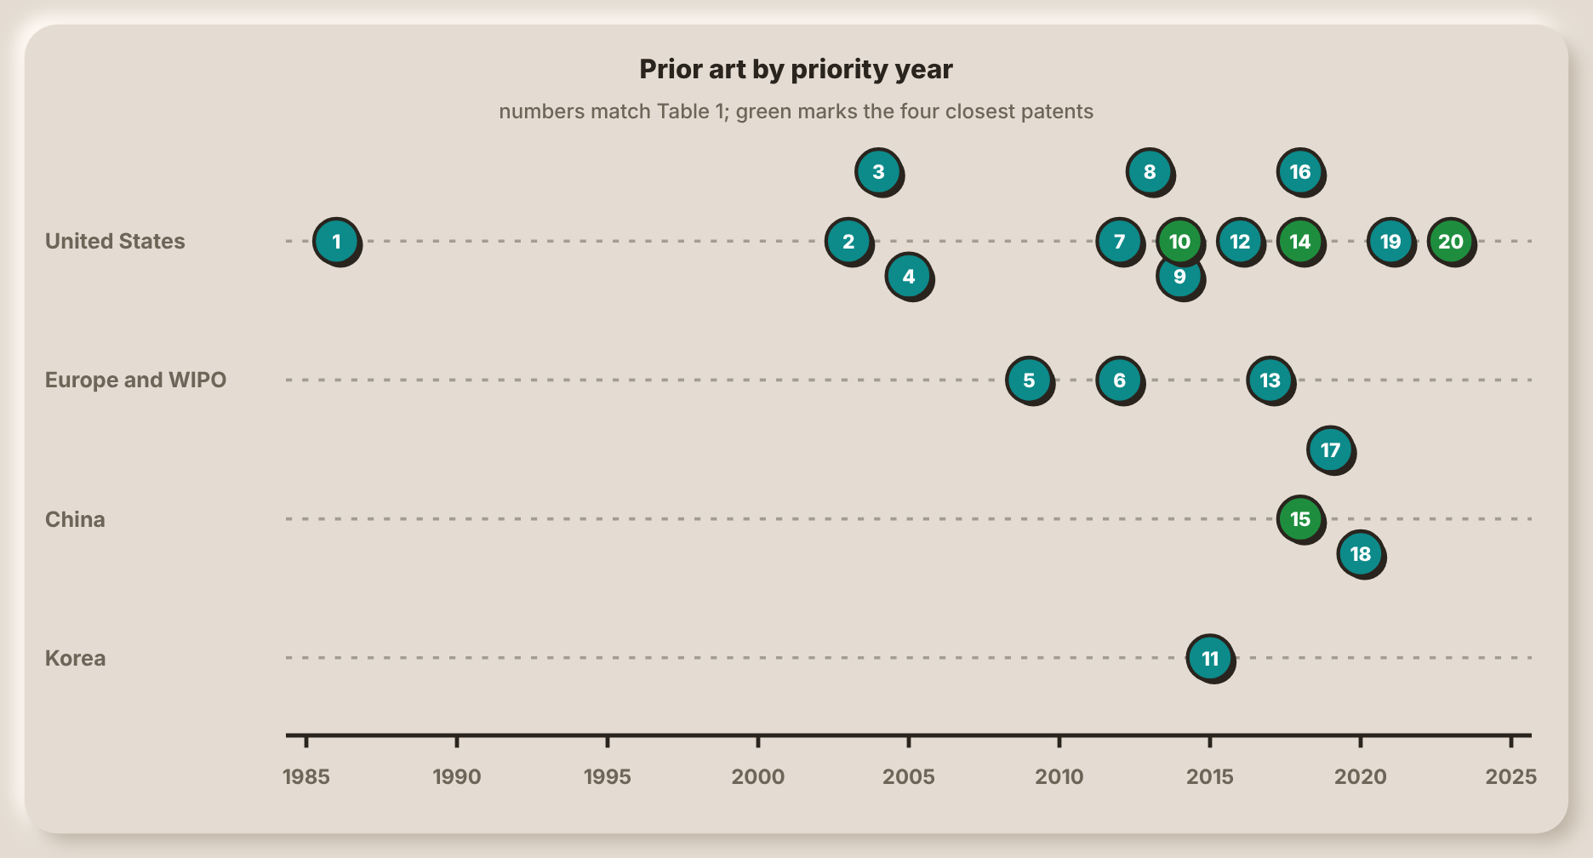
Note. Numbers match Table 1. The four patents in green are the closest to Smart-Bin.
Automated Trash Management System (Neumann & Allison, 1991)
Figure 3
Remote Status Units Linked to a Central Unit
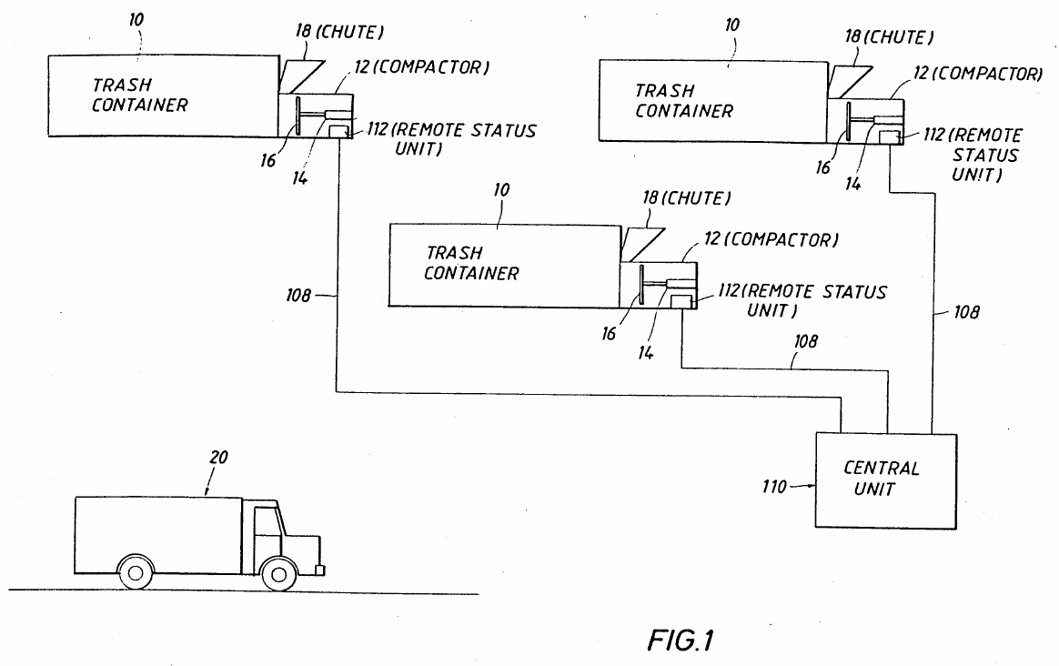
Note. From Automated trash management system (U.S. Patent No. 5,016,197), by R. H. Neumann and C. B. Allison, 1991, U.S. Patent and Trademark Office.

Figure 3 shows the layout of the system that Neumann and Allison (1991) patented for MGM Services. Each remote status unit serves three containers, each with its own compactor, and all units are linked by a communications line, typically a telephone line, to a central unit that keeps a database. The hauler sends a truck only to the containers that report full. For compactors, fullness is inferred from the hydraulic pressure during the packing stroke, from the work done per stroke or from the current drawn by the pump motor, and for any container a measured weight can be compared with a preset full weight.
Calling for a pickup only when a container is full is the idea behind the priority tags of Smart-Bin, and the load cell is a signal that both systems can use. The differences come from the era. The data travel by modem, a person calls the hauler, and no alert or route is generated. The patent describes no gas, temperature or tilt sensing, no lid, no display on the container and no phone app. Smart-Bin also measures the fill directly with an ultrasonic sensor and does not infer it from the work of a compactor.
Solar Powered Compaction Apparatus (Poss et al., 2006)
Figure 4
Compacting Ram and Chambers of the Solar Compactor
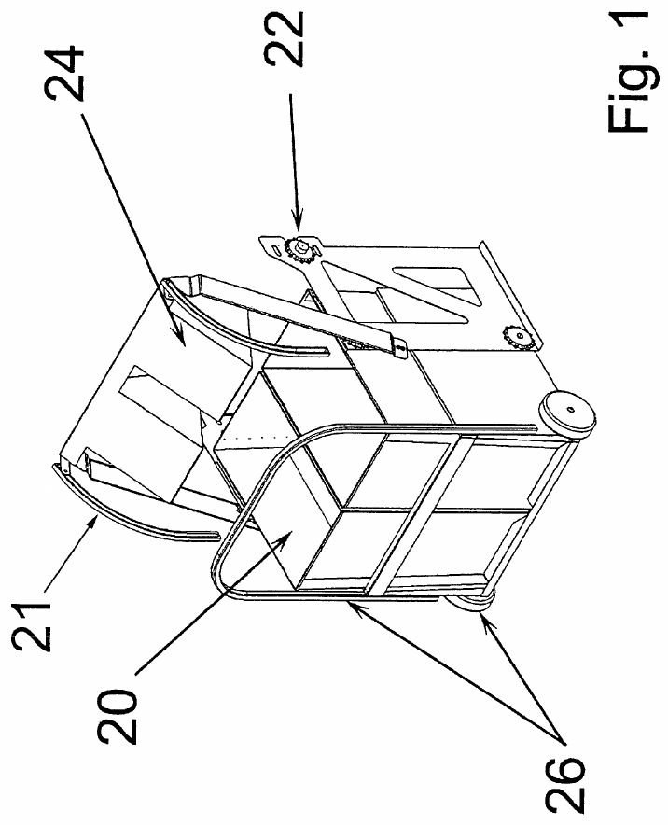
Note. From Solar powered compaction apparatus (U.S. Patent No. 7,124,680), by J. Poss, J. Satwicz, B. Richmond, and M. Taylor, 2006, U.S. Patent and Trademark Office.

Poss et al. (2006) of BigBelly Solar patented a public compactor that a photovoltaic array powers, so that it can stand where there is no mains power but many people pass. Figure 4 shows the compacting ram with its chain drive and guide track and the compaction chambers. One of the roof panels charges a battery, which causes a compaction cycle to be skipped if the battery has low charge. The trash is compacted, which means that it will not need to be emptied as frequently as a regular trash bin. Fullness is sensed by a photo-eye, by the ram motor current (the stall time) and by pressure sensors, and a wireless transmitter reports to sanitation staff.
The patent attacks the same public-space problem as Smart-Bin, a bin that overflows and is costly to visit, but it answers with compaction and solar power instead of sensing. Scales are named only as an alternative fullness sensor, and the only display is a set of status lamps. No weight or air sensing, tilt alarm, touchscreen, PIN mode or phone app is described. One remark does bear on the project: the patent says that real-time fill data could feed routing and scheduling software, which is the use that Smart-Bin makes of its fill ranking.
Compactor Service and Monitoring System (Brown, 2006)
Figure 5
Path of a Full Message From the Compactor Monitor to the Service Provider
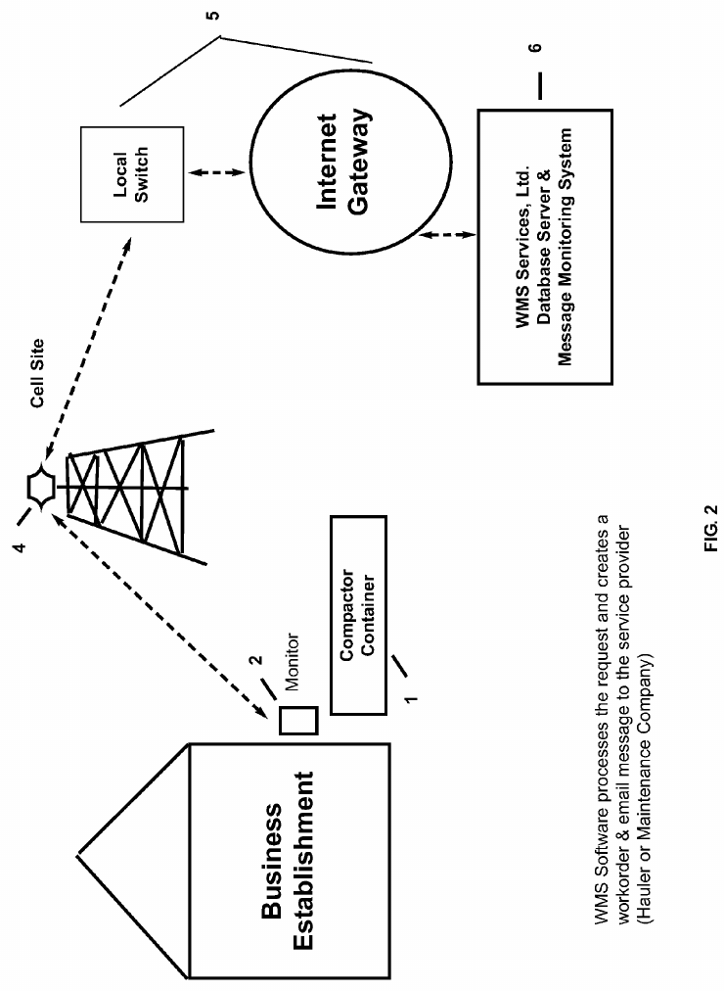
Note. From Compactor service and monitoring system (U.S. Patent No. 7,145,450), by W. J. Brown, 2006, U.S. Patent and Trademark Office.

Brown (2006), an individual inventor, patented a monitor that is added to an existing compactor. A pressure sensor on the hydraulic system of the ram measures the pressure during each cycle, and when the pressure stays at or above a preset value for a preset time the unit is flagged as full. Figure 5, which is Figure 2 of the patent, shows the path of a message. The monitor at the compactor reaches a cell site, an internet gateway and a server that runs the message monitoring software, which creates a work order, emails it to the service provider (a hauler or maintenance company) and supplies a tracking web link.
Like Smart-Bin, the system detects a full container by itself and notifies the people who must empty it. Fullness is inferred from pressure, though, and the patent has no level or weight sensor, since the tonnage is typed in by hand after a pickup. Alerts go out as email work orders, with fax as an option, and not as phone notifications, and the only local indication is a set of LEDs. Overdue work orders are flagged for staff, which is a rough counterpart of the priority tags of Smart-Bin, except that Smart-Bin bases its tags on the measured fill rate.
Trash Can With Power Operated Lid (Yang & Sandor, 2010)
Figure 6
Trash Can With a Motor-Driven Lid
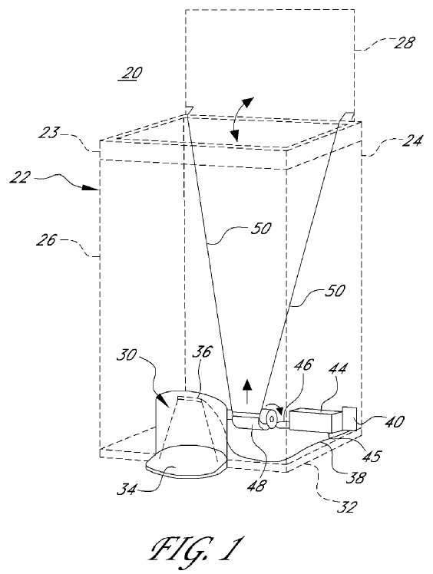
Note. From Trash can with power operated lid (U.S. Patent No. 7,781,995), by F. Yang and J. Sandor, 2010, U.S. Patent and Trademark Office.

Yang and Sandor (2010) patented the power-operated lid of Simplehuman. Figure 6 shows the can with its lid open. There's a recess in front that houses the sensor, two link rods on the back wall connect a motor-operated lifting bar to the lid, and the circuit board, batteries and motor gear all reside in the base. If the sensor senses an object in the proximity of the bottom of the can, the electric drive opens the lid and the lid remains open for a predetermined period (2 seconds, for example). Claim 1 relates to the motor for the door. The controller on each command verifies the supply voltage, regulates the motor power to maintain the speed of the door within a certain range, stops the motor by reversing it for a short time, and if the corresponding motor is running for too long, the motor stops and a fault is output.
Smart-Bin also opens its lid by motor when a sensor notices a user, so that nobody has to touch the lid, but it uses a PIR sensor and a servo and not a foot-level light beam. Everything else in the patent concerns lid mechanics. It has no fill, weight, air-quality, tilt, lock, display or wireless feature, and nothing on the collection side. The patent shows that a hands-free lid is old, so the contribution of Smart-Bin cannot be the lid itself. It lies in the sensing and reporting behind the lid.
Measuring Device and Monitoring System for Containers (Di Giugno et al., 2016)
Figure 7
Container With a Bag Between Capacitive Plates
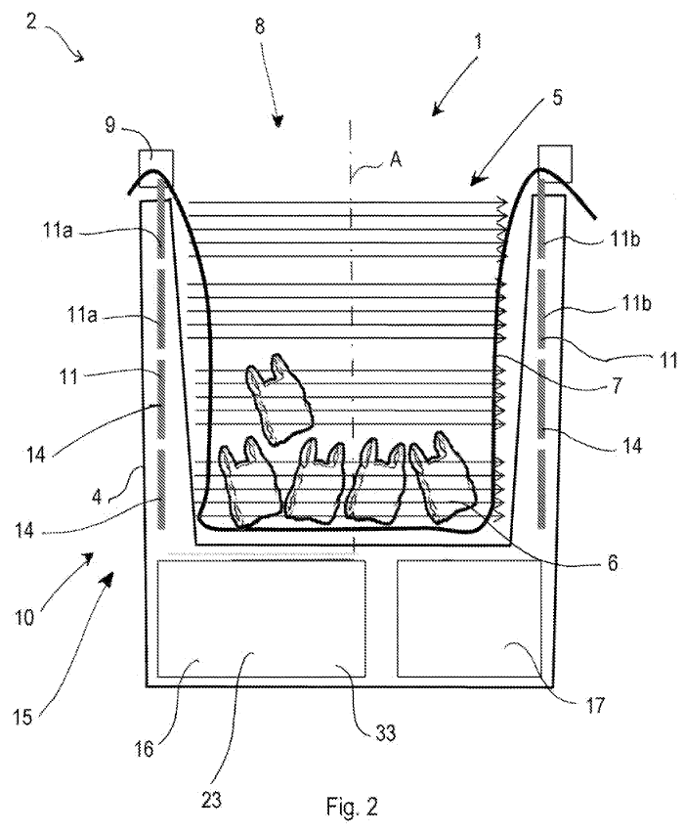
Note. From Measuring device, container means and system for monitoring and managing container means (European Patent No. 2516974), by M. Di Giugno, F. Giovanelli, S. Tiraboschi, and P. Villa, 2016, European Patent Office.

Di Giugno et al. (2016), from Cefriel and the Milanese environmental services company AMSA, describe a container whose casing holds a bag. Figure 7, which is Figure 2 of the patent, shows the container: the casing, the bag that the lid element holds in place and the plates at the sides of the cavity. Claim 1 places capacitive plates on opposite sides of the cavity, spaced along its length, so that the change in electrical capacity caused by the waste gives several progressive fill levels, with the bag lying between the plates. Status goes by GPRS or short-range wireless to an internet server, and stations plan the paths of the vehicles.
What matches Smart-Bin is the chain and not the sensor: measure the fill inside the bin, send it to a back end with a user interface, and use it to plan the collection of full bins. The sensing is different. Capacitive plates around a bag give levels in steps, while Smart-Bin measures distance by ultrasound and converts it to a percentage with two calibrated distances. It has no gas, temperature, tilt or weight sensing, no powered lid or lock, no PIN collect mode and no phone app.
Smart Waste Collection System and Method (Kekalainen & Engstrom, 2014)
Figure 8
Waste Collection System of Containers, Server and Vehicles
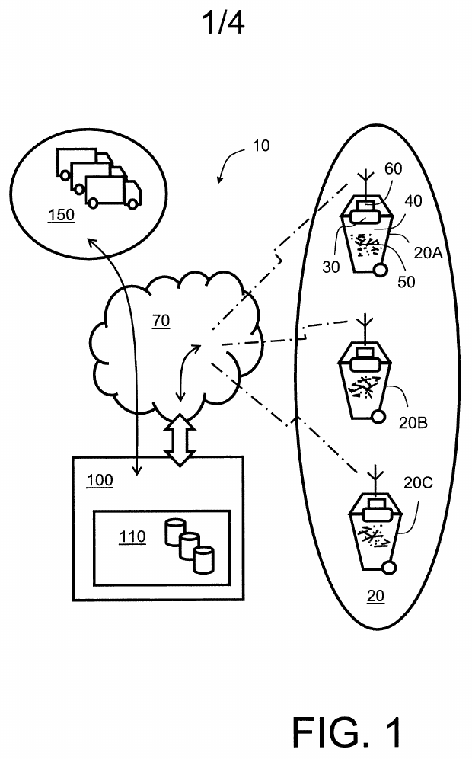
Note. From Smart waste collection system and method (International Patent Application Publication No. WO 2014/079586 A1), by F. Kekalainen and J. Engstrom, 2014, World Intellectual Property Organization.

Figure 8 shows the system in the application that Kekalainen and Engstrom (2014) filed for Enevo. The status is transmitted via a wireless network (GSM/3G) to a central server, which maintains the information in a database and arranges collection for vehicles on the way to collection or recycling facilities. The sensors are located in a rotating lid to measure fill level, gasses (methane, CO2 and CO type) and temperature. Weight is not measured. The server forecasts container fill times and routes them using a Monte Carlo simulation based on GPS data of the vehicles.The application also describes a marketplace in which haulers bid for collection jobs.
This is an early statement of the idea that fill data should decide which bins are collected first, and Smart-Bin carries it out on a much smaller scale with its priority tags. The patent works at fleet level, with bidding, simulated models and vehicle tracking, and the bin is only a sensor. It has no weight sensing, tilt or tamper alarm, powered lid, PIN mode or display on the bin, and humidity and odor are not measured.
Refuse Container With Weight Indicator and Danger Alerting (Mullaney, 2016)
Figure 9
Refuse Container With Scale, Display and Lights
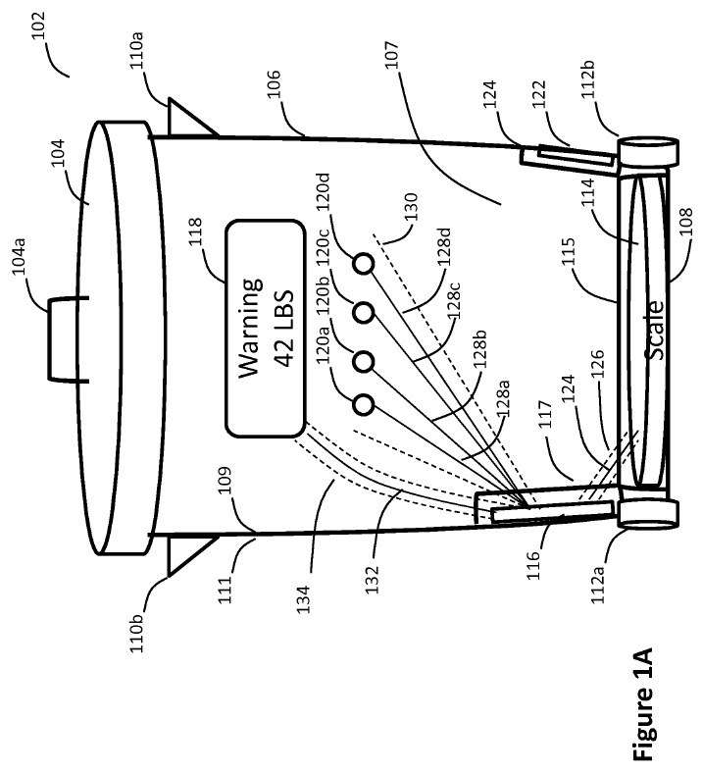
Note. From Refuse container with weight indicator and danger alerting (U.S. Patent No. 9,347,821), by G. Mullaney, 2016, U.S. Patent and Trademark Office.

Mullaney (2016), an individual inventor, patented a refuse container that shows how heavy its contents are. Figure 9, which is Figure 1A of the patent, shows a container with a floor scale, a controller, a display and four lights. The lights track the percentage of the maximum weight, and all of them light, with one flashing, once the limit is exceeded. The maximum weight can be set by location (a city or ZIP code lookup), by the user or by default, and an optional beep is mentioned. Claim 1 adds a memory that stores a history of readings, a controller that sends that history to a service provider, and a lock that locks the lid once the refuse reaches a predetermined weight. An inversion sensor releases the lock for emptying.
The container weighs its contents, shows the weight and warnings on the bin, locks the lid under a condition and can report to a remote party, and Smart-Bin does all four. The lock is the point of difference. It closes at a weight limit to stop overloading, where the lock of Smart-Bin is controlled remotely or by a PIN. The patent does not measure fill level or air quality, has no tamper alarm, PIR lid or collection priority list, and uses the mobile app only for configuration.
Sensor Device for Smart Waste Collection Systems (Kekalainen & Engstrom, 2018)
Figure 10
Sensor Device Mounted Under the Lid Behind a Thermal Barrier
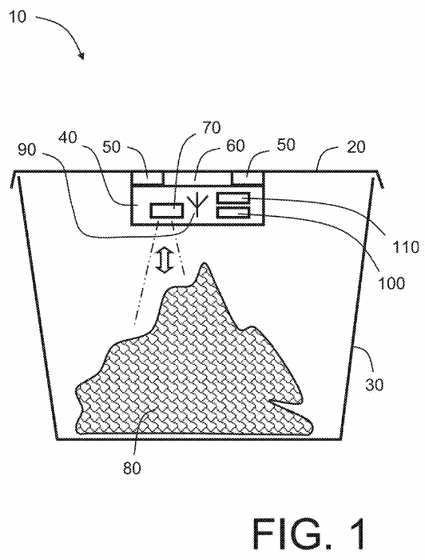
Note. From Sensor device for smart waste collection systems and method (U.S. Patent No. 9,927,278), by F. Kekalainen and J. Engstrom, 2018, U.S. Patent and Trademark Office.

Kekalainen and Engstrom (2018) patented the sensor module itself and not the system around it. Figure 10 shows a container with a pivoting lid and the sensor device under the lid, held off its surface by spacers that leave an air gap. The spacers and a heat-reflecting metal foil layer form a thermal barrier between the lid and the electronics. The module has an ultrasonic sensor for the amount of waste and sensors for temperature, humidity and a hydrocarbon or methane gas that indicates decomposition. The data is sent constantly, periodically or when a threshold is reached via a cellular modem (GSM or 3G), and the fasteners can be designed to avoid unauthorized removing.
This is the nearest match to the sensing side of Smart-Bin. Ultrasonic fill, temperature, humidity and gas are all on the bin, and the data go wirelessly to a remote location. The novelty lies in the insulated lid mounting and not in the sensors. The data support collection scheduling, but the device does not compute routes, and no weight sensor, powered lid, PIN mode or priority list is described. The anti-removal fasteners are a mechanical measure, where Smart-Bin senses the tilt and sounds an alarm.
Monitoring and Communicating the Fill Rate of a Container (Kekäläinen, 2018)
Figure 11
Gauge Mounted Under the Lid of a Container
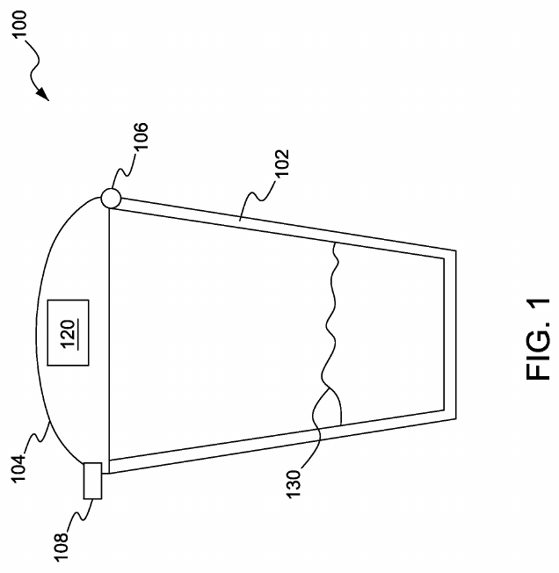
Note. From Method and system for monitoring and communicating fill rate of container (U.S. Patent No. 9,930,429), by F. Kekäläinen, 2018, U.S. Patent and Trademark Office.

Kekäläinen (2018), also for Enevo, is about how often the gauge talks and not about what it measures. Figure 11 shows a garbage container with a hinged lid and the gauge attached under the lid. The model of how the gauge is supposed to function is sent to the gauge by a server that includes the maximum and minimum fill-rate limits and a communication schedule. The gauge maintains the microcontroller and transceiver in sleep mode, sensing the fill rate and waking only if the fill rate is at, or exceeds, a limit, transmitting the fill rate measurement and receiving an updated model. A lower number of transmissions equals a longer battery life.
Smart-Bin takes the opposite path over the same issue. It reports on a fixed schedule, with a write to ThingSpeak every 30s. A bin that is left outside for weeks could be threshold driven. The parts read the patent describes no motorized lid, tamper alarm, PIN mode, touchscreen or phone app. Its user device is a laptop or desktop.
Smart Garbage Bin (Shahabdeen, 2016)
Figure 12
Smart Garbage Bin With a Lid-Mounted Sensor Device
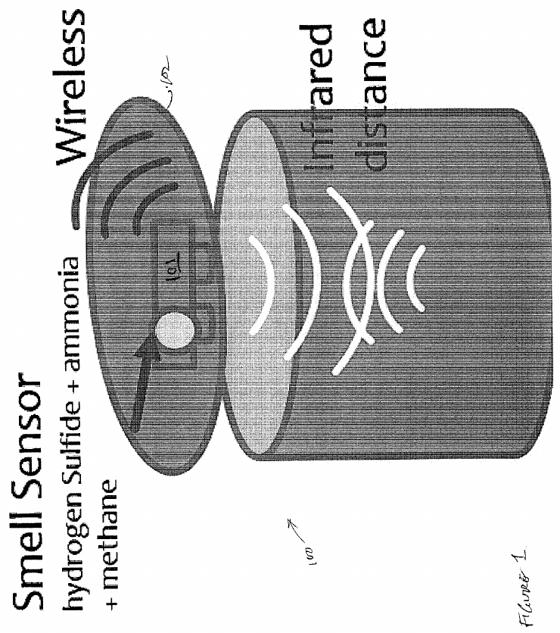
Note. From Smart garbage bin (U.S. Patent Application Publication No. 2016/0176630 A1), by J. A. Shahabdeen, 2016, U.S. Patent and Trademark Office.

Shahabdeen (2016) filed this application for Zan Compute. Figure 12 shows the bin with a battery-powered wireless sensor device on its lid. The sensor is a reflective infrared range finder (a Sharp GP2Y0A41SK0F) aimed at the waste, and the description adds MQ-136, MQ-137 and MQ-4 gas sensors for hydrogen sulfide, ammonia and methane. A weight sensor at the base is the alternative way to measure how much has been deposited. A local controller sends the data wirelessly to a remote controller (MQTT in claim 17), and claim 13 sends an alert when a sensed value passes a threshold. The application says that an ultrasonic sensor was a possible alternative to the infrared range finder but judged it too power-hungry.
It's the closest to Smart-Bin in hardware: the distance to the trash from under the lid, the weight under it, gas sensing, and wireless reporting. It does not provide tamper detection, powered lid, lock, display, Pin mode, priority list and does not talk about temperature and humidity. The lid only carries the sensor. Google Patents lists the application as abandoned.
Input Device for a Pay-by-Weight Food Waste Processor (Shin, 2016)
Figure 13
Pay-by-Weight Food Waste Processor With a Load-Cell Hopper
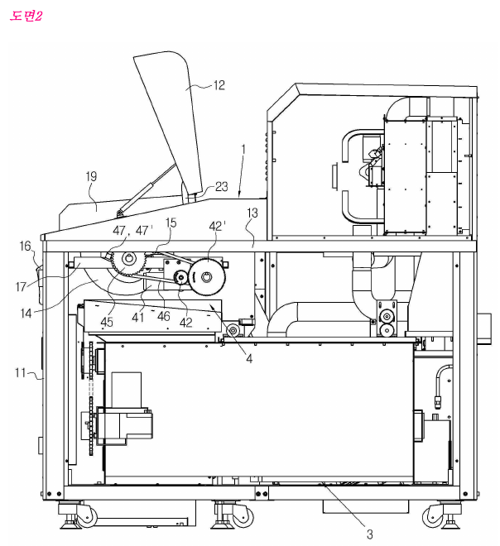
Note. From Inputting device for quantity and weight loss of food garbage container (Korean Patent No. 10-1581944), by H. Shin, 2016, Korean Intellectual Property Office.

Shin (2016), for Concoftech, patented the waste input device of a pay-by-weight food waste processor. Figure 13 is a perspective view of part of the machine, with some parts omitted and separated. The waste is dropped into a hopper which sits on a load cell, the user pays electronically on the display, and the hopper then rotates approximately 170-180 degrees and releases the waste into a crushing and stirring tank. The guide member with rollers allows hopper to be turned within the space of the lid without snagging, maintaining the machine compactness and convenient loading height. Drawings show that payment data is sent to a primary server not shown in the drawing.
The load cell, a powered lid and a display for the user are shared with Smart-Bin. It is not for the same purpose. The Korean device crushes the garbage and charges according to its weight, while Smart-Bin weighs to verify the garbage level. There is no fill-level, gas, tilt or tamper sensing, no wireless or cloud reporting in the text read, no collection priority list and no mobile alerts in the patent. The reason for earlier deodorant sprayers and sterilizing lamps is that the odor is only in the background.
Techniques for Optimally Sensing Full Containers (Devitt & Walsh, 2021)
Figure 14
Infrared Beam Across a Container
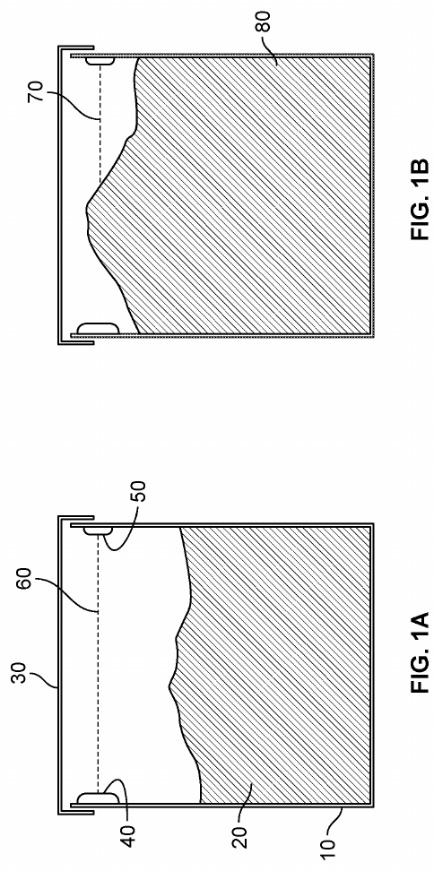
Note. From Techniques for optimally sensing full containers (U.S. Patent No. 11,054,545), by S. Devitt and B. Walsh, 2021, U.S. Patent and Trademark Office.

Devitt and Walsh (2021), for Oneplus Systems, give two ways to detect a full container while keeping very low the current drawn by battery-powered wireless circuitry. Figure 14, which combines Figures 1A and 1B of the patent, shows the first: an infrared emitter and receiver mounted on the side walls, so that the line between them marks the full level. The emitter transmits a wake-up signal and coded pulses, the receiver waits in sleep mode until the wake-up signal is received, and at the end of a specified period of time, if the coded signals are not received, the container is considered full. The second method checks the resting tilt angle of lid in three axes since a lid that overfull waste holds up is set at a different angle. The data from fullness is sent to a cloud server.
The patent only gives full or not full, with Smart-Bin providing a calibrated percentage and a time to full. No weight, gas, temp, powered lid, PIN mode/tamper alarm is displayed in parts read. The tilt here is the angle of the lid, used as a sensing element, and it is not a tamper check, so it should not be confused with the BMI160 tilt alarm of Smart-Bin, which watches the whole bin.
Trash Can With a Sensing Flip Lid (Wang, Chen, et al., 2020)
Figure 15
Circuit of the Induction Flip Lid With a Settable Sensing Distance
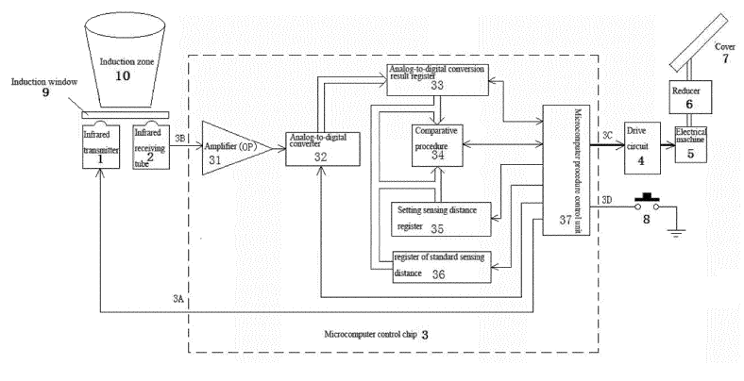
Note. From Trash can having sensing flip lid having settable sensing distance and control method therefor (European Patent No. 3 620 405 A1), 2020, European Patent Office, X. Wang et al. (sensing flip lid).

A clamshell trash can with an infrared sensing distance set by the user is described by Wang, Chen and Lin (2020) of Fujian Nashida Electronic. The circuit diagram is shown in figure 15. The major components are an infrared transmitter and receiver underneath an induction window, a single microcomputer chip for the amplifier, analog-to-digital converter and distance registers, and a drive circuit to operate the motor and reducer. Only when the reading is above the standard distance value, the motor will flip the cover open and when the user selects a distance by pressing a setting button, it will be stored and used for comparison later.
This is the closest equivalent of the servo-lid of Smart-Bin that is triggered by a PIR. A hand near the induction window opens the lid and how near is up to the user. As no fill or weight, gas, tilt, display or wireless link or monitoring is involved in the project, nothing else is addressed in the patent. It was listed as a published application (kind code A1) on Google Patents and withdrawn in 2021, meaning that it was not granted.
Smart Waste Bin Sensor Device and Methods (Kurani, 2023)
Figure 16
Overall Smart Waste Management System
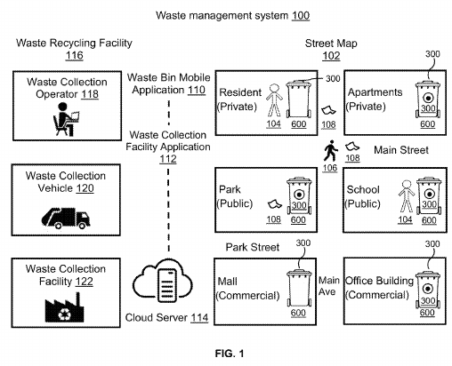
Note. From Smart waste bin sensor device and methods for waste management system (U.S. Patent No. 11,702,280), by H. B. Kurani, 2023, U.S. Patent and Trademark Office.

Kurani (2023) is the broadest patent of the twenty on sensing. Figure 16 gives the whole system for monitoring bins continuously to optimize collection and reduce littering. The bin is equipped with a battery powered smart sensor device carrying approximately a dozen sensors, including fill level, temperature, humidity/pressure, air quality, smoke, gas, motion, a pathogen biosensor and sterilizer, and an accelerometer. Readings are transmitted via a wireless network to a cloud server which creates real-time bin statistics and optimizes collection routes. The data is displayed in a bin app and a facility app, and biohazard and biosafety alerts are sent to nearby phones. The accelerometer detects when the bin has been tilted, and resets the fill level to zero when the bin tips over.
It matches Smart-Bin on sensing, cloud, apps and routes: fill, gas, temperature and tilt data go to a cloud server with mobile alerts and an optional touchscreen on the device. Its centre of gravity lies elsewhere, in litter, biohazard and pathogen sensing with a sterilizer. The parts read show no PIR-actuated servo lid, remote lock, PIN collect mode or tamper alarm with a latch, and the tilt serves to reset the fill level and does not sound an alarm.
Smart City Garbage Management System (Yan & Chen, 2021)
Figure 17
Garbage Cans and the Monitoring Center
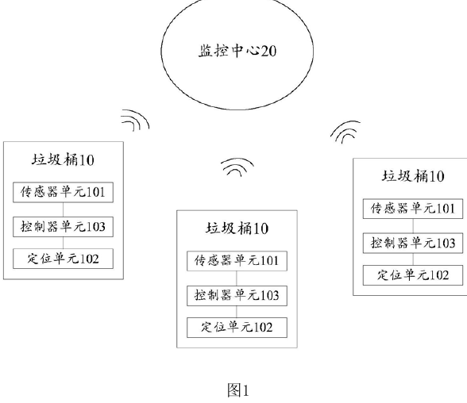
Note. From Smart city garbage management system (Chinese Patent No. CN 109324552 B), by S. Yan and J. Chen, 2021, China National Intellectual Property Administration. The labels in the original are in Chinese.

Yan and Chen (2021), for Shanghai Shuncom Smart Technology, patented a city-wide system. Figure 17 is the schematic of the garbage cans and the monitoring center. Each can has a positioning unit, a controller and sensors for weight, infrared height, odor and smoke, and the controller uploads the readings to the monitoring center. The center decides which cans need inspection (weight, height or odor above a threshold, or any smoke), generates the route of the truck. When a special-condition signal arrives, a nearby truck is rescheduled by priority, in the order fire, fault, pollution and full bin.
This patent is the closest in purpose. Weight, height and odor decide which cans are serviced first, as the priority tags of Smart-Bin do. It goes further by building routes for trucks with GPS, and Smart-Bin stops at ranking the bins. It also includes smoke sensing, which Smart-Bin does not have. No powered lid, tamper detection, PIN mode, on-bin display or phone alert appears in the text read.
Apparatus and Method for Waste Monitoring and Analysis (Balachandran & Talavera, 2023)
Figure 18
Waste Measurement System With Weighing Devices and Reports
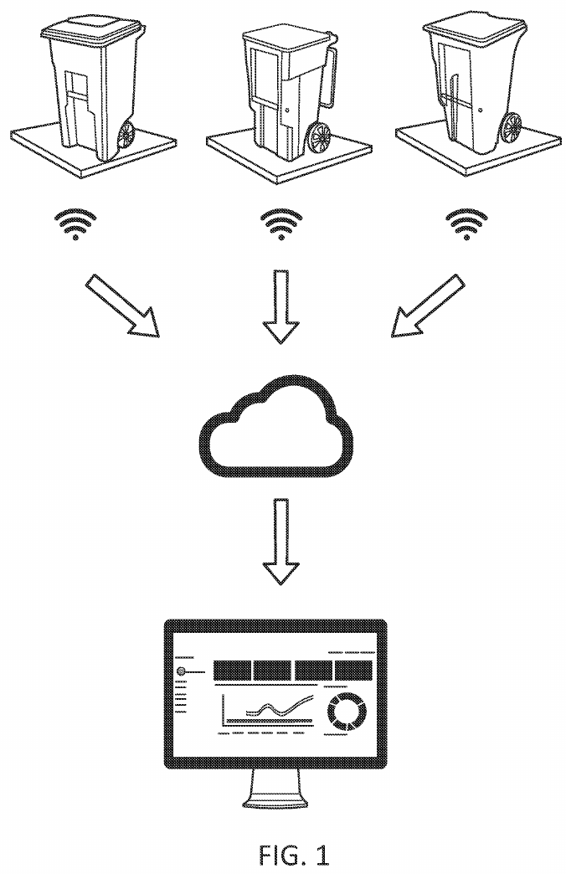
Note. From Apparatus and method for waste monitoring and analysis (U.S. Patent No. 11,788,877), by N. Balachandran and O. Talavera, 2023, U.S. Patent and Trademark Office.

Balachandran and Talavera (2023), for Zabble, cover waste audits. Figure 18 gives an overview of the measurement system: a series of weighing devices record the weight of the waste, the data go to networked storage, and the stored data are turned into visual reports for an operator. Claim 1, though, is about images: a method that acquires images of the contents of at least two containers of a waste generator, identifies characteristics of the contents and generates a report by computer. The disclosure adds load cells under a platform for two or more bins and gas sensors for compost bins.
The shared ground with Smart-Bin is remote monitoring of bin contents, with cloud upload and dashboards, and gas sensing in one special case. The aim is different. This patent is an audit and reporting service that tells a waste generator what is being thrown away, while Smart-Bin is a single bin that works out when it needs emptying. The claims do not cover a bin with fill, tilt, lid and lock control, a PIN collect mode or a collection priority list.
Capacity Inspection Garbage Bin With Infrared Induction (Yang et al., 2020)
Figure 19
Block Diagram of the Capacity-Detecting Bin
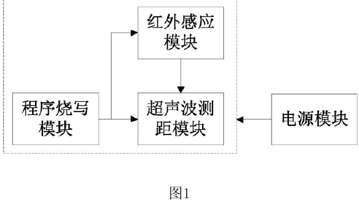
Note. From Capacity automated inspection garbage bin with infrared induction function (Chinese Patent No. CN 210504152 U), by S. Yang, D. Liao, R. Li, and Y. Yu, 2020, China National Intellectual Property Administration. The labels in the original are in Chinese.

Yang et al. (2020), for Sichuan Grid Environmental Protection Technology, is a utility model for a bin that shows how much capacity it has left. Figure 19 is a block diagram of the inside of the bin. The body holds an infrared induction module, an ultrasonic ranging module, a programming module and a power module. The ultrasonic module is connected to the infrared and programming modules, and the power module supplies all three. The ultrasonic module measures the remaining capacity and two nixie-tube digits show it on the bin, while the infrared module detects a nearby user to wake the system. Google Patents lists the rights as terminated for non-payment of fees.
This utility model matches the local side of Smart-Bin: an ultrasonic ranging module, a wake-up by a nearby user, and the capacity shown on the bin itself, where Smart-Bin shows it as a percentage on its touchscreen. Little else carries over. The device is stand-alone, with no weight, gas, tilt, lid actuator, wireless link, server, route planning or phone app.
Garbage Bin Intelligent Controller and Supervisory System (Wang, Zhang, et al., 2020)
Figure 20
Electrical Block Diagram of the Bin Intelligent Controller
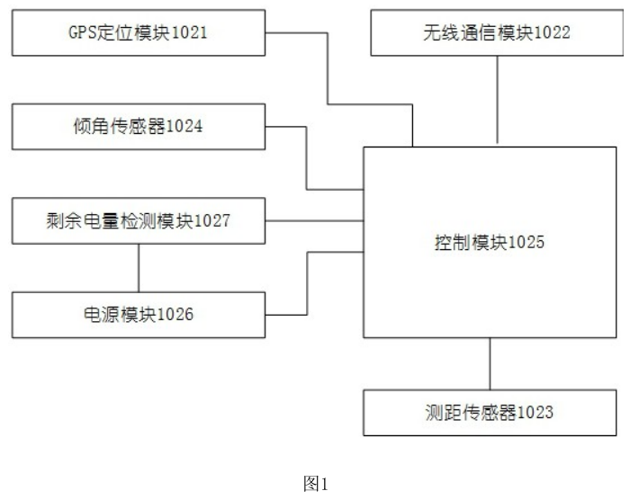
Note. From Garbage bin intelligent control ware and garbage bin supervisory systems (Chinese Patent No. CN111559590A), by X. Wang, Y. Zhang, and Z. Wang, 2020, China National Intellectual Property Administration. The labels in the original are in Chinese.

Wang, Zhang, and Wang (2020), for Weihai Jingxun Changtong Electronic Technology, published an application for a bin controller that can be installed on top of the bin or at its side. Figure 20 is its electrical block diagram, with a wireless communication module, a control module and a distance sensor in one housing. In top mode the controller works out the height of the garbage, in side mode it reports the distance to the opposite wall, and either value is uploaded to monitor whether the bin is full. In the description, an ultrasonic module measures the distance, an inclination sensor raises a tip-over or movement alarm, the data go by NB-IoT and alerts reach the phones of workers.
The overlap with Smart-Bin is strong on the alert side: a distance sensor for fill, an inclination sensor for tip-over alarms, wireless upload and alerts on a phone. The patent has no weight or gas sensing, powered lid, lock, PIN or touchscreen collect mode, priority list or time to full, and in the parts read the inclination alarm has no countdown or latch, which Smart-Bin adds. Google Patents lists the application as withdrawn.
Measuring the Fill Level of a Trash Can Using a Sensor (Keller et al., 2024)
Figure 21
Automatic Alerting System for a Trash Can
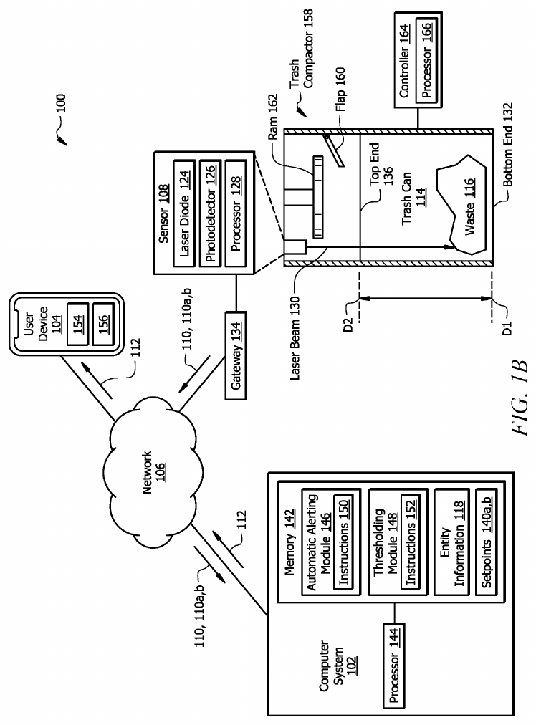
Note. From System and method for measuring the fill level of a trash can using a sensor (U.S. Patent No. 12,125,361), by J. R. Keller, M. O. Redmond, and S. A. Mirza, 2024, U.S. Patent and Trademark Office.

Keller et al. (2024), for 7-Eleven, patented a way to turn a distance reading into a fill percentage. Figure 21 shows the automatic alerting system: a sensor above the container, a gateway and network, and a computer system with its modules and a user device. In claim 1 a sensor above the can holds a laser diode that sends a pulse toward the bottom and measures the time of flight. A computer converts the distance to a percentage of waste with two calibration setpoints, picks a threshold for the current time period from stored information about the owner of the can, and alerts a user device when the threshold is exceeded. Alerts can be email or text on a smartphone.
The two setpoint calibration is identical to that of Smart-Bin: the empty distance (default: 30cm) and the full distance (default: 5cm) are programmed from the interface, and the fill percentage is programmed to the distance between. A threshold-based alert reaches a phone in both. Everything else in the patent is narrower: a single laser sensor, no weight, gas, tilt or tamper sensing, no lid control or lock, no touchscreen collect mode and no priority list.
Waste Bin Collection and Monitoring Method Using Bin Sensors (Sait et al., 2025)
Figure 22
Network of Waste Bins, Cloud Server and Vehicles
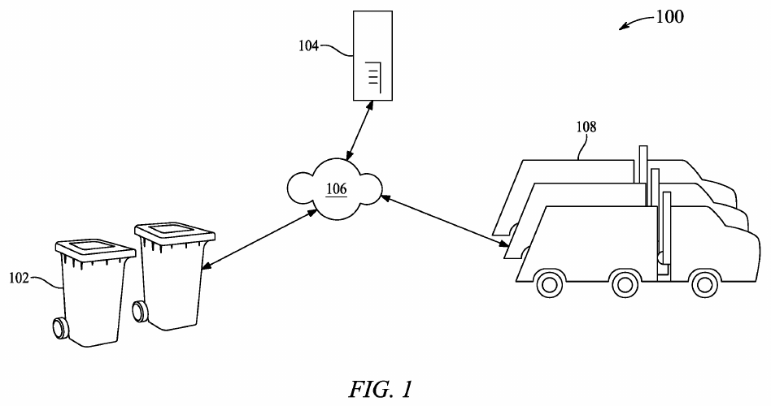
Note. From Waste bin collection and monitoring method using waste bin sensors (U.S. Patent No. 12,450,575), by S. Sait, F. M. Aliyu, S. Bukar, B. S. Maina, and D. U. Lawal, 2025, U.S. Patent and Trademark Office.

Sait et al. (2025), from King Fahd University of Petroleum and Minerals, is the newest patent in the set. Figure 22 is a network diagram of the waste bins, the cloud server, the cloud network that connects them and the waste vehicles. Claim 1 describes a method to monitor and control the CO2 and CH4 emissions of a collection system. The methane, humidity, waste level, location and temperature are sensed under every separate bin lid and transmitted to a cloud server. One processor calculates the time in which the methane limit will be reached and a second processor calculates the time in which the fill limit will be reached, and a third processor, based on the CO2 and CH4 readings of the vehicles, prepares the collection schedule and routes. Two neural networks make the time estimates, and a mobile app sets parameters and shows data.
It is the nearest to Smart-Bin in using a time to full, in sensing fill, gas, temperature and humidity inside the bin, and in sending them to a cloud server with a display and a mobile app. The estimate is made differently. Neural networks work from methane and fill data, while Smart-Bin uses the fill rate of the last 15 minutes with no trained model. The patent is centered on methane prediction and routing based on emissions. It has no load cell, tilt or tamper alarm, PIR lid, remote lock or PIN collect mode, and weight and tilt appear only in a list of possible sensors.

Related Literature and Studies
Thirty studies were reviewed between 2023 to 2026. Each of them is listed in Table 2 with its hardware, the main reported result and what it is lacking in comparison with Smart-Bin. If a figure is derived from training data or is a synthetic data set, this is indicated in the table as these figures are not representative of the actual system in use. Each study is then taken in turn under one of four headings, according to what it puts the most weight on: level-sensing bins with lids and alerts, bins that add weight, gas or access control, collection routes and priority, and cameras, sorting and system design. A figure is shown wherever the source is open access and has a drawing or photograph that helps, with the licence of the figure in the note under it. The other studies are text only, because their publishers do not allow the figures to be reused.
Table 2
Related Studies From 2023 to 2026
Study | Hardware and platform | Reported result | What it lacks
Saad et al. (2023) | NodeMCU ESP8266 and Arduino Nano, HC-SR04, HX711 load cell, GPS, SG90 lid, WhatsApp through Twilio | Lid opens within 50cm. Full at 3cm of free space or 4,000g. Height error 0.4%, weight error 0.15%, message in 2.61s. | Dashboard, air quality, tamper detection, cloud history, roles
Abdullahi et al. (2024) | Arduino with HC-SR04 and SIM800L GSM, servo lid, cloud server | Lid opens only when the bin is not full. Full at 20cm. No performance figures are given. | Weight, air quality, tamper detection, dashboard, app
Alnuaimi et al. (2024) | Simulation of smart-bin collection as a travelling salesman problem (AnyLogic) | Shorter travel distance and lower emissions than static routes. No figures are given. | Bin hardware, alerts, app
Ayyanagoudar et al. (2024) | Ultrasonic and weight sensors, web page for each bin level | Real-time level tracking for each bin on a web page. No measured results are given. | Air quality, tamper detection, app, alerts
Azmi et al. (2024) | Arduino Uno with LoRa, HC-SR04, DHT11, GPS, ThingSpeak dashboard | Ultrasonic accuracy 89.9% at half full, humidity 96.9%, temperature 94.4%. Alerts are dashboard indicators only. | Weight, app, push alerts, on-bin display
Enache et al. (2024) | ESP32-CAM nodes with solar cell, ESP-MESH, server image processing | Fill ratio estimated from hourly bin photographs. Relative error 11.43% to 30.00% on five bins. | Weight, air quality, tamper detection, app
González et al. (2024) | ESP32 and ESP32-CAM, ultrasonic fill, simulated weight, Oracle APEX dashboard, App Inventor app | Camera classifies waste; weight is simulated with potentiometers. No accuracy figures. | Real weight sensing, air quality, tamper detection, priority list
Kuzhin et al. (2024) | IoT sensors with route analytics; no hardware described | The results are 20% fewer overfilled bins, 15% fewer collection trips, 25% shorter trips, and 10% less fuel. | Any bin hardware; setting and sample are not given
Mehta and Rathour (2024) | Ultrasonic, temperature, weight and tilt sensors and data software. | 6-month pilot: approximately 50% improvement in collection efficiency, 25% reduction in cost, and 83.3% reduction in overflows. | Detail on site and method; air quality, app, on-bin display
Muthukumar et al. (2024) | Camera-based AI segregation bin with a staff app for fill level and temperature and humidity | Classifier test accuracy 92.3% (training accuracy 71.8%). The scalability claim is not tested. | Weight, air quality, tamper detection, collection priority; main aim is segregation
Rathnayake et al. (2024) | Three ESP32 bins with ultrasonic and methane sensors, Node-RED cloud, machine learning | 4-month pilot: fill accuracy 95%, methane detection 92%. Route simulation 15% more path-efficient. | Weight, tilt, app, on-bin display
Salleh et al. (2024) | Using NodeMCU ESP8266, ultrasonic sensor and ThingSpeak dashboards. | Live container levels support need-based collection scheduling. Proteus simulation and PCB layout are included. | Weight, air quality, tamper detection, app
Shaharil and Po’ad (2024) | Arduino, ultrasonic lid sensor, IR fill sensor, load cell, MQ-2, LCD, Blynk | Weight errors of −5g to +10g on four items. The Blynk app shows a full-bin notification. No numbers for the IR or gas sensors. | Web dashboard, collection priority, tamper detection
Thangam et al. (2024) | Use of ESP8266, ultrasonic and soil-moisture sensors | Analytics are meant to let authorities adjust routes. No results are reported. | Weight, air quality, tamper detection, app
Aasish et al. (2025) | Dual-core ESP32 on FreeRTOS, ultrasonic, DHT sensor, RFID bin tags, LCD or OLED, cloud server | Splits sensing and cloud communication across tasks. No measured results. | Weight, tamper detection, app, test data
Alnanih et al. (2025) | Arduino Uno and ESP8266 with GSM, HC-SR04, flame sensor, GPS, LCD, Firebase, web app, Flutter app | 6-month, 50-bin campus pilot: 99.5% uptime, fill error within ±3%. Smoke Test fire alarm in 5s. | Weight, humidity, tamper detection, time to full, UI calibration
Alourani et al. (2025) | Arduino Nano and ESP8266, ultrasonic sensor, Firebase, Android app, VGG-19 classifier | App alerts collectors at a fill threshold. Classifier 99.7% training accuracy. | Weight, air quality, tamper detection, priority list
Banciu et al. (2025) | GPS and RFID bin locations; Nearest Neighbor, OR-Tools and genetic algorithm | Three real routes with 735 locations: up to 52% shorter distance, over 14kg less CO₂. | Any bin sensing; the study is about routing
Gajula et al. (2025) | ESP32, HC-SR04, Moisture sensor, Servos and Arduino IoT Cloud. | Separates dry and wet waste by moisture. No figures are given. | Fill-level role of the ultrasonic sensor, weight, tamper detection, app
Gupta et al. (2025) | Microcontroller with ultrasonic sensor and Wi-Fi, cloud platform | 30-day, 50-bin pilot: 58.9% less distance, 59.2% less fuel, 95% fewer overflows, 99.8% uptime. | Weight, air quality, tamper detection, app detail
Ishaq et al. (2025) | Ultrasonic sensors in bins at ten hospitals, cloud monitoring station | Alerts led to pickups 3 to 16 minutes later. Biomedical waste about 43.6% to 52.5% of hospital waste. | Weight, air quality, tamper detection, app (proposed only)
Karthi et al. (2025) | ESP32, RFID reader, ultrasonic sensor, metal detector, MQ135, Blynk | 95% fill accuracy, 92% RFID reliability, 40% less manual intervention. | Weight, tamper detection, priority list, web dashboard
Kumar et al. (2025) | Using ESP32, ultrasonic sensors, Ant Colony Optimization, machine learning, and map. | Prioritizes filled bins and builds depot-to-depot routes. No numbers are reported. | Weight, air quality, tamper detection, app, alerts
Maulida et al. (2025) | ESP32, HC-SR04, MQ-2, HX711, SG90 lid, Firebase, Android app | Level accuracy about 95%, weight about 93%, 92% of spoiled-food cases flagged, usability score 86 (15 officers). | Tamper detection, collection priority, web dashboard, roles
Mehta et al. (2025) | ESP8266 with ultrasonic sensor, MQ4, MQ136, MQ137 and GPS, Firebase and React Native Application | Gas sensors 96% to 98% accurate against a reference. Field test of 28-bin samples cut trucks from 3 to 2. The 100-bin results are synthetic. | Weight, tilt, on-bin display; some tables conflict
Sadikin et al. (2025) | ESP32 with ultrasonic, infrared and GPS, Firebase, Kotlin Android app | Ranking by distance, vehicle capacity and fill level (greedy). 69 respondents: 92.37% effectiveness, 89.92% satisfaction.. | Weight, air quality, tamper detection, on-bin display
Shahibollah et al. (2025) | ESP32, ultrasonic sensors, servo lid, tri-colour LED, Blynk | Tested by simulation and on hardware. No figures are given. | Weight, air quality, tamper detection, priority list
Yogesh et al. (2025) | ESP32, HX711 load cell, ultrasonic sensor, Firebase, App Inventor app, LCD | Weight and fill percentage with full-bin alerts. No measured results are reported. | Air quality, tamper detection, priority list, test data
Awotayo and Dodo (2026) | ESP32, two HC-SR04, MG90S servo lid, LEDs and buzzer, Blynk email | Fill zones at 40% and 60%; email when full. No accuracy or response-time results. | Weight, air quality, tamper detection, dashboard, app
Mugaruka et al. (2026) | LoRaWAN-style network of ultrasonic sensors in seven 120-L bins | 12-week pilot: 57% of sensors at or below −107dBm; mass and route times are estimates. | Weight, air quality, tamper detection, app
Note. Results are as reported by the authors. Lacks means that the feature is not described in the study.
A. Level-Sensing Bins With Lids and Alerts
Smart Bin With Automatic Lid Control (Abdullahi et al., 2024)
Figure 23
Block Diagram of the Smart Waste Management System
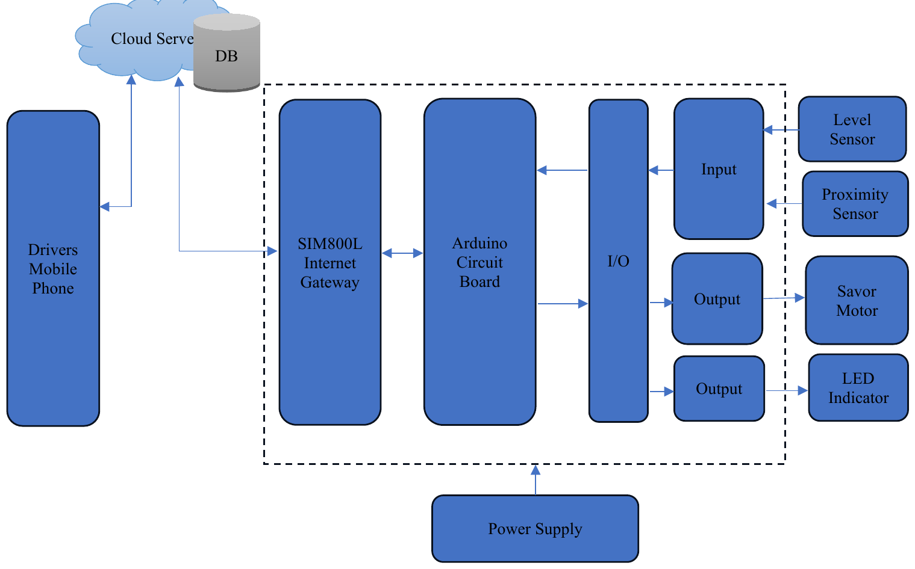
Note. From “Development of a smart waste management system with automatic bin lid control for smart city environment,” by A. Abdullahi, A. Mohammed, M. U. Bonet, A. El-Suleiman, R. B. Ahmad, and T. D. Chollom, 2024, EAI Endorsed Transactions on Smart Cities, 7(3). CC BY-NC-SA 4.0.

Abdullahi et al. (2024), of the Air Force Institute of Technology in Kaduna, Nigeria, built a bin whose lid opens only when the bin is not full. Figure 23 is their block diagram. The fill level is measured by an ultrasonic sensor (HC-SR04) and an Arduino, which also detects the approaching user, and the lid is opened by a servo motor that rotates 0-90 degrees. The thresholds are 20cm for a full bin, and 12cm for a user. Status connects to the cloud server via a SIM800L GSM module where data is stored and full bin notifications are sent to the collection team.
There are no figures for performance and it is inconsistent regarding the board as one figure shows Uno and the other shows Nano. There's a phone block in the diagram, but the app is never mentioned. Smart-Bin includes the ultrasonic fill sensor, a servo lid and weight, air sensing, tilt, a dashboard, and a phone app, all of which this study lacks.
Smart Waste Management System Using LoRa (Azmi et al., 2024)
Figure 24
Circuit Setup of the LoRa Bin Unit
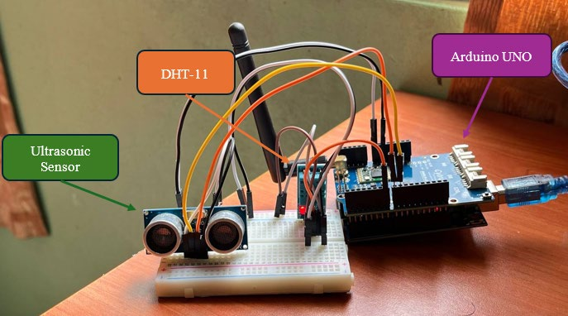
Note. From “Smart waste management system using LoRa technology,” by A. Z. Azmi, N. M. Sahar, and M. T. Islam, 2024, E3S Web of Conferences, 599, Article 04007. CC BY 4.0.

Azmi et al. (2024) installed a LoRa connection between the bin and the receiver. The setup for their circuit is shown in Figure 24. The ultrasonic fill distance, DHT11 temperature and humidity and GPS position are transmitted through a bin-side Arduino Uno with LoRa shield to a second Arduino Uno with LoRa receiver, and then relayed to a NodeMCU which updates a ThingSpeak dashboard with indicators when thresholds are reached. The tests indicated an ultrasonic accuracy of 89.9% at half full, a humidity accuracy of approximately 96.9% and a temperature accuracy of approximately 94.4%.
The authors report that the ultrasonic sensor was not successful in a narrow, shallow bin, and the DHT11 temperature sensor error exceeded the sensor's specified error. They state that they have a LoRa range of several kilometers, but they did not measure it, and the abstract mentions air quality monitoring, but does not go into any detail about it in the body of the paper. Also, Smart-Bin senses temperature and humidity (BME680 used instead of DHT11) and uses ThingSpeak. The study has no weight sensing, push alerts, phone app or display on the bin.
Ultrasonic Trash Can Surveillance With ThingSpeak Dashboards (Salleh et al., 2024)
Salleh et al. (2024) developed a prototype for waste collection based on demand at a low cost. An ultrasonic distance sensor mounted in each container is read by a NodeMCU ESP8266 module which uploads the fill level to ThingSpeak so that live dashboards indicate the status of each container and enable container status-based scheduling. Also included is a Proteus simulation and a PCB layout. No results are reported, and the authors view this work as a scheduling tool, rather than a validated route planning method.
Smart-Bin also employ ThingSpeak for charts and analysis, but only as a second cloud besides Firebase, as optional. It provides the weight, air quality, tamper detection and a phone app, things this study doesn't.
ESP8266 Waste Monitor With Moisture Sensing (Thangam et al., 2024)
Thangam et al. (2024) of Amrita Vishwa Vidyapeetham, Bangalore, have developed an ESP8266 monitor that utilizes ultrasonic fill sensors, soil-moisture sensors to assess the waste composition. The real-time data is supposed to enable the authorities to modify routes and reduce trips and gas. The route claim is a stated aim but not a measured result, as no quantitative results are reported in the abstract.
Smart-Bin senses are filled by the same type of ultrasonic sensor with the addition of weight, air quality, tamper detection and a phone app. It makes no attempt to judge the composition of the waste.
Smart Bins for Hospital Waste in Kaduna (Ishaq et al., 2025)
Figure 25
Proposed System Architecture for Hospital Waste Monitoring
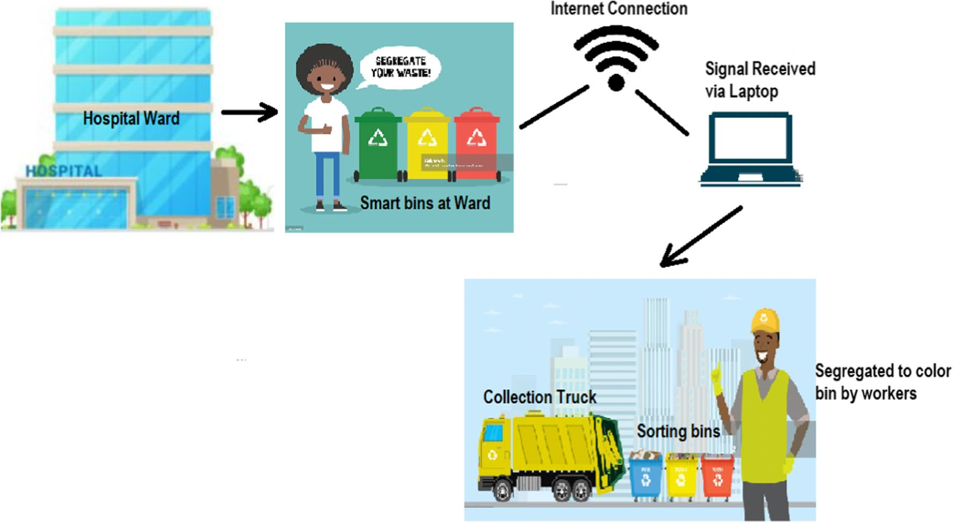
Note. From “Smart waste bin monitoring using IoT for sustainable biomedical waste management,” by A. Ishaq, S. J. Mohammad, A. D. Bello, S. A. Wada, A. Adebayo, and Z. T. Jagun, 2025, Environmental Science and Pollution Research, 32(32), 19434–19449. CC BY 4.0.

Ishaq et al. (2025) put ultrasonic fill-level sensors in bins at ten hospitals in Kaduna, Nigeria. Figure 25 is the proposed system architecture, from the hospital ward to the smart bins, an internet link, a laptop at the monitoring station and the collection truck. The bins connect wirelessly through the routers of the hospitals to a central cloud monitoring station, which alerts waste collectors when a bin is full. The authors also measured waste generation. Biomedical waste made up about 43.6% to 52.5% of hospital waste, at an average of 69.14kg per day and 1.52kg per bed per day, and they analysed the data with principal component analysis.
Alerts led to pickups 3 to 16 minutes later. The phone app appears only in the proposed system and is not described as built, and no microcontroller is named for the bins of the authors. The study shows what level sensing is worth in a place where overflow carries a health risk. Smart-Bin senses more than level, but it has not been tested in any such site.
IoT-Enabled Smart Dustbin for Real-Time Monitoring (Shahibollah et al., 2025)
Shahibollah et al. (2025), from Universiti Teknologi MARA in Terengganu, built an ESP32 dustbin with ultrasonic sensors for fill level and for proximity, a servo-driven lid and a tri-colour LED for local status. Data go over Wi-Fi to the Blynk platform, which alerts the maintenance staff. The authors tested the bin by simulation and with hardware, but the abstract gives no ranges or accuracy figures and describes the result as prototype function and not as municipal-scale reliability.
Smart-Bin uses the same ESP32 family and a servo lid. Its touchscreen takes the place of the LED, and it adds weight, air quality, tamper detection and a priority list.
IoT Smart Bin for Real-Time Fill Level Monitoring (Awotayo & Dodo, 2026)
Awotayo and Dodo (2026) of Baze University, Abuja designed and implemented an ESP32-based bin equipped with two HC-SR04 sensors. One of these is facing outwards and will open a servo lid (MG90S 0 to 90 degrees) when someone is in range of 30cm. The other indicates the level of fill, with a green LED when the fill level is between 0 and 39%, a yellow LED when the fill level is between 40 and 59%, and a red LED and buzzer when the fill level is between 60 and 100%. An e-mail is sent by Blynk when the bin is full. Two 3.7V Li-ion cells (7.4V, 3500mAh) power the unit. There are no accuracy or response-time results reported.
The local feedback is LEDs and a buzzer and not a screen. Smart-Bin also includes a touch screen, weight detection, air quality, tamper detection, dashboard and a phone app, none of which were identified in this study.
LoRaWAN Network for Waste Collection in Bukavu (Mugaruka et al., 2026)
Figure 26
Proposed Network Architecture for Waste Collection in Bukavu
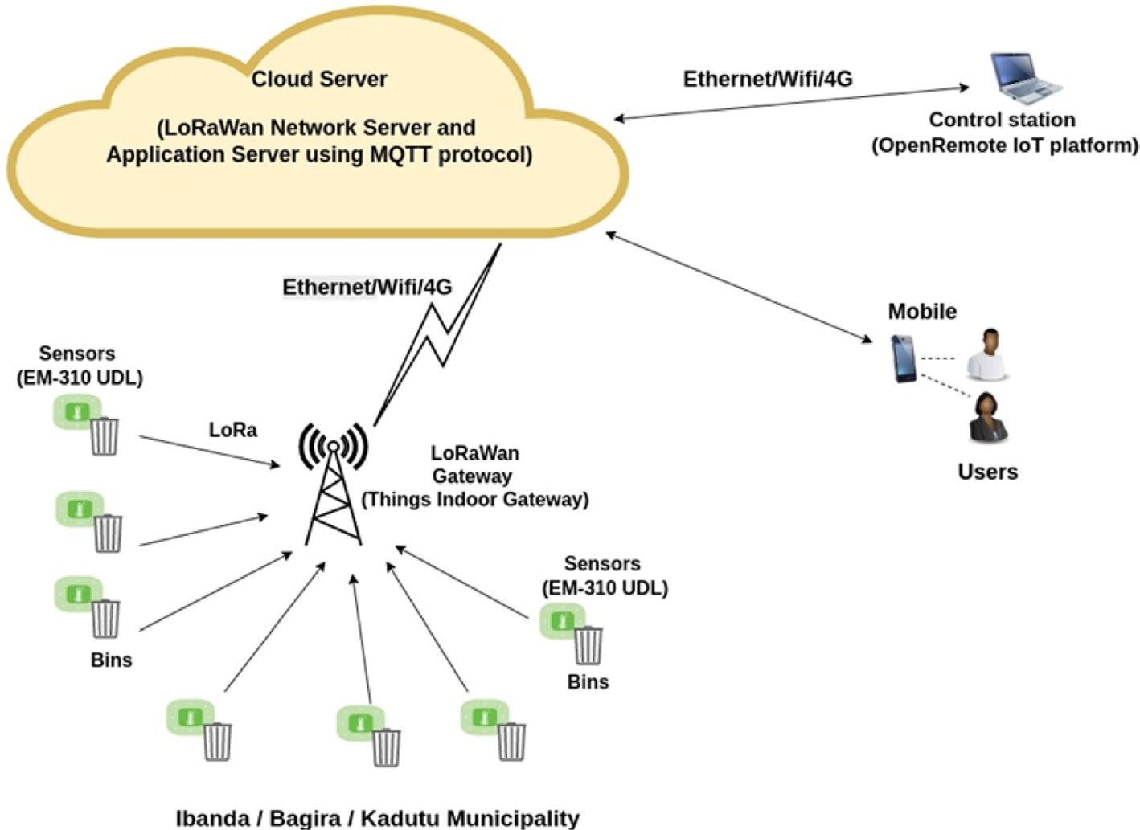
Note. From “Design of an IoT sensor-based network architecture for waste collection in Bukavu city (DRC),” by O. M. Mugaruka, J. R. Kala, J. Ndikumagenge, R. van Schadewijk, and R. Nibitanga, 2026, Discover Internet of Things, 6(1), Article 168. CC BY-NC-ND 4.0.

Mugaruka et al. (2026) designed a LoRaWAN-style network for waste collection in Bukavu, in the Democratic Republic of the Congo. Figure 26 shows the proposed network. EM310-UDL ultrasonic sensors on the bins talk over LoRa to a gateway, the gateway reaches a cloud server by Ethernet, Wi-Fi or 4G, and users view the data on a control station and on mobile phones. The authors tested it in a 12-week pilot with seven 120-litre prototype bins in residential, dense and peri-urban areas.
The results concern the network more than the bins. Of the sensors, 57% had a signal at or below −107dBm, and the mass collected (an estimated 641kg over 14 days in one area) and the route times are estimates from sensor data and not direct measurements. The authors also report an energy autonomy above 90% for most units after 11 months, a period that the paper does not clearly tie to the 12-week pilot. Smart-Bin does not use LoRa at present, and the study is a reminder of the opportunity listed in the SWOT analysis: LoRa for places without Wi-Fi.
B. Bins That Add Weight, Gas or Access Control
IoT-Based Smart Dustbin Prototype (Saad et al., 2023)
Figure 27
Prototype of the Smart Dustbin
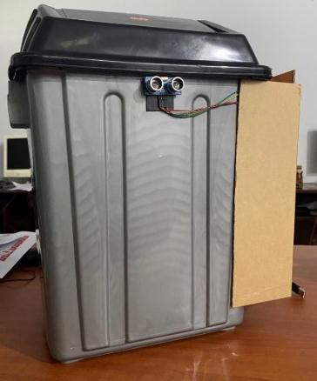
Note. From “IoT-based smart dustbin prototype,” by A. M. Saad, B. O. Jul, A. Basalamah, and S. Sayuti, 2023, PROtek: Jurnal Ilmiah Teknik Elektro, 10(2), 120–125. CC BY-NC-SA 4.0.

Saad et al. (2023) built the smart dustbin shown in Figure 27. An Arduino Nano with an ultrasonic sensor opens an SG90 servo lid to anyone who is within 50cm, while a NodeMCU ESP8266 reads the waste height with an HC-SR04, the weight with an HX711 load cell and the position with a NEO-6M GPS. Once the bin is full (either by level (3cm free space) or weight (4,000g), the NodeMCU will send a WhatsApp message via Twilio with a Google Maps link.
The tests reported a height error of 0.4%, a weight error of 0.15% and a message delay of 2.61s. This is the nearest study to the pairing of fill and weight with a servo lid in Smart-Bin. Its lid is triggered by an ultrasonic sensor, where Smart-Bin uses a PIR sensor. The study has no dashboard, air quality sensing, tamper detection, cloud history or roles.
Smart Bin With Real-Time Garbage Level Tracking (Ayyanagoudar et al., 2024)
Ayyanagoudar et al. (2024) propose a smart bin that uses weight sensors and ultrasonic transducers to track the fill level in real time and shows the level of each bin on a web page. The abstract also states that it can classify trash based on its weight, which is used for planning transportation. The abstract does not mention any microcontroller or cloud platform and does not provide any results of measurements.
Smart-Bin also correlates weight to an ultrasonic level. It includes air sensing, tamper detection and a mobile phone app, which are not included in this study.
Efficiency of IoT-Enabled Smart Bins (Mehta & Rathour, 2024)
Mehta and Rathour (2024) present the description of IoT smart bins, which are equipped with ultrasonic, temperature, weight and tilt sensors and software to collect and process the data. They claim a 6-month pilot in one city where collection efficiency has improved by approximately 50%, operating costs have decreased by approximately 25% and there have been approximately 83.3% fewer overflow incidents, while also offering reduced emissions through route optimization and increased satisfaction of citizens. Abstract makes no mention of the location or nature of these measures or of the number of samples collected, these figures are merely the authors' claims.
This is the only study to mention a tilt sensor but does not indicate a tamper alarm. Smart-Bin does exactly that, a 10 second (latched) countdown followed by a siren that latches.
Dual-Sensing Bins for Fill Level and Methane (Rathnayake et al., 2024)
Rathnayake et al. (2024) developed the dual sensing bins which combined the ultrasonic fill sensor with methane sensor for detection of spoilage. The ESP32 modules transmit the data via Wi-Fi to a cloud platform where the data is processed by the Node-RED software and ML algorithms predict the waste and optimize routes. Three bins were deployed in a four month pilot in Dehiwala, Sri Lanka and reported a 95% fill-level accuracy; methane-detection accuracy was 92% and simulated routes were 15% more path-efficient than fixed routes. There is no definition of the accuracies in the abstract and 15% is obtained from a simulation.
The ESP32 and the ultrasonic level are shared between Smart-Bin. It is not a methane reading, but rather an air-quality estimate as it is a gas channel. This study doesn't include any weight sensing, tilt alarm, phone app or on bin display.
Arduino-Based Smart Dustbin (Shaharil & Po’ad, 2024)
Figure 28
Block Diagram of the Arduino-Based Smart Dustbin
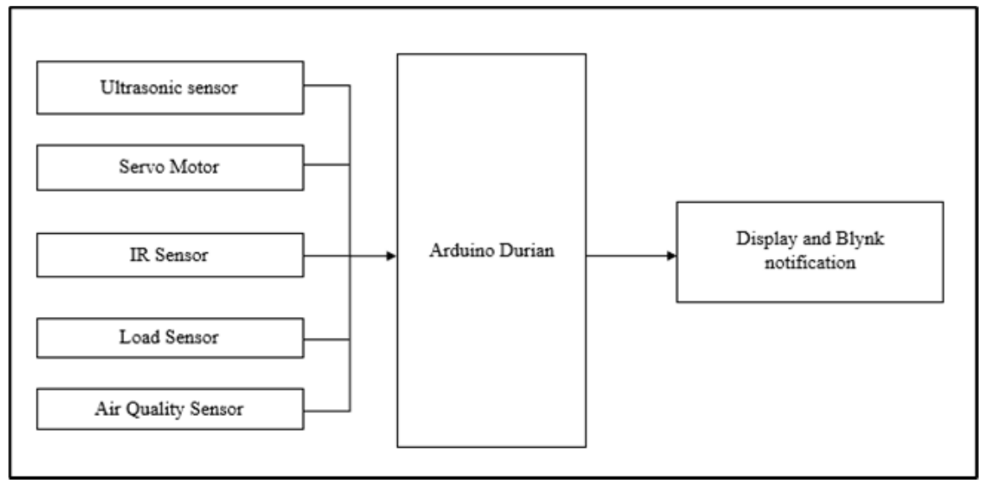
Note. From “Arduino-based smart dustbin with ultrasonic sensor for efficient waste management,” by M. H. F. Shaharil and F. A. Po’ad, 2024, Evolution in Electrical and Electronic Engineering, 5(2), 92–97. CC BY-NC-SA 4.0.

Shaharil and Po’ad (2024) built a household-scale bin and show its block diagram in Figure 28. The ultrasonic sensor opens up the servo lid if a person is within 30cm, the infrared sensor detects the level of fullness of the bin, the weight is displayed on the LCD using a load cell, and finally, a buzzer alerts when air quality is poor with the help of an MQ-2 sensor. The Blynk app shows a notification when the bin is full.
The testing is small: 15 distance trials and four weighed items with errors from −5g to +10g, and no numbers for the infrared or gas sensors. The bin is the closest study to the local side of Smart-Bin, with a lid, weight, gas and a display on the bin. It has no web dashboard, no collection priority and no tamper detection.
IoT-Driven System With Fire Detection and Role-Based Apps (Alnanih et al., 2025)
Figure 29
Data Communication Structure of the Smart Waste Management System
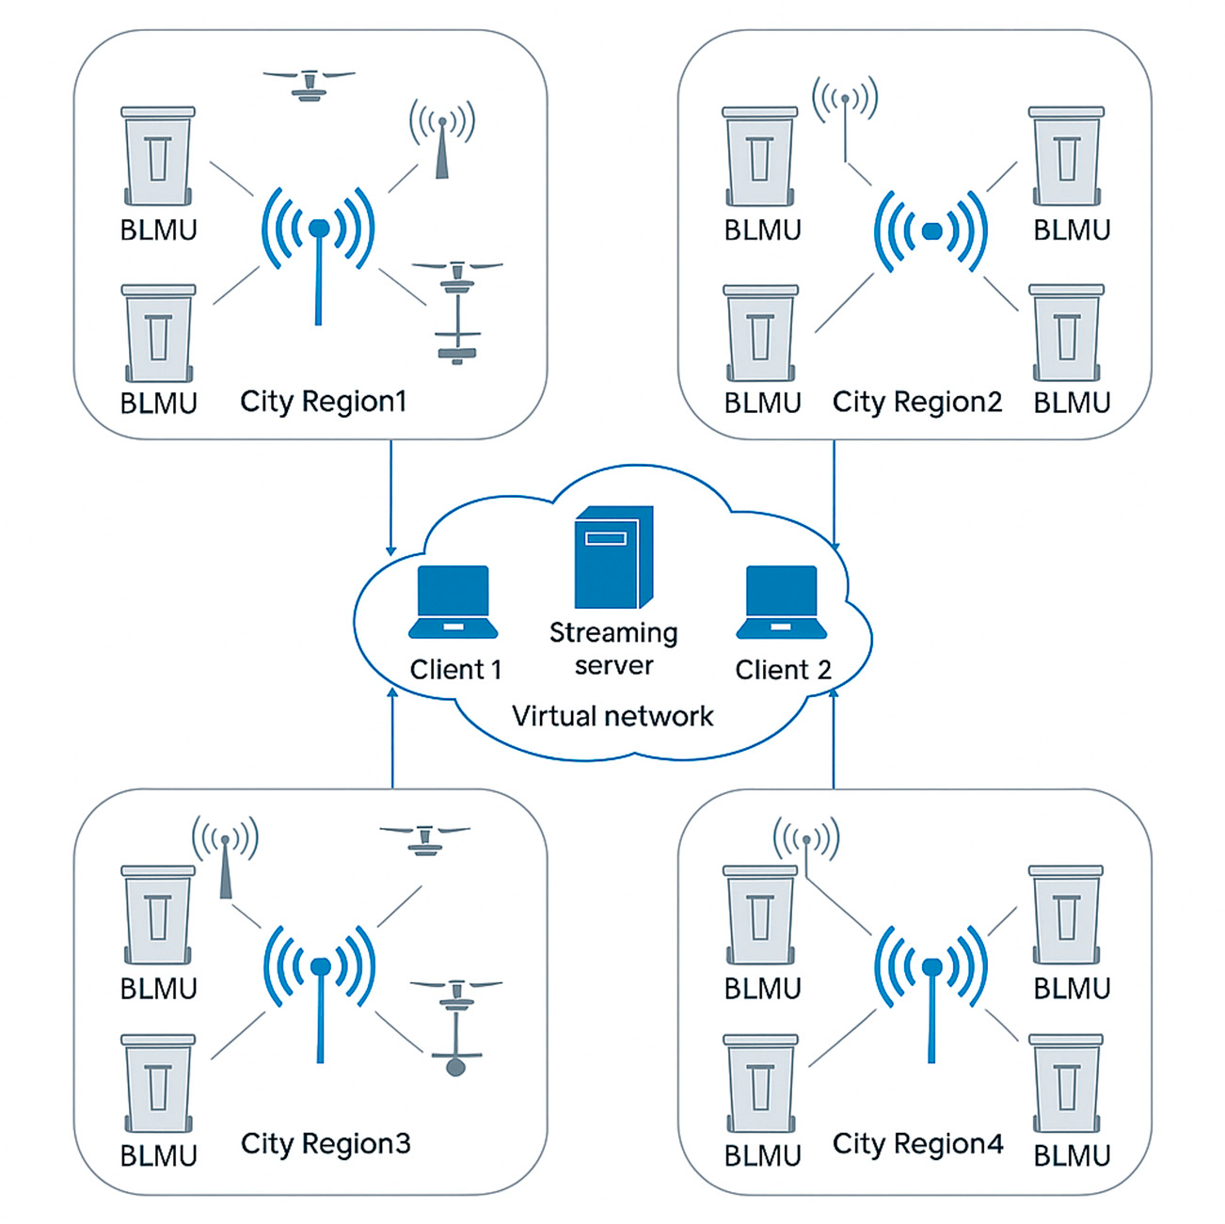
Note. From “Advancing sustainability through an IoT-driven smart waste management system with software engineering integration,” by R. Alnanih, L. Elrefaei, and A. Al-Ahwal, 2025, Sustainability, 17(21), Article 9803. CC BY 4.0.

Alnanih et al. (2025) combine fill and fire sensing in one bin unit. Figure 29 shows their data communication structure. An HC-SR04 is used to measure the fill level, a flame sensor detects fire, smoke and gas and an Arduino Uno with an ESP8266 and GSM receives the sensor data and an LCD, buzzer are added. Firebase and Firestore are used to launch alerts, coordinating collection routes from a central command center. A desktop web application is used by administrators and a Flutter Android application for workers based on their roles.
6-months pilot on campus with 50 bins achieved 99.5% uptime with fill error within ±3%, and a fire alert within 5s (smoke test). This is one of the longest field pilots of the studies which constructed their own bins. It's similar to Smart-Bin, it has Firebase, a web app, a phone app and different views for different users. There is no weight, tilt or lid feature and nothing is calibrated from the interface in the hardware list.
ESP32 Smart Trash Bin With Firebase (Maulida et al., 2025)
Figure 30
Prototype of the SmartTrashBin
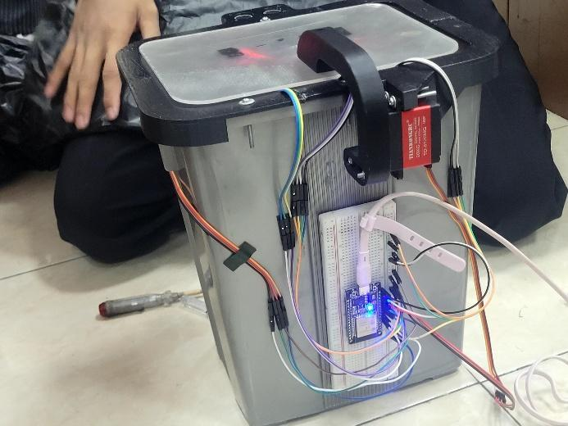
Note. From “Design of IoT-based smart trash bin monitoring using ESP32 and Firebase,” by A. Maulida, C. S. Fayzalmi, F. A. C. Anaam, D. Ardiansyah, M. A. Gunawan, and N. Ridwan, 2025, Jurnal Komputer, Teknologi Informasi dan Sistem Informasi (JUKTISI), 4(2), 420–428. CC BY 4.0.

The SmartTrashBin in Figure 30 was created by Maulida et al. (2025) from Politeknik Negeri Semarang. The hand detection & fill level is read using HC-SR04, while MQ-2 is used to detect the odour and the load cell (HX711) detects the weight that is then fed to ESP32, which controls the opening of the lid using a servo (SG90). Data is stored in Firebase Realtime Database and sent to an Android application that includes notifications.
They claim a level accuracy of approximately 95%, a weight accuracy of approximately 93% (+/- 320g on 20kg), 92% of cases of spoiled food identified and 98% of notification reliability and a System Usability Scale score of 86 from 15 sanitation officers. The numbers require carefulness as the paper mentions both of Android Studio and Flutter and also provides two notification thresholds. The closest of the studies to Smart-Bin is the following: ESP32, ultrasonic sensor, load cell, servo lid, firebase and an android app. No tamper detection, collection priority or web dashboard/roles.
Real-Time Sensing and Methane Mapping (Mehta et al., 2025)
Figure 31
Data Flow of the Garbage Monitoring System
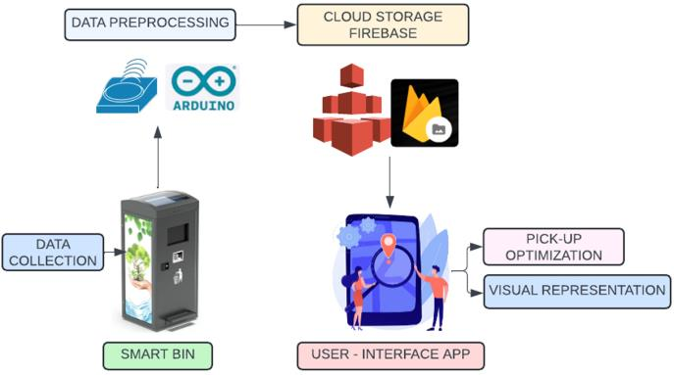
Note. From “Smart bins, smarter cities: IoT-driven waste collection with real-time sensing and methane mapping,” by H. Mehta, V. Deriya, D. Sankhe, P. Kanani, G. Pandya, and V. Shelke, 2025, Mathematical Modelling of Engineering Problems, 12(6), 2110–2122. CC BY 4.0.

Mehta et al. (2025) show the data flow of their system in Figure 31. Each bin has the ESP8266 equipped with an ultrasonic fill sensor, MQ4, MQ136 and MQ137 gas sensors, GPS and uploads data to Firebase every 10s. A React Native application displays a bin map, a methane and odor heatmap and truck routes that are ranked based on a priority score derived from fill and gas.
Gas sensors accuracy was 96% - 98% with reference. There are a number of trucks that are different – field samples of 28 bins in Malad v. 100 bins in the results (which use synthetic data), and some tables in the paper clash. The study is like Smart-Bin, which is based on Firebase, a mobile application and implements role-based views and priority-driven collection. No weight sensing and no tilt sensors and no display on the bin.
ESP32 Smart Dustbin With Weight and Level Monitoring (Yogesh et al., 2025)
Yogesh et al. (2025) created an ESP32 dustbin that includes an HX711 load cell and an ultrasonic sensor, which is called “Eco Bin”. Weights and fill percentage are sent to Firebase Realtime Database and a phone app, designed with MIT App Inventor, for full-bin alerts, and a 16×2 I2C LCD displays the alerts on the bin. However, since the paper doesn't report any actual results, it is here as a hardware precedent, not as a performance metric.
It's almost the same as in Smart-Bin, which is ESP32, load cell, ultrasonic sensor, Firebase, Android app and local display. Smart-Bin brings in air quality, tamper detection, a priority list and a web dashboard.
RFID Access Control and Blynk Integration (Karthi et al., 2025)
Karthi et al. (2025) developed ESP32 dustbin with servo lid which will open only for the authorized RFID user. A fill level sensor (ultrasonic sensor), a metal detector, and an air-quality sensor (MQ135) are used to perform measurement checks, with the data sent to the Blynk platform. Abstractly, the authors state 95% fill level accuracy, 92% RFID authentication reliability, 40% less manual work and 35% more efficient collection.
It is the only one study, which can open the bin, that is found. On the collecting side, however, Smart-Bin provides control via a PIN collect mode and remote lock, plus weight, tamper detection and a priority list. The web dashboard is not available for this study.

C. Collection Routes and Priority
Smart-Bin Collection as a Travelling Salesman Problem (Alnuaimi et al., 2024)
The paper by Alnuaimi et al. (2024) from University of Sharjah, UAE, considers the problem of municipal waste collection as a travelling salesman problem (TSP). The fill level of the bins is reported and the route is planned using the Nearest Neighbor heuristic within an AnyLogic simulation. The abstract claims that there are savings in travel distance and carbon emissions when compared to traditional static routes, but it does not provide figures and there is no description of hardware. The work is not a field deployment, but rather a simulation.
The results of this study is where the Smart-Bin ends. It is a list of bins sorted by fill and sorted by time to fill; and a planner such as this one might use that list as input.
Waste Management Optimization Through IoT and Analytics (Kuzhin et al., 2024)
According to Kuzhin et al. (2024), a case study of IoT sensor real-time data and analytics for route optimization has resulted in a 20% reduction in overfilled bins, a 15% reduction in collection frequency, a 25% reduction in the distance traveled, a 10% reduction in fuel consumption, and a 15% increase in recyclables collected. The abstract does not identify a location, sample size, hardware, time frame, and fails to specify whether the values are from a field experiment; the evidence is weak.
The study shows the size of the gain that people expect from collecting by priority. It gives no design that Smart-Bin could borrow.
Route Optimization With GPS and RFID Bin Locations (Banciu et al., 2025)
Banciu et al. (2025), from Lucian Blaga University of Sibiu, collect bin locations with GPS and RFID, build distance matrices and compare the Nearest Neighbor heuristic, Google OR-Tools and a genetic algorithm on three real routes with 735 locations. The genetic algorithm did best, with up to 52% shorter travel distance and more than 14kg less CO₂. RFID here only records the location of a bin when it is emptied, and the study senses no fill level.
It sits entirely on the routing side. Smart-Bin supplies the part that this study takes for granted, which is knowing which bins are worth a visit now.
IoT E-Tracking System for Waste Management (Gupta et al., 2025)
Gupta et al. (2025) propose an IoT system in which bins carry an ultrasonic fill sensor, a microcontroller (Arduino-based, going by the figure captions) and a Wi-Fi module that sends data to an unnamed cloud platform for on-demand routes. They say that in a 30 day trial with 50 bins they achieved 58.9% less distance, 59.2% less fuel, 95% less overflows and 99.8% uptime..
These are some of the highest figures in the entire review, and no pilot dates are mentioned, and no method of routing nor protocol for accuracy tests, so as a result this is what the authors report, but not an independent result. Only level sensing. Smart-Bin builds upon the same level reading with weight, air, tilt and user interface.
Ant Colony Route Optimization With Machine Learning (Kumar et al., 2025)
In Kumar et al. (2025), a system is designed where ultrasonic sensors are mounted on ESP32 boards to send fill level data to a central database. On one hand, Ant Colony Optimization is used to plan routes from the depot to the depot, only stopping at the bins that are filled; on the other hand, machine learning is used to forecast waste from past data; and the collection teams are provided with a Folium map as an interface. The abstract does not provide any actual figures, so there is no actual saving in fuel or cost that can be quoted from the abstract.
Smart-Bin also has the ESP32, the ultrasonic fill sensing and the concept of only going to bins that need it. It sets that priority from the fill and the time to full and not from a learned model. Weight, air quality and tamper detection and phone app not included in this study.
TrashTrack Collection Ranking (Sadikin et al., 2025)
Telkom University (Bandung) Researcher, Sadikin et al., (2025) developed an Android application using Kotlin and Jetpack Compose called TrashTrack. ESP32 bins are equipped with ultrasonic, infrared and GPS sensors and upload the collected data to a Firebase database; a modified constraint-based greedy algorithm is used to rank the collection based on the distance of the bin, vehicle capacity and fill level. The results of the usability test with 69 respondents showed that 92.37% were effective, 92.29% were useful and 89.92% were satisfied.
Smart-Bin is powered by the same ESP32, Firebase and a kotlin android app. It ranks by fill and time to full (no dist or vehicle capacity – it doesn't plan roads). Weight, Air Quality, Tamper Detection and Display on bin are not included in this study.
D. Sorting and System Design
Camera-Based Fill Level Detection (Enache et al., 2024)
Figure 32
Power Chain of the ESP32-CAM Node
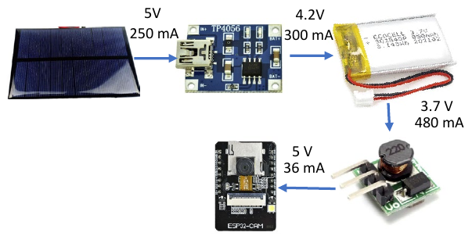
Note. From “Intelligent trash level detection for sustainable urban waste management,” by B.-A. Enache, C.-K. Banica, and A. G. Bogdan, 2024, The Scientific Bulletin of Electrical Engineering Faculty, 24(1), 56–59. CC BY-NC-ND 4.0.

Enache et al. (2024), from the University Politehnica of Bucharest, estimate the fill level from photographs. Figure 32 shows the power chain of one node. A 5V solar cell feeds a TP4056 charger, which charges a 3.7V LiPo battery of 850mAh, and a step-up converter brings the voltage back to 5V for the ESP32-CAM. The battery was sized for 24 hours of operation. The fill ratio is estimated by a Python script with OpenCV and an SQL database, each node takes one image per hour and sends it over an ESP-MESH network to a server.
On five test bins the relative error of the estimated fill ratio ran from 11.43% to 30.00%, and the authors name the angle of the camera, the light, the kind of waste and the placement of the bag as causes. The figure matters to Smart-Bin because it shows what a stand-alone node needs between the source and the board: a charger, a battery and a converter. Smart-Bin builds the same chain with its battery shields and 18650 cells. It is not camera based, it is based on distance and weight and this study has no weight, air quality, tamper detection, or phone app.
AI-Based Waste Segregation With Monitoring (Muthukumar et al., 2024)
At M. Kumarasamy College of Engineering in Karur, Muthukumar et al. (2024) developed a bin fitted with a camera that can identify plastic, glass, metal and paper using AI and place them in separate compartments. A mobile application displays the level of fill, plus the temperature and humidity levels, and notifies cleaning personnel and allows for one team to use the application to claim each task. The number of images used is about 1500 images per class and the paper reports 71.8% training accuracy and 92.3% test accuracy, but does not explain the difference between these. The microcontroller and the cloud service are not named.
Segregation is outside the scope of Smart-Bin. The claim-a-task feature of the app echoes the collector role in Smart-Bin, and the study has no weight, air quality, tamper detection or collection priority.
Smart Trash Bins With IoT and AI (González et al., 2024)
González et al. (2024) constructed a bin made of ESP32 and ESP32-CAM. This includes ultrasonic sensors that measure fill level, an AI that detects waste from images from the camera, and potentiometers that replace the weight sensor. Events are captured by readings, which are transmitted over Wi-Fi to a central server and displayed on Oracle APEX dashboards; and an MIT App Inventor app is used to manually record the status. The abstract does not contain any accuracy figures.
The weight is simulated and the study indicates a dashboard design without any actual weighing. Smart-Bin offers a real load cell, and always offers a simulation as an option for testing, all set from the interface. This study has no air quality sensing, tamper detection or priority list.
Smart Waste Classification With IoT and Deep Learning (Alourani et al., 2025)
Alourani et al. (2025) propose iSSWMs, a framework that joins an IoT smart bin to a deep-learning classifier. The bin has an ultrasonic level sensor on an Arduino Nano and an ESP8266 that sends its status to Firebase, and an Android app alerts the collectors at a threshold. A VGG-19 classifier sorts plastic, glass and metal and reached 99.7% accuracy on about 1,530 TrashNet images over 100 epochs. That figure is training accuracy, and the authors report no field test.
Smart-Bin shares the ultrasonic level, Firebase and an Android app with alerts for collectors. Image classification is outside its scope, and this study has no weight, air quality, tamper detection or priority list.
ESP32 Smart Bin That Separates Dry and Wet Waste (Gajula et al., 2025)
Gajula et al. (2025) developed an ESP32 dust bin which detects the wetness of the waste deposited and separates dry and wet waste with the help of SG90 servo and MG90 servo. The HC-SR04 ultrasonic sensor and the moisture sensor provide information to the Arduino IoT Cloud that triggers the separation mechanism. Abstract does not provide any numbers that were measured.
It's not about monitoring the bin, it's about sorting, and shares only the ESP32, a servo and the cloud link with Smart-Bin. No weight measurement, tamper detection or phone application.
FreeRTOS-Based Smart Waste Management (Aasish et al., 2025)
Aasish et. al (2025) presents a system on a dual core ESP32 based on FreeRTOS. It has an ultrasonic sensor to track the level of the bin, as well as a DHT11/DHT22 to measure temperature and humidity, it has an optional LCD or OLED display and can upload to a cloud server via Wi-Fi for alerts and dashboards and dynamic collection scheduling using RFID modules to identify each bin. The basic concept is to separate the sensor acquisition and actuation tasks, from the cloud communication tasks, so that a slow upload does not block a reading. No actual results are stated and the RFID is not used for access control, it is merely used to identify bins.
The task split is a design to consider for the Smart-Bin firmware, as it is also based on the ESP32 family. The study has no weight sensing, tamper detection or phone app.

Commercial Systems
Commercial systems are available. Bigbelly's CLEAN software provides the data from the bins on a console and uploads it to a collector app (Bigbelly, n.d.). According to its website, Ecube Labs offers ultrasonic fill sensors and a cloud platform that provides fire event notification and route optimization, and claims to predict bin status up to 24 hours in advance (Ecube Labs, n.d.). Sensoneo's platform displays a map of each bin's fill and predicted full time, and plans routes from them (Sensoneo, n.d.), Nordsense's driver app with dynamic routing (Nordsense, n.d.), and Evreka's sensor enhances temperature and motion to flag fires (Evreka, 2020). Compology monitors containers with cameras (Compology, n.d.), and Bin-e is a segregating bin with a touch-free lid (Greenwalt, 2020). In the Philippines, students of the University of the Cordilleras built the Baraki bins for the DOST-TAPI Regional Invention Contest, which open automatically and report to an information center (Asido, 2024). Table 3 summarizes what the vendor pages state.
Table 3
Commercial and Student Systems as Described by Their Own Pages
System | Sensing described | Who sees the data | Collection priority or route
Bigbelly | Fill level, collection events and GPS; sensor type not named | Management console and collector app | Not stated
Ecube Labs | Ultrasonic fill level, battery level and fire events | Cloud dashboard | Route optimization; predicts status up to 24h ahead
Sensoneo | Ultrasonic or radar fill level | Dashboard with a map and predicted full time | Semi-automated route planning
Nordsense | Page covers routing, not sensors | Driver app | Dynamic routing
Evreka | Ultrasonic fill level, temperature, motion and location | Web platform with SMS and email alarms | Route optimization
Compology | Camera: fullness, location and motion | Web dashboard | Not described
Bin-e | Fill level, motion for the flap and waste type | Mobile app | Not covered
Baraki | Automatic sensors; types not stated | Information center | Not stated
Note. Sources: Bigbelly (n.d.), Ecube Labs (n.d.), Sensoneo (n.d.), Nordsense (n.d.), Evreka (2020), Compology (n.d.), Greenwalt (2020) and Asido (2024).
All of them sell via quotation: none of these pages mentions weight, gas or tilt sensing, or a price. That doesn't mean that the products don't have these characteristics, just that vendor pages are concise and designed to sell. What it shows is that a small system with those features at about ₱4,900 for two bins (Appendix B) occupies a different place from these services. Smart-Bin does not compete with them on scale, and it cannot, but it can show what a bin that senses more costs to build.

Technical Merit
Seven design choices in Smart-Bin decide how much its readings can be trusted. Table 4 gives the reason for each. Each one is also a place where a measured result could differ from the real condition of the bin, which is what the tests of the project will have to check.
Table 4
Technical Basis of the Main Design Choices
Design choice | What Smart-Bin does | Why it is sound
BME680 for the air check | One I2C chip gives temperature, humidity, pressure and a gas resistance reading, from which the firmware estimates an air-quality index. | In Table 2, the studies that sense gas use MQ-series modules, which only provide a reading for the gas. Bosch Sensortec (n.d.) states that the BME680 uses 0.09 to 12mA during its different modes. The index is an estimate and needs about 5 minutes to settle.
Median distance reading is calculated from five distance readings. | The firmware makes five measurements using the HC-SR04 and uses the middle measurement. | When the echo bounces off an edge or soft material, a single reading from the ultrasonic can be spiked. One or two of such readings will be ignored without delaying the update, this is the median.
Two-point calibration | The full distance (5cm by default) and empty distance (30cm by default) are defined from the interface and the fill percentage is the distance between them. | The two setpoints are the same as in Keller et al., 2024. Other heights of bins do not require new firmware.
Weight as a second check | The HX711 and a 5kg load cell weigh the contents next to the fill percentage. | Level and weight are also combined in Saad et al. (2023) and Maulida et al. (2025). A loose pile in a bin is light but a full bin is heavy.
Tilt with a countdown | If the tilt is over 30° a countdown of 10s begins. When the bin is steady again the alarm will clear, or if not, the alarm will latch and need to be reset by an operator. | Countdown will not allow for a bump or moving bin to cause a false alarm and an overturned bin or carried away bin will still sound.
Local and cloud together | The bin responds on its local WiFi within ~1s, and to Firebase and ThingSpeak. | Fast control and calibration with local path, history, remote commands and alerts when phone is away with cloud path. The data is uploaded every 30s, which is half the frequency ThingSpeak can accommodate on its free plan of 1 write every 15s
Calibration and simulation from the interface | Distances, limits can be changed, without re-flashing, any sensor can be set to a test value. | None of the 30 studies describes this. It lets a test be repeated at a chosen reading and keeps demonstrations safe.
Note. Defaults are those set in the firmware and can be changed in the settings.

SWOT Analysis
The strengths, weaknesses, opportunities and threats of Smart-Bin are presented in Figure 33. The strengths and weaknesses are related to the construct itself, while the opportunities and threats are related to the literature mentioned above and to the situation in the Philippines. The count of studies that sense tilt or offer role-based views comes from this review. RA 9003 puts segregation and collection at the barangay level and leaves the collection of non-recyclable and special waste to the municipality or city (Ecological Solid Waste Management Act of 2000, 2001), and the World Bank (2022) puts the share of Metro Manila waste that is collected at about 60%.
Figure 33
SWOT Analysis of Smart-Bin
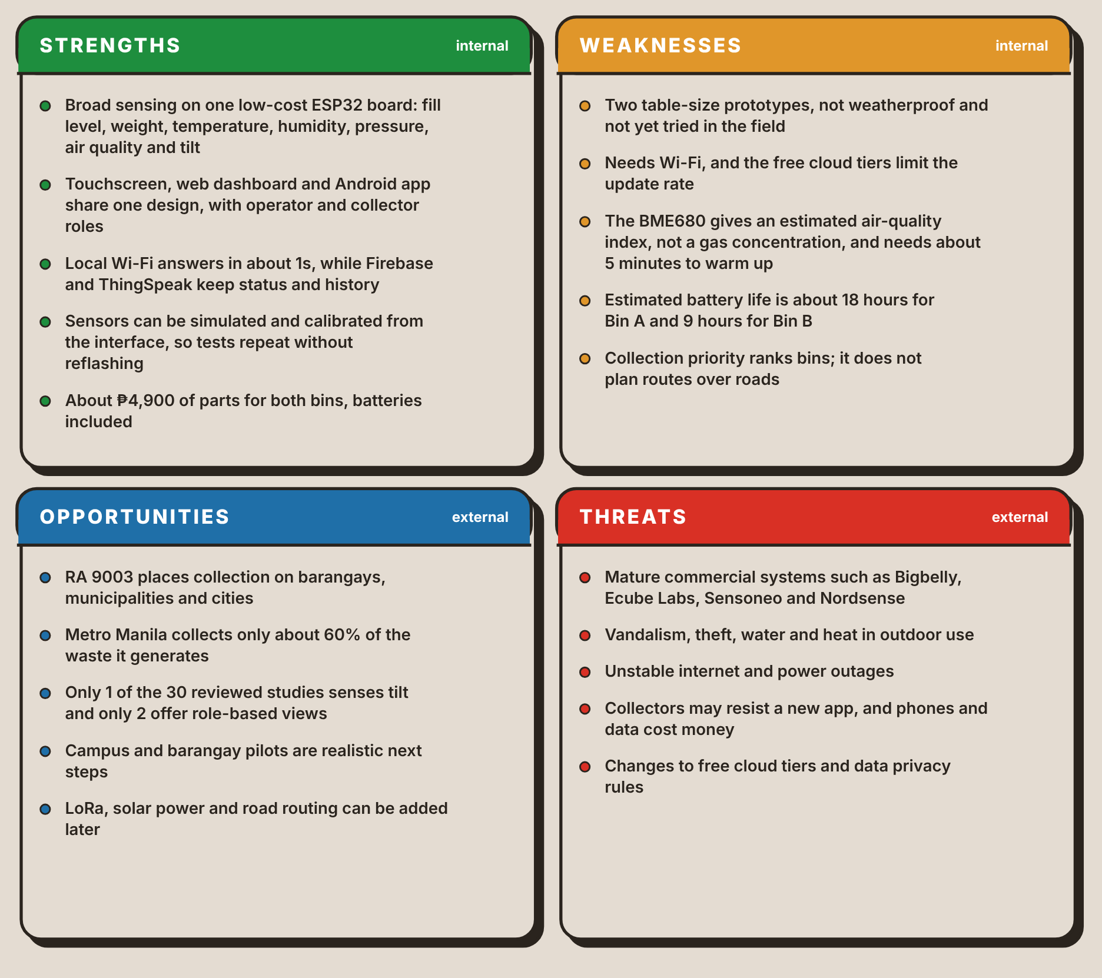
The weaknesses set the limits of what the tests of this project can claim. The tests demonstrate that it works on a bench, but not that the prototype can last on the street for 18 hours in Bin A and 9 hours in Bin B and that it is a table-size prototype that has never been outside. The opportunities are on the other side, the weaknesses: pilots on campus or in a barangay hall, LoRa for where there is no Wi-Fi, solar power and road routing.

Synthesis of the Review
The patents, studies and products reviewed above converge on four points. First, the problem is a documented one. The Ecological Solid Waste Management Act of 2000 (2001) leaves the collection of non-recyclable and special waste to the municipality or city, and the World Bank (2022) puts the share of Metro Manila waste that is collected at about 60%. A bin that overflows between collections is therefore an expected condition of the system that these sources set out to monitor.
Second, sensing the fill level is a solved problem. It is measured by 27 of 30 studies, often using an HC-SR04: Patents have done it with hydraulic pressure (Neumann & Allison, 1991), capacitive plates (Di Giugno et al., 2016), an infrared beam (Devitt & Walsh, 2021) and an ultrasonic sensor (Kekalainen & Engstrom, 2018) and a laser (Keller et al., 2024). The commercial services in Table 3 sell the same measurement with a cloud console on top.
Third, the other sensors exist, but they are added one or two at a time. Saad et al. (2023) and Maulida et al. (2025) add weight, Mehta et al. (2025) add gas, Alnanih et al. (2025) add a flame sensor and Azmi et al. (2024) add temperature and humidity. There is only one reference by Mehta and Rathour (2024) who mention a tilt sensor but do not mention any alarm. In the patents, Mullaney (2016) weights contents, Kurani (2023) mentions around a dozen sensors, but one is based on litter and pathogens, not the user of the bin.
Fourthly, the work is directed more into the route than into the bin. Twelve of the 30 remaining studies report on routes or priority of collection, and have the biggest improvements: up to 52% shorter distance in Banciu et al. (2025) and 58.9% in a pilot of Gupta et al. (2025) with no date or method provided. The bins in these studies stay simple, ten studies have a phone app, two give different users different views, and none of them describes calibration or simulation from the interface of the bin.
None of the sources brings these pieces together in one bin. The studies that weigh the waste have no tilt alarm, the one that lists a tilt sensor describes no alarm, the ones with phone apps and roles have no weight, and the route studies take the readings of the bin for granted. Table 5 sets the four closest patents against Smart-Bin, feature by feature, and Figure 34 counts the features found in the studies. None of the twenty patents, as far as their text was read, combines a latched tamper alarm, a PIN collect mode on a touchscreen, a remote lock and sensor simulation and calibration from the interface with fill, weight and air sensing in one bin. A search of this size cannot prove that no such patent exists, so this is a statement about what was found and not about what exists.

Table 5
The Four Closest Patents Compared With Smart-Bin
Feature | Shahabdeen  (2016) | Yan and Chen  (2021) | Kurani  (2023) | Sait et al.  (2025) | Smart-Bin
Fill level | Yes (range finder) | Yes (infrared height) | Yes | Yes | Yes
Weight | Yes (or fill level) | Yes | Yes | Not found | Yes
Gas or odor | Yes | Yes | Yes | Yes (methane) | Yes
Temperature and humidity | Not found | Not found | Yes | Yes | Yes
Tilt or tamper alarm | Not found | Not found | Accelerometer listed | Not found | Yes
Motorized lid | Not found | Not found | Not found | Not found | Yes
Remote lock or PIN collect | Not found | Not found | Not found | Not found | Yes
On-bin display | Not found | Not found | Not found | Not found | Yes
Phone alert | Not found | Not found | Yes | Not found | Yes
Priority or route | Not found | Yes (truck route) | Yes (route) | Yes (route) | Yes (priority)
Note. Counts are derived from the hardware and the function described in each study (Table 2).
Figure 34
Features Found in the 30 Related Studies
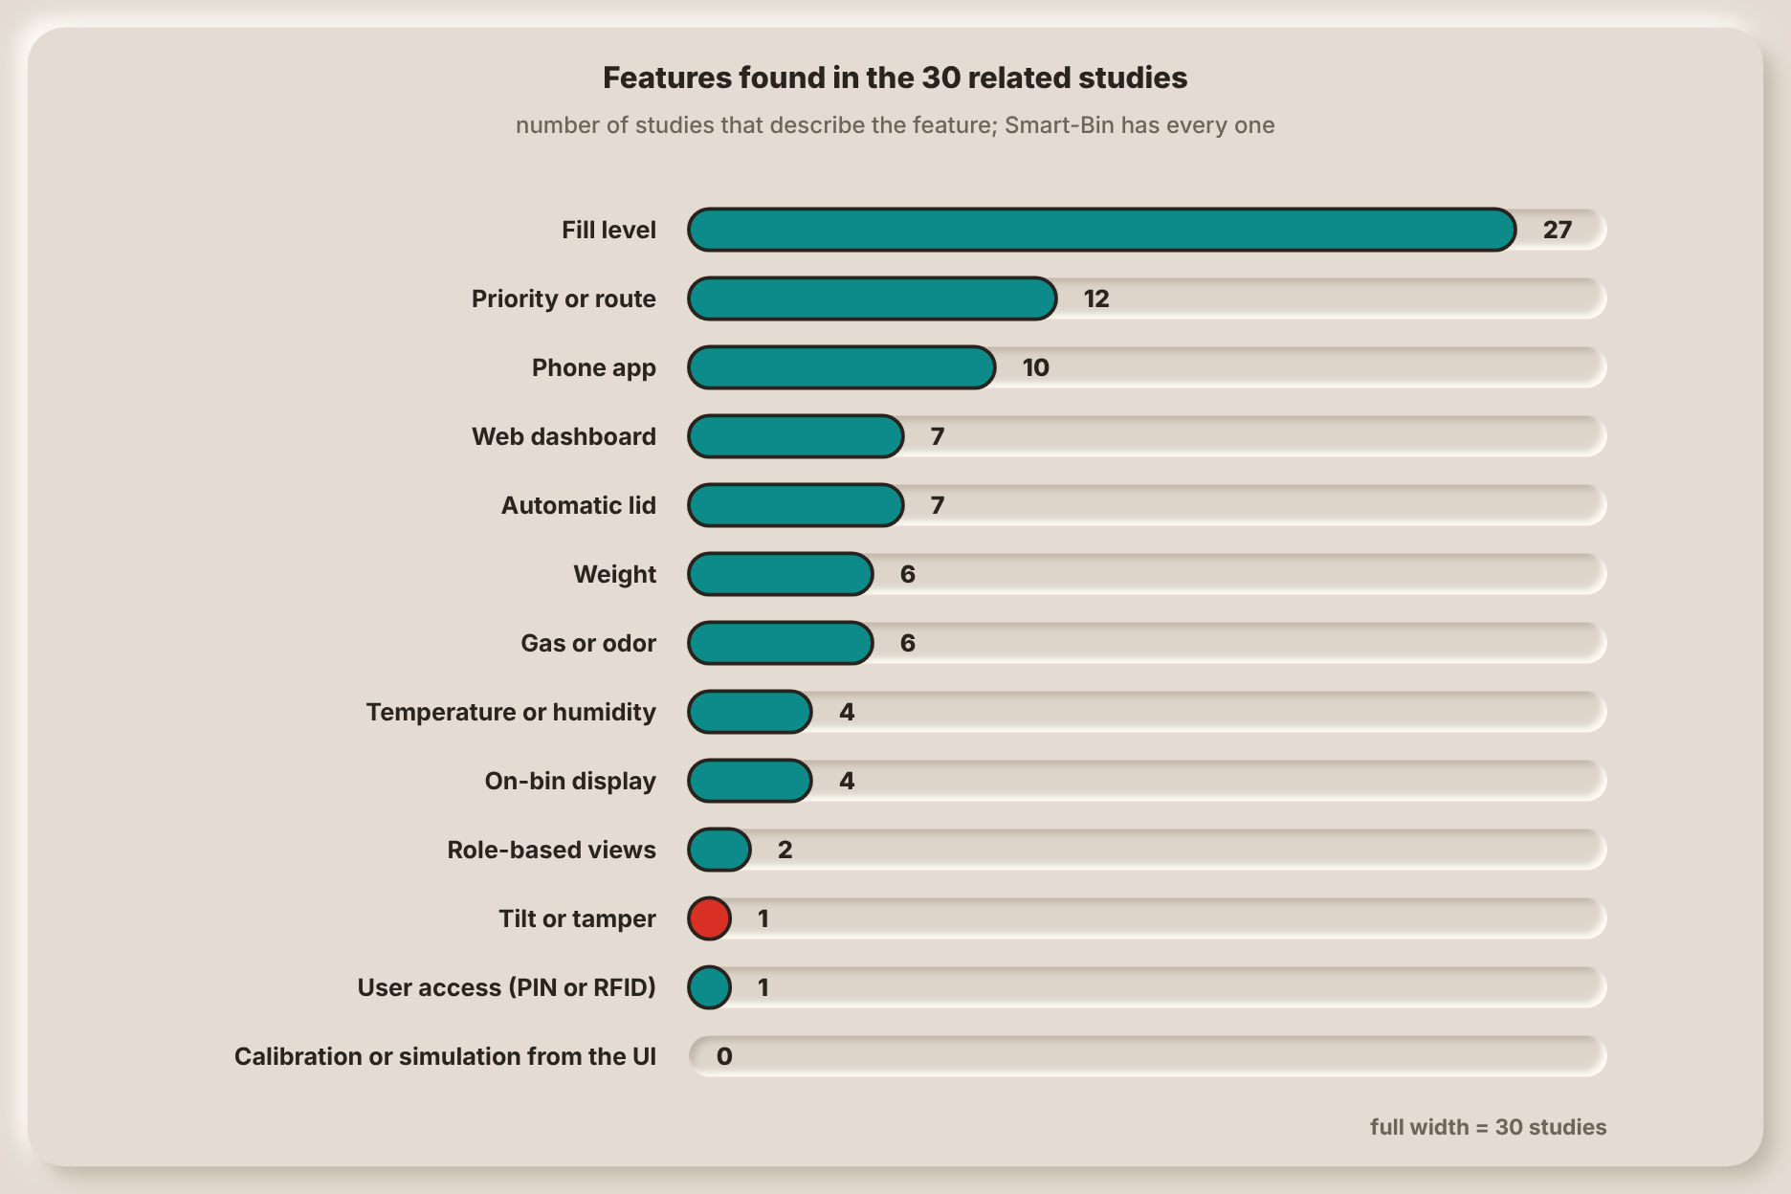
Note. Counts come from the hardware and function each study describes (Table 2).

Research Gap
There are 30 studies; 27 sense fill level. None has all of weight, gas, temperature, humidity and tilt in one bin; 6 add weight, 6 add gas, 4 sense temperature/humidity and 1 senses tilt. Two studies are providing role-oriented perspectives, one of which is using an RFID-based access control mechanism. None indicates simulation / calibration from the interface. The bin indicates its fill level, and the focus is on routes and fleet software in the patents and commercial systems. None of the four most closely related patents have all ten of the features listed in Table 5.
So, it's not a sensor, it's a gap. These factors: fill, weight, air and tilt sensing, alerts to the operator, collector and person at the bin, collection priority from the fill and time to fill, interfaces to allow bin calibration and testing without need to re-flash, are all combined in one single low-cost bin. The gap by capability and the specific objective in Section 1.4 which addresses it is provided in Table 6.
Table 6
The Research Gap by Capability
Capability | Related studies | Patents and products | Smart-Bin | Objective
Sensing breadth on one board | 27 fill, 6 weight, 6 gas, 4 temperature or humidity, 1 tilt; none has all | Kurani (2023) lists about a dozen sensors; the others are narrower | Fill, weight, temperature, humidity, pressure, air quality and tilt on one ESP32 | SO1
Tamper detection | One study lists a tilt sensor | No latched tamper alarm found in the four closest patents | Tilt beyond 30° starts a 10s countdown, then a latched siren until RESET TAMPER | SO1
Alerts to each kind of user | 10 studies have a phone app and 7 a web dashboard | Phone alerts in Kurani (2023) | Buzzer, LED and touchscreen on the bin, web dashboard, Android app and push alerts | SO2
Roles and access | 2 studies have role-based views; 1 uses RFID | None found | Operator and collector views, remote lock, PIN collect mode | SO2, SO3
Collection priority | 12 studies are about routes or priority, mostly with GPS and algorithms | Route planning in the closest patents | Fullest first, with a time to full from the recent fill rate; no road routing | SO3
Testing and demonstration | No study describes simulation or calibration from the interface | None found | Per-sensor simulation and calibration from the dashboard and app | SO3

1.4 Objectives

General Objective
To design and develop Smart-Bin, an IoT based Waste Bin Monitoring System which will monitor the fill level, weight and air quality of the waste bin, detect tampering and give real time monitoring and alerts to the concerned entities via Web Based Dashboard, Android App and On-Bin Touchscreen.

Specific Objectives
- Sensor Monitoring and Detection
To develop 2 Smart-Bin units, which include sensors to measure fill level, weight, temperature, humidity and air quality, as well as to detect bin tilting and tampering and open the lid automatically when hand movement is detected.
- Real-Time Monitoring and Alerts
To develop a web dashboard and an Android application to display real-time data from the sensors, bin status, retrieve data from Thingspeak/Firebase and notify the operators and collectors when the bin is full, poor air quality, high temperature, tampered sensor reading and when the bin is not online.
- Bin Control and Collection Prioritization
To implement Collection Prioritization, based on bin fullness and estimated time to fullness, remote bin locking and unlocking, on-bin collection functions (via PIN), sensor simulation and system interface sensor calibration. This will lead to the prioritization of collections and will also help with efficient collection routes and fuel gas efficiency.

1.5 Conceptual Framework
The framework of Smart-Bin is shown in two parts. The first one which is below describes the process of a reading going from the sensor to the person who is going to respond to it and it is known as the Input-Process-Output (IPO) model. The second, under IoT Level, shows how the parts are deployed and connected. Both refer to the same system and both result in the three specific objectives listed in Section 1.4 above.

Input-Process-Output Model
Figure 35
Input-Process-Output Model of Smart-Bin
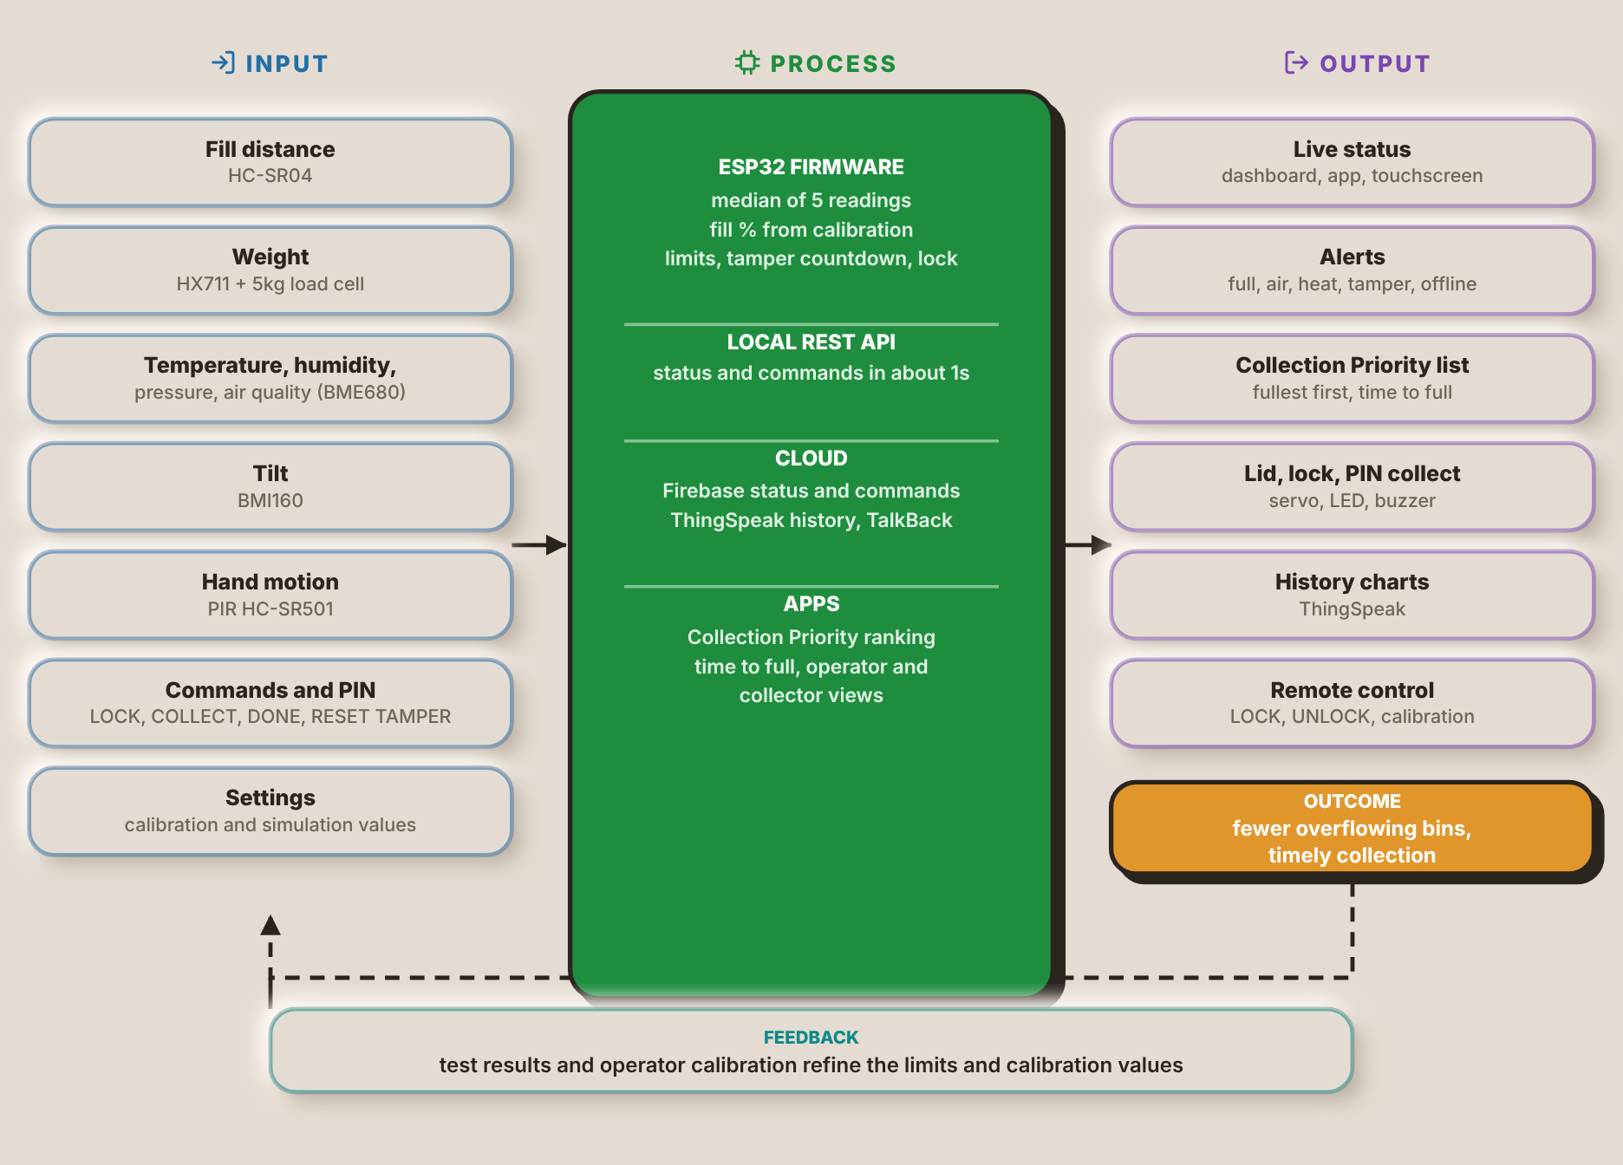
The input column has seven items. The distance to the trash is measured by the HC-SR04 sensor, the weight is measured by the HX711 sensor (which includes a 5kg load cell), the BME680 sensor provides temperature, humidity, pressure and an estimate of the air quality, the BMI160 sensor gives the tilt, and the PIR sensor detects a hand. The final two inputs are from the people: commands input on the touchscreen, in the dashboard or in the app, and the settings, which contain the calibration and simulation values. All of these inputs are related to Specific Objective 1, and commands and settings are related to Specific Objective 3.
The process column is how the ESP32 firmware and the cloud use them. The firmware takes the median of five readings, converts the distance to a fill percentage from the calibration limits, compares the readings with their thresholds, runs the tamper countdown and applies the lock. Local REST API provides response in ~1s and status is stored in Firebase while the commands are stored in thing speak where the history is stored. The apps rank the bins by fullness, by time until they are full and give the operator or collector views. Specific Objectives 2 and 3 are addressed in this column.
Live status on the touch screen, the dashboard and the app, alerts for a full bin, bad air, heat, tamper, or bin being offline, Collection Priority list, live status for the lid, lock, and PIN collect on the bin, history charts, and remote control, are all things people see and do, which is the output column. The result is reduced overfilling bins and timely collection, which is the problem stated in Section 1.1. Feedback closes the loop; the results of the test and the operator's calibration will improve the limits and calibration values used by the firmware next.

IoT Level
Figure 36
System Architecture of Smart-Bin
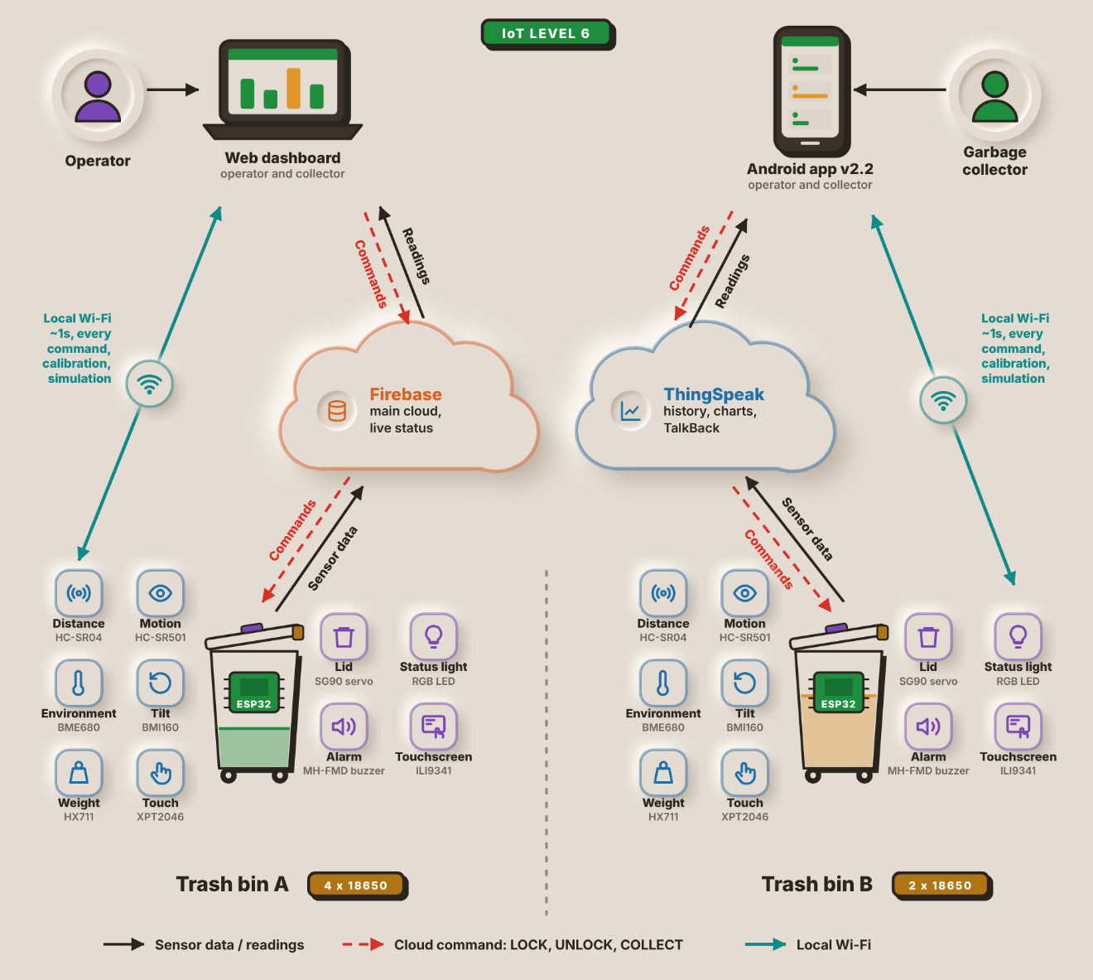
The connections between the parts of Smart-Bin are shown in Figure 36. The readings are sent from the cloud to the two apps at the top: the web dashboard (primarily for the operator) and the Android app (primarily for the garbage collector). Both apps can also reach a bin directly over the local Wi-Fi in about 1s for any command, calibration, or simulation.
There are two end nodes at the bottom: Trash bin A and Trash bin B. All are equipped with the same ESP32 and six input sensors (HC-SR04, PIR sensor, BME680, BMI160, load cell, touch panel) and four output actuators (servo, RGB LED, buzzer, TFT). Bin A is powered by 4x 18650 cells, Bin B by 2x.
Each bin sends its sensor data up to two cloud services and receives the LOCK, UNLOCK and COLLECT commands from them. Firebase is the primary cloud and stores the live status, ThingSpeak stores the history and charts and relays commands via TalkBack.
Smart-Bin fits IoT Level 6 of the deployment templates in Bahga and Madisetti (2014). A Level 6 system has several independent end nodes that sense or actuate and send their data to the cloud, where it is stored and shown by a cloud-based application. An analytics component works on that data and keeps its results in the cloud as well, and a centralized controller knows the status of every end node and sends control commands back to them. Trash bin A and Trash bin B are the end nodes in Figure 36. Both have their own ESP32, they read their own sensors and update their own status to Firebase and ThingSpeak, they don't depend on each other and there is no gateway between them and the cloud.
Cloud side is Firebase for live status, and ThingSpeak for stored history. ThingSpeak keeps the readings of every bin and plots and analyses them over time, and the apps use the same data to rank the bins by fill level and estimated time to fill in the Collection Priority list. The web dashboard and the Android app take the role of the centralized controller. They show the state of both bins side by side and send LOCK, UNLOCK and COLLECT back through the cloud, and calibration and simulation commands go to a bin directly over the local Wi-Fi.

1.6 Target Beneficiaries
- Waste Collectors and Utility Staff
Smart-Bin will assist waste collectors and utility workers by notifying them which bins are fullest and need to be emptied first. It could also prevent visits to bins that are not full and offer PIN access to the bin during collection.
- Facility Managers and Operators
The web dashboard can be used by facility managers or barangay hall, school, office or mall operators to monitor the status of the bins, make assessment of the data and set thresholds for the sensors, apart from the messages they receive on overflowing bins, poor air quality, high temperature, and even possible tampering.
- Barangay and Local Government Unit (LGU) Sanitation Offices
The sanitation offices of barangays and LGUs can utilize Smart-Bin's data readings to aid in garbage collection scheduling and management. The percentage of fullness and time to be full will help them optimize their collection routes and minimize the amount of fuel they need to use by making fewer unnecessary collections.
- Filipino Citizens
How about if the environment is cleaner, trash bins are not overflowed and there is increased awareness about waste among Filipino citizens who are residents, employees or students of schools, offices or other places? The hands-free lid would also improve the disposal of waste; making it easier and sanitary.

II. PROTOTYPE DESIGN AND DEVELOPMENT

2.1 Prototype Design
[Describe and show the physical design of the Smart-Bin prototype here.]

2.2 Block Diagram
The block diagram of one Smart-Bin unit and the network around it is shown in Figure 37. It has two separate ESP32 microcontrollers, one in each of the two bins, both bins reporting to the same cloud services and user apps.
Figure 37
Block Diagram of the Smart-Bin System
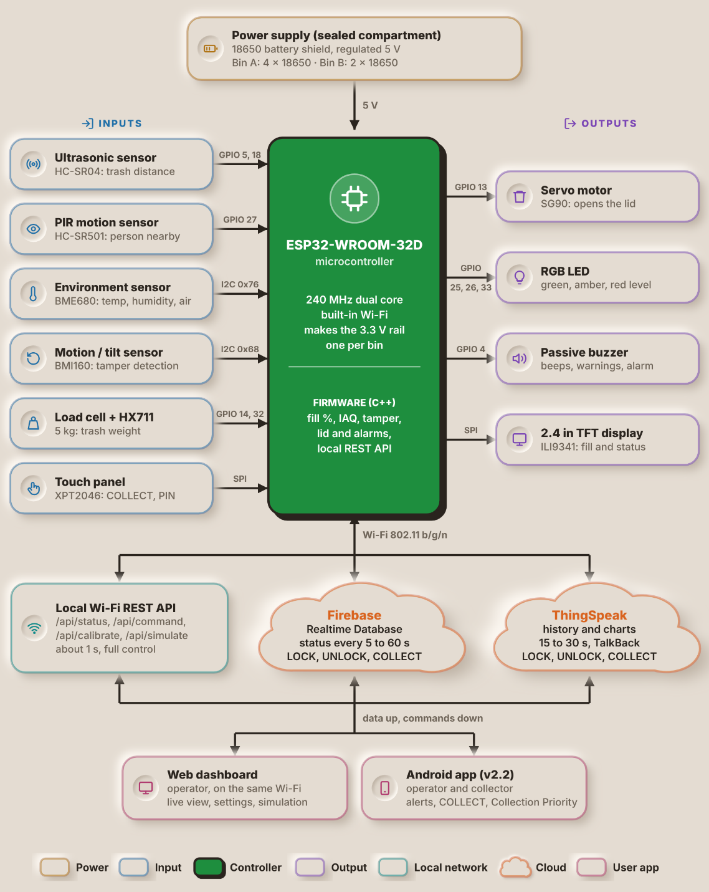
The power supply is located in the top portion of the diagram, consisting of an 18650-battery shield in a closed compartment providing the circuit a regulated 5V. Bin A is powered by 4x 18650 cells and Bin B by 2x. The 5V is fed to the ESP32-WROOM-32D which supplies the 3.3V needed by the sensors, display and buzzer; the servo, HC-SR04 and PIR sensor operate directly from the 5V. ESP32 is a 240MHz dual-core Wi-Fi enabled micro-controller. It has firmware written in C++ and uses that to determine the fill percentage, indoor air quality (IAQ) estimate and tamper state, as well as controlling the lid and alarms and providing a local REST API.
The inputs are on the left. The HC-SR04 Ultrasonic sensor on GPIO 5 and 18 can be used to detect the distance between the lid and the garbage bin, and output the fill level information, the HC-SR501 PIR sensor on GPIO 27 can be used to sense whether a person approaches the garbage bin. Two sensors, BME680 (address 0x76) for temperature, humidity and air quality and BMI160 (address 0x68) for motion and tilt for tamper detection share this I2C bus. Using a 5kg load cell, it is connected to GPIO 14 and 32 via an amplifier module named HX711 to measure the weight of the trash. On the SPI, the touch panel XPT2046 accepts the COLLECT and PIN inputs.
The outputs are to the right. The lid is opened and closed by the SG90 servo on GPIO 13 (PWM). The fill level is indicated by an RGB LED (GPIO 25, 26 and 33) in green, amber or red. Beeps, warnings and the tamper siren come from a passive buzzer on GPIO 4. The fill level and the bin status are displayed on the 2.4 in. ILI9341 TFT display (also SPI).
Three paths of data exit the bin via Wi-Fi (802.11 b/g/n) as shown in the bottom half of the image. The local REST API (/api/status, /api/command, /api/calibrate and /api/simulate) responds in ~1s and provides full control of the bin. The status is sent to the Firebase Realtime Database every 5 to 60s and to ThingSpeak every 15 to 30s, as well as the LOCK, UNLOCK and COLLECT commands (the latter via ThingSpeak's TalkBack feature). Data goes up and commands come down to two user apps. The web dashboard runs in a browser on the same Wi-Fi and gives the operator a live view, settings and simulation, while the Android app gives operators and collectors alerts, the COLLECT command and the Collection Priority list.

2.3 System Flowchart
Figure 38
System Flowchart of the Smart-Bin
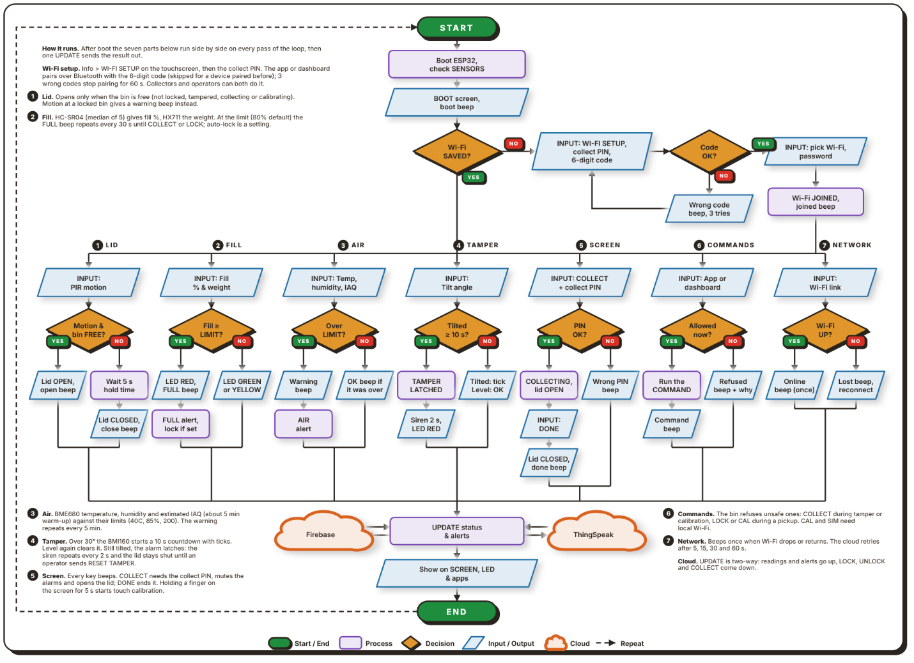
Note. Figure 38 shows the main program loop that runs on each bin. After start-up, seven parts run side by side on every pass of the loop, and their results meet at one update step.
Upon powering on the bin, the ESP32 starts, checks its sensors and loads its saved settings, with a boot screen and a beep. It then examines if a Wi-Fi network is saved. If not, the user opens WI-FI SETUP on the touchscreen and enters the collect PIN, and the app or dashboard pairs with the bin over Bluetooth. The 6-digit code on the bin's screen is typed into the pairing box (a device paired before skips it, and three wrong codes stop pairing for 60s). The bin returns a list of all the Wi-Fi networks within its range, and the user selects one and enters its password, after which the bin beeps to join. This loop is split into 7 parallel sections (1-7 on chart).
The lid part (1) reads the PIR sensor. If the bin is free (not locked, tampered with, collecting or being calibrated), it beeps to open the lid. Otherwise, bin lid remains closed and a beep is heard when motion occurs with the lid closed. The lid beeps and closes 5 seconds after the movement is stopped. The fill part (2) reads the weight from the HX711, and takes the median of 5 HC-SR04 readings for the fill percentage. At the default setting of 80%, the LED flashes red and an alert message is sent every 30s until the bin is collected (or locked) when the fill is at the limit. When set to auto-lock, the bin itself locks as well. If lower than the limit the LED is green or yellow. The air part (3) compares the measured temperature, humidity and estimated air quality of the BME680 with their limits (40C, 85% and an index of 200). The air quality is an approximation based on the gas reading and should be warmed up for approximately 5 minutes. When over a limit the buzzer sounds and an alert is sent every 5 minutes, whilst a short beep indicates when the reading is back under.
The BMI160 tilt angle is monitored by the tamper part (4). If the tilt exceeds 30°, a countdown of 10 seconds begins with a "tick" every second. The alarm automatically resets if the bin is steady once more. Until an operator sends RESET TAMPER, the alarm latches when it remains tilted: the siren sounds every 2s, the LED is red, the lid remains closed and an alarm message is generated. The screen part (5) is used for handling the COLLECT touch command. Once collect PIN is entered lid will open and alarms will be muted until DONE is pressed and the lid is closed and the fill level is reset, or if the collect PIN is wrong, an error beep is provided. Finger on screen for 5s to start touch calibration. The command’s part (6) receives the following commands from the app or dashboard: LOCK, UNLOCK, COLLECT, calibration (CAL) and simulation (SIM). Bin beeps if an unsafe one is attempted such as COLLECT during tamper alarm and CAL and SIM are Wi-Fi only. The network part (7) beeps once when the Wi-Fi is lost and once when it returns.
All seven paths then lead to an UPDATE step. The two arrows between this step and each cloud reflect that the reading and the alerts are sent to Firebase and the ThingSpeak, and the LOCK, UNLOCK and COLLECT commands are returned to it. This new status is then reflected on the screen, on the LED and in the apps and the process is repeated.
Figure 39
Operator Flowchart of the Smart-Bin Apps
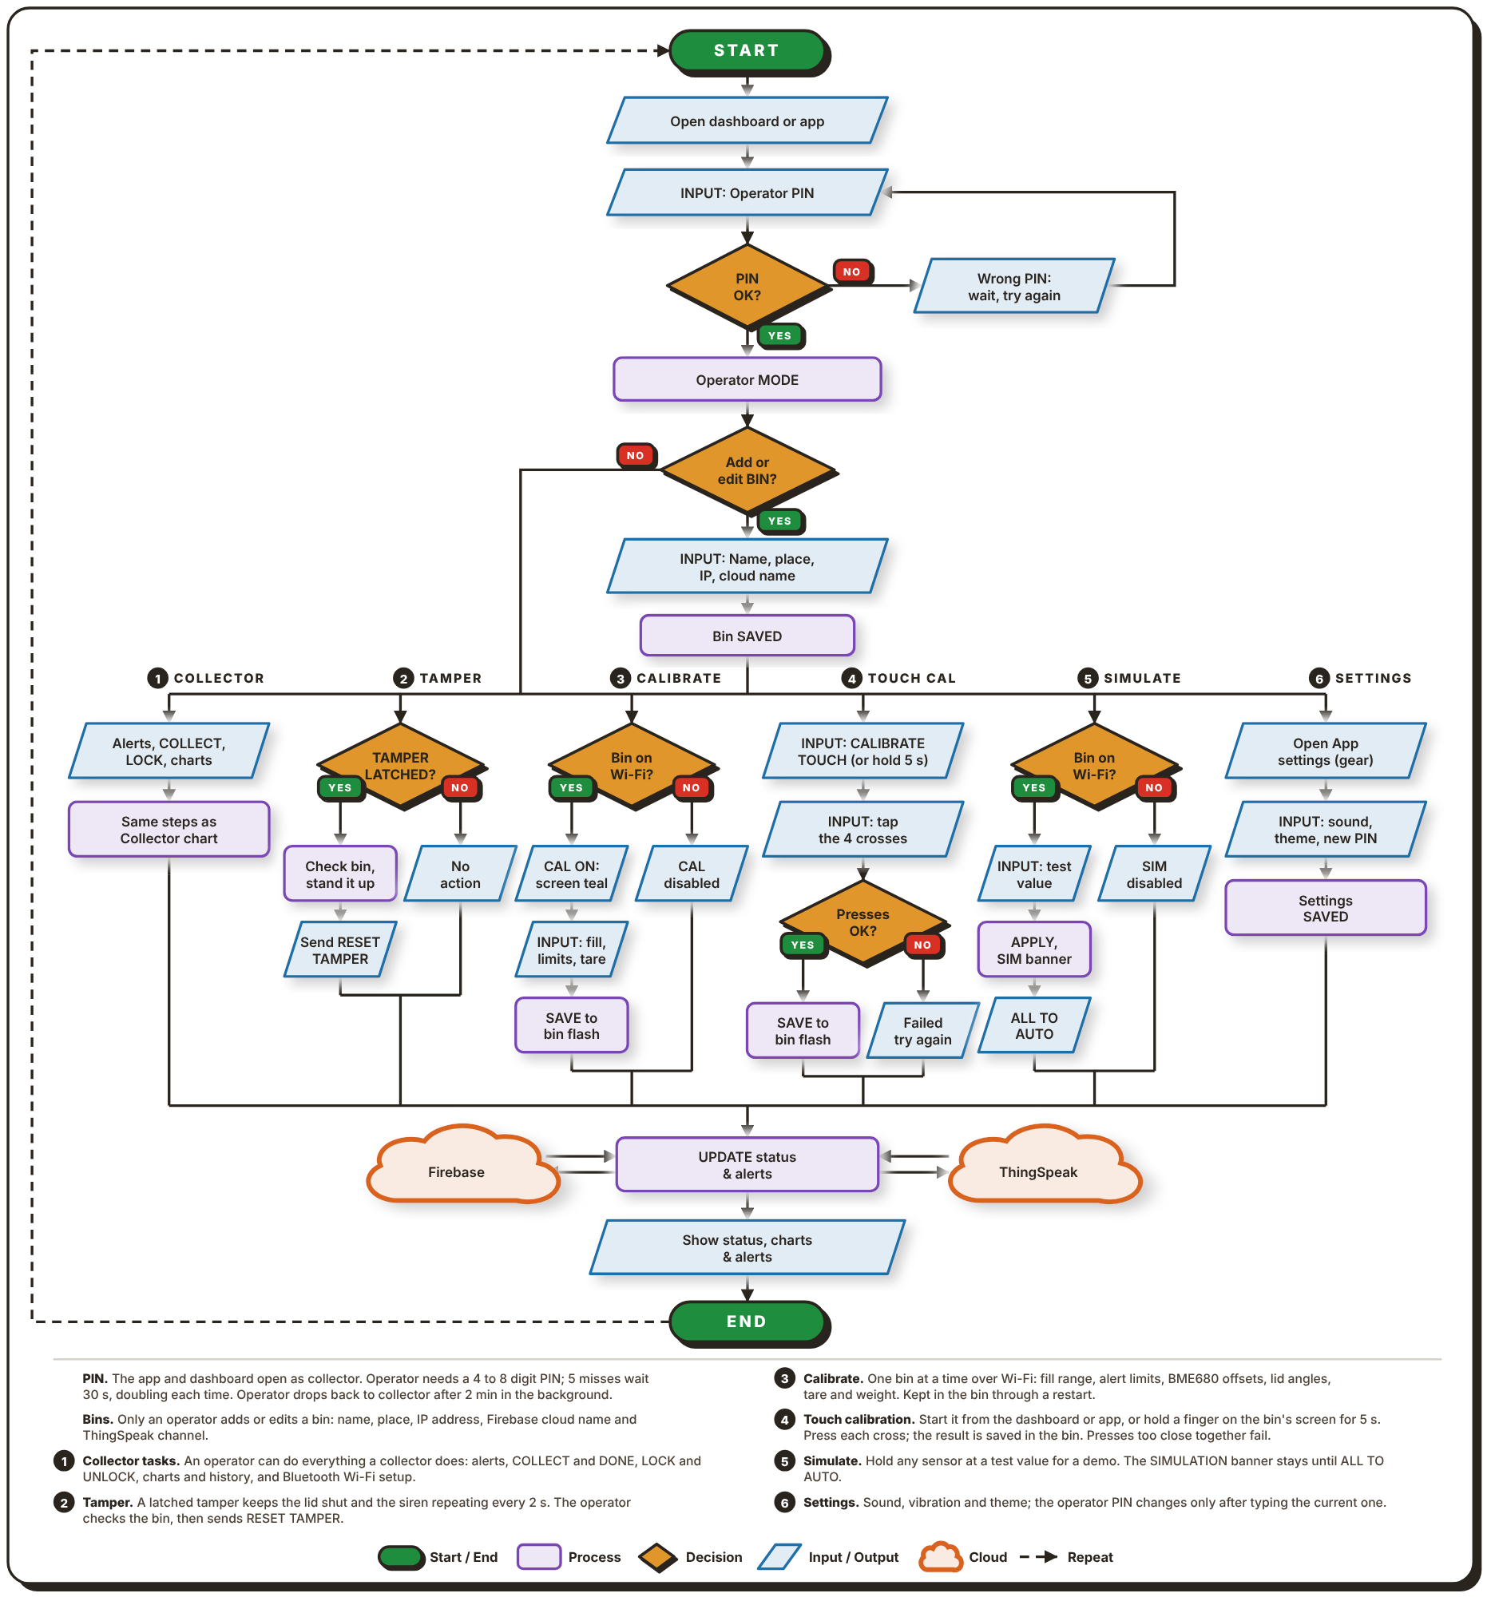
Note. As seen in Figure 39, an operator can do the following actions in the Web Dashboard or in the Android App
.
In both apps, the collector mode is the default, and the operator enters his 4- to 8-digit PIN. A wrong PIN requires a delay between attempts, with 30s after 5 failed attempts and the delay for subsequent failed attempts doubling. The app puts itself in operator mode with the appropriate PIN. The operator can then add or edit a bin, giving it a name, a place, the IP address and cloud name for Firebase and ThingSpeak, and the bin is saved in the app.
There are five tasks branching out from there. Everything that a collector can do is Collector (1), as shown in Figure 40: alerts, COLLECT and DONE, LOCK and UNLOCK, charts and history, and setting up the Wi-Fi over Bluetooth. Tamper (2) is for a bin with an alarm that latched. The operator checks the bin and stands it up and then sends a RESET TAMPER to clear the alarm. Calibrate (3) requires bin to be on same Wi-Fi. The operator sets new limits (fill range, alert limits, BME680 offsets, lid angles, weight tare and more) and these limits are stored in the flash memory of the bin. Calibration is disabled if the bin is not connected to Wi-Fi. The touch calibration (4) can be initiated from the dashboard or app or by holding a finger on the bin's screen for 5s. Operator presses four crosses sequentially and result is stored on the bin (if pressed too close, it is a fail and the operator retries).
Simulate (5) keeps the value of any sensor for demonstration purposes. A SIMULATION banner will appear on the screen while it is on until the operator returns everything to AUTO. The sound, vibration and theme are set by Settings (6) and the operator can change the PIN in the settings after entering the PIN. The result of whichever task is used then iterates through the same 2-way UPDATE process with both the Firebase and the ThingSpeak services and the app will display the new status, plus the charts and alerts.
Figure 40
Collector Flowchart of the Smart-Bin Apps
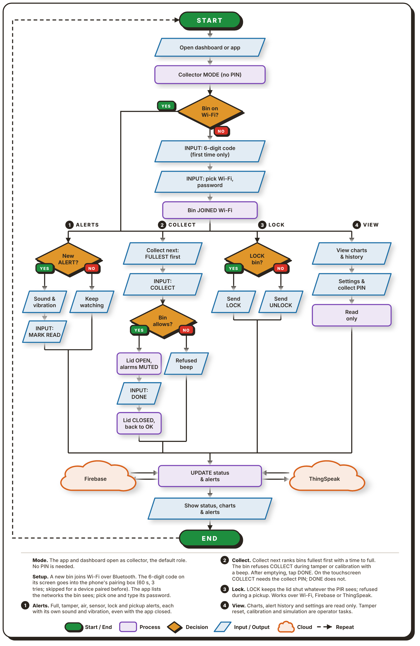
Note. As seen in Figure 40, the collector's job in the web dashboard or in the Android app.
The apps are opened to collector mode which is the default mode and no pin is required. The collector uses Bluetooth to set up the bin if not already connected to Wi-Fi. The 6 digit code displayed on the screen of the bin is entered into the pairing box of the phone (code will be valid for 60s, 3 failed attempts will lock pairing for 60s, a device that has been paired before will not require a code). The app then lists the Wi-Fi networks the bin can see, and the collector picks one and enters its password. After the bin joins the network, there are four tasks available.
Alerts (1) are issued for a full bin, tampering, bad air, lock and pickup. Each has its own sound and vibration and they come even when the app is not in use. The primary task is collect (2). The Collection priority list is a ranking of the bins, with the first bin in the list being the one with the most capacity, and the time to fill each bin is shown. The collector taps COLLECT in the app or on the screen, and enters the collect PIN at the bin. Lid opens and alarms stop. The collector then empties the bin and taps DONE (no PIN required) and the lid will then close and the fill level will reset. A bin refuses COLLECT, with a beep, while a tamper alarm or a calibration is on.
Lock (3) allows the collector to lock or unlock a bin, while resetting a tamper alarm, calibration and simulation stay with the operator. View (4) displays the charts, alert history, and status and collect PIN in read-only mode. All tasks are completed with the same step in Firebase and ThingSpeak and the app updates the status.

2.4 Schematic Design
The circuit of each unit is drawn as one schematic split into three sheets: the microcontroller, the actuators and outputs, and the sensors and inputs. The order of the sheets is: Figures 41, 42, 43. Instead of long wires between sheets, each connection to the ESP32 has a net label (IO25, etc.) and a bunch of pins with the same net label are grouped together.
Figure 41
Schematic Diagram, Sheet 1: Microcontroller
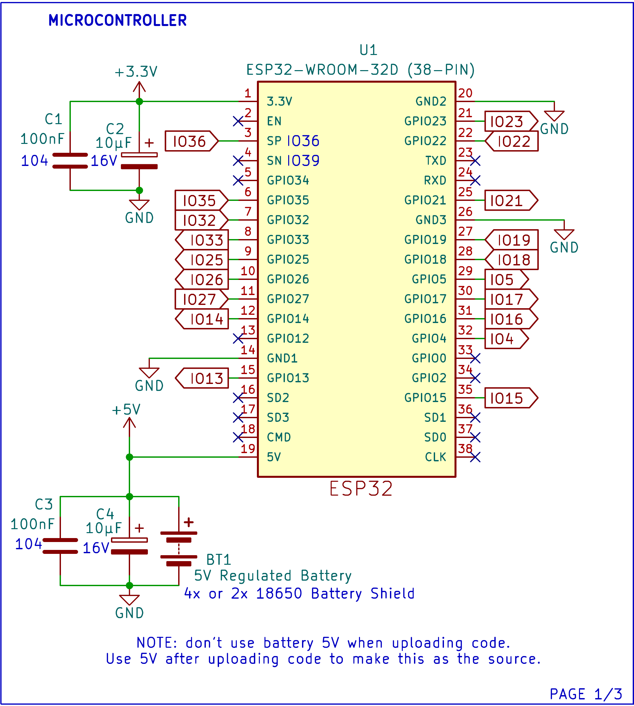
U1 is the ESP32-WROOM-32D on a 38-pin board. The 4x or 2x 18650-battery shield, BT1, provides the 3.3V rail for the sensors, the display and the buzzer (pin 1) and a regulated 5V to pin 19. C1 and C2 (100nF and 10µF) smooth the 3.3V rail, and C3 and C4 (100nF and 10µF) do the same at the battery input. The ground pins share one GND net. Pins which are not configured in the design (such as EN, TXD, RXD, GPIO0, GPIO2) are identified as "no-connect". According to the note on the sheet, the battery's 5V should not be used while code is being uploaded; rather, it should only be used after the code is uploaded.
Figure 42
Schematic Diagram, Sheet 2: Actuators and Outputs
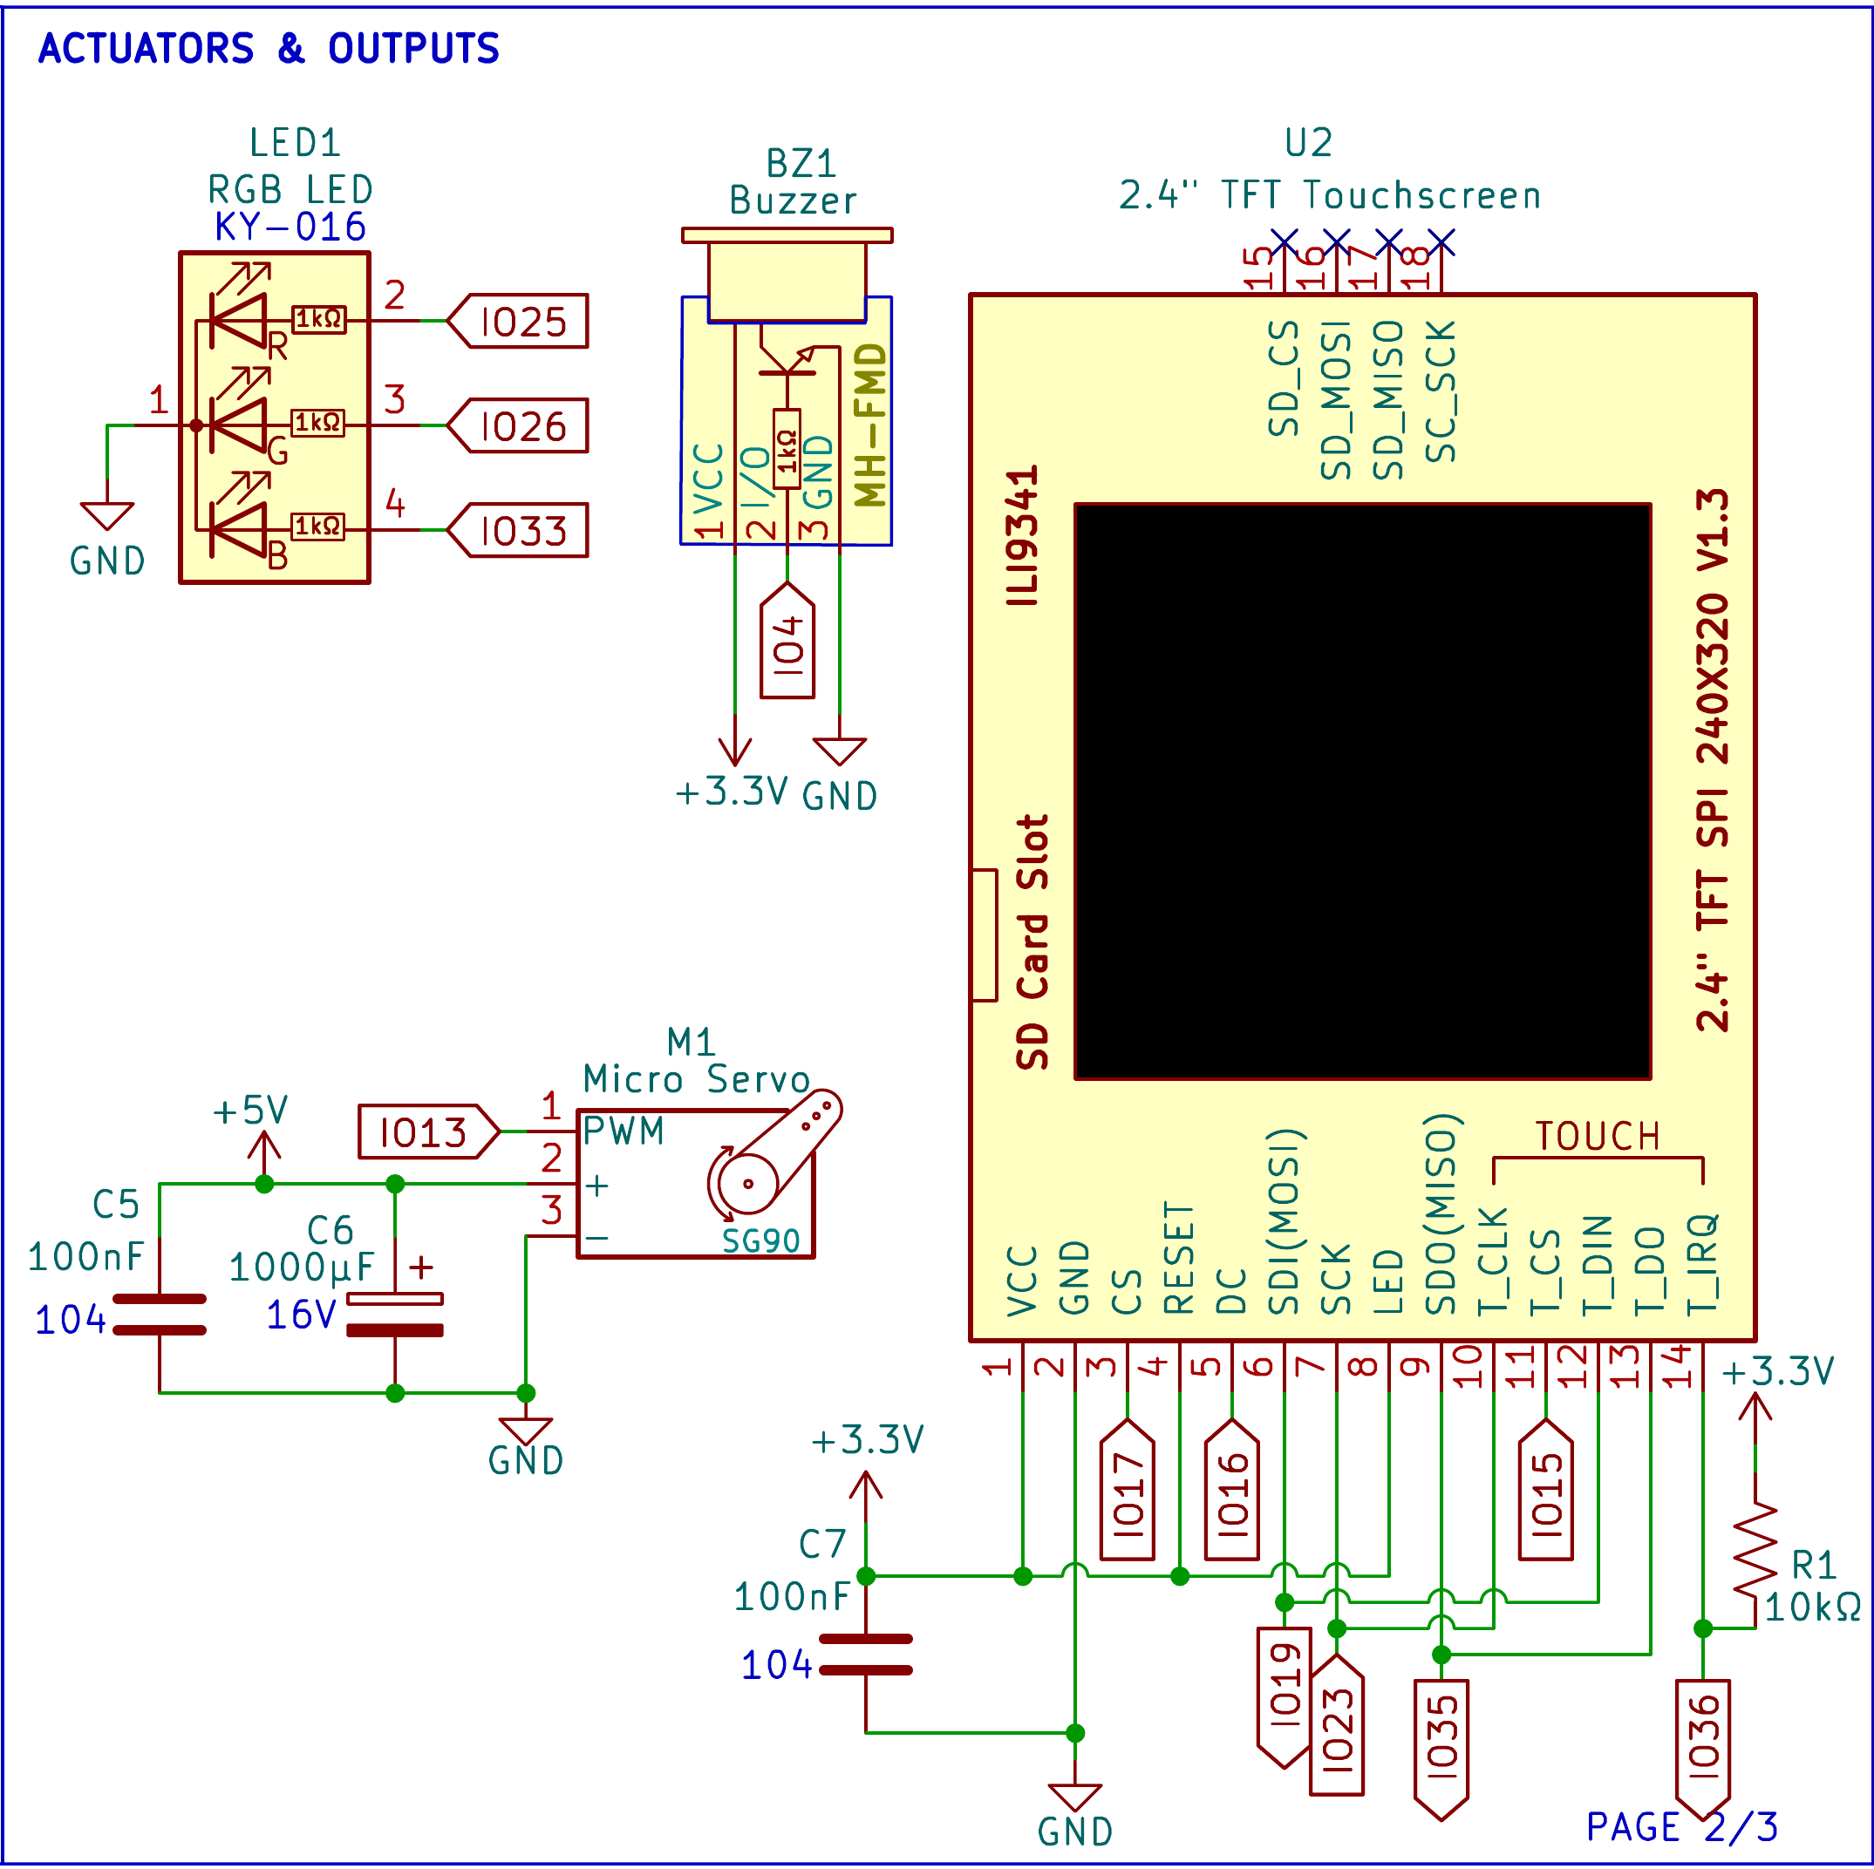
LED1 is a common cathode RGB LED KY-016. Its red, green and blue legs have 1kΩ resistors connected to IO25, IO26 and IO33. BZ1 is a buzzer module (MH-FMD) that operates on 3.3V and is controlled by IO4. The SG90 micro servo (M1) operates on the 5V power supply, and is controlled by IO13 via PWM, with C5 (100nF) and C6 (1000µF) placed across the power supply to filter current spikes as the servo moves.
U2 is the 2.4 in. ILI9341 touchscreen (240 × 320, SPI). It runs on 3.3V, with C7 (100nF) across its supply. The display and its touch controller share the SPI clock and data lines on IO19, IO23 and IO35, and each has its own chip select: IO17 for the display and IO15 for touch. DC goes to IO16 and the touch interrupt T_IRQ to IO36. R1 (10kΩ) pulls T_IRQ to 3.3V, the line remains high until a touch pulls it down. The RESET and the backlight pin (LED) are connected to 3.3V and the SD card pins are not connected.
Figure 43
Schematic Diagram, Sheet 3: Sensors and Inputs
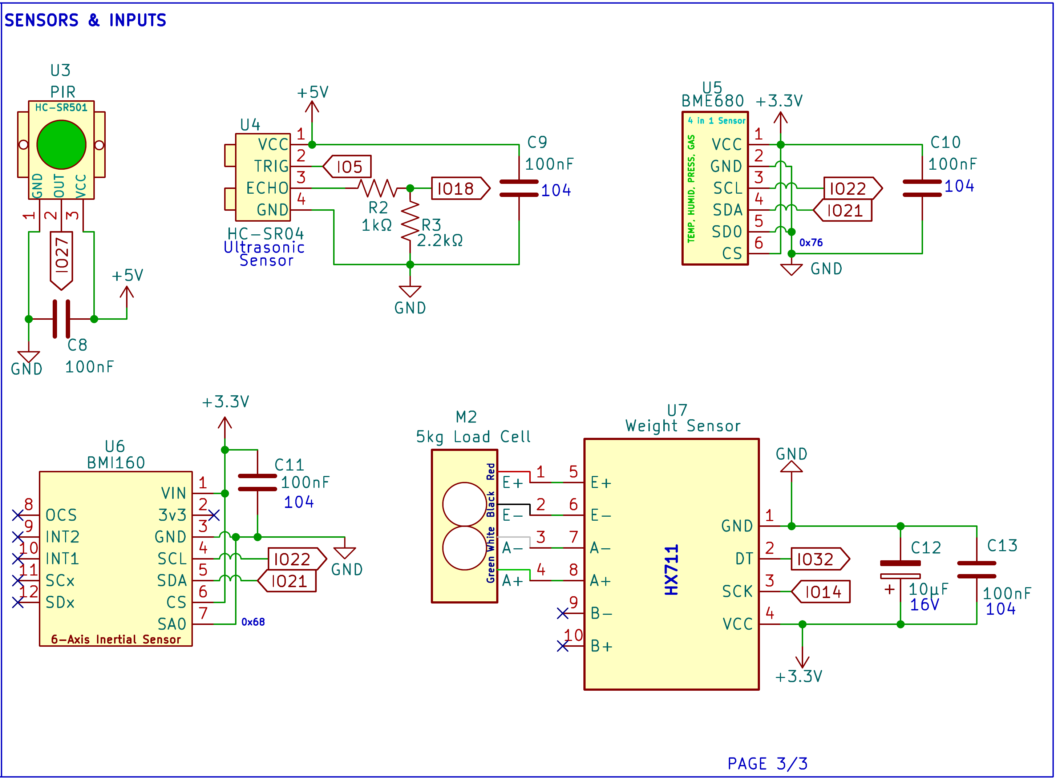
U3, the HC-SR501 PIR sensor, runs on 5V and sends its output to IO27, with C8 (100nF) across its supply. The HC-SR04 (U4) operates on 5V also with the C9 (100nF) from supply and TRIG on IO5. It outputs a 5V pulse to its ECHO pin, which is then divided by R2 (1kΩ) and R3 (2.2kΩ) to produce ~3.4V before reaching IO18, and is thus very close to the 3.3V level that the esp32 input expects for it can tolerate up to 3.6V.
U5 (BME680) and U6 (BMI160) both run on 3.3V, with C10 and C11 (100nF each) across their supplies, and share the I2C bus, with SCL on IO22 and SDA on IO21. Tying the BME680's SDO pin to ground sets its address to 0x76, and tying the BMI160's SA0 pin to ground sets its address to 0x68, so the two do not clash. M2, the 5kg load cell, connects its red, black, white and green wires to the E+, E−, A− and A+ inputs of U7, the HX711. The HX711 runs on 3.3V, with C12 (10µF) and C13 (100nF) across its supply, and sends its data on IO32 with its clock on IO14.

2.5 Component Materials
This section describes the main electronic parts used in each Smart-Bin unit. Both bins use the same parts except for the battery shield. Figures 44 to 54 show each part, followed by what it does and how the system uses it.
Figure 44
ESP32 DevKit V1 (38-Pin, ESP32-WROOM-32D)
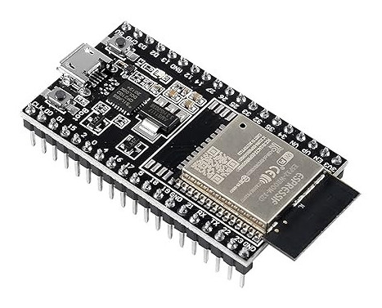
Note. Image from Sigmanortec (n.d.).
The ESP32 DevKit V1 is a development board built around the ESP32-WROOM-32D module. The module has a dual-core processor that runs at up to 240MHz, with Wi-Fi and Bluetooth on the same chip. The 38-pin board provides an additional USB connector for uploading code and power, a voltage regulator for 3.3V power and pin headers for breadboarding.
There is one board for each bin and each board governs all of the contents of that bin. It reads all six inputs (the HC-SR04, PIR sensor, BME680, BMI160, load cell and touchscreen), calculates the fill percentage, air quality reading and tamper state, and controls the servo, LED, buzzer and display. Providing the local REST API over Wi-Fi, it receives the status update command from the dashboard and the Android application and sends status update to Firebase and ThingSpeak.
Figure 45
HC-SR04 Ultrasonic Distance Sensor
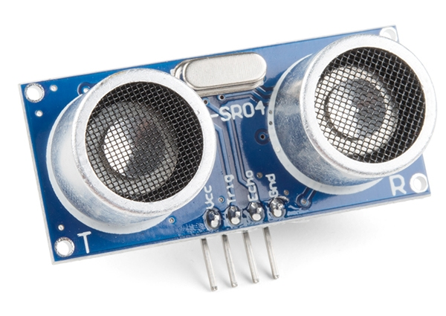
Note. Image from SparkFun Electronics (n.d.).
The HC-SR04 is a sound-based distance sensor. It outputs a 40kHz ultrasonic burst when a short pulse is received at its TRIG pin and will keep its ECHO pin high until the echo is received. The distance is determined by the width of that pulse which varies in the range of 2cm to 4m. The sensor runs on 5V.
In Smart-Bin it is installed under the lid and points downward, and thus measures the distance between the lid and the top of the trash. The firmware converts that distance into the fill percentage displayed on the LED, touch screen and the apps and once the fill level reaches the fill limit (80% by default), the full-bin alert is activated. TRIG is wired to IO5, and ECHO is wired to IO18 through a divider of R2 (1kΩ) and R3 (2.2kΩ), which brings the 5V pulse down to about 3.4V, close to the 3.3V input level of the ESP32.
Figure 46
HC-SR501 PIR Motion Sensor
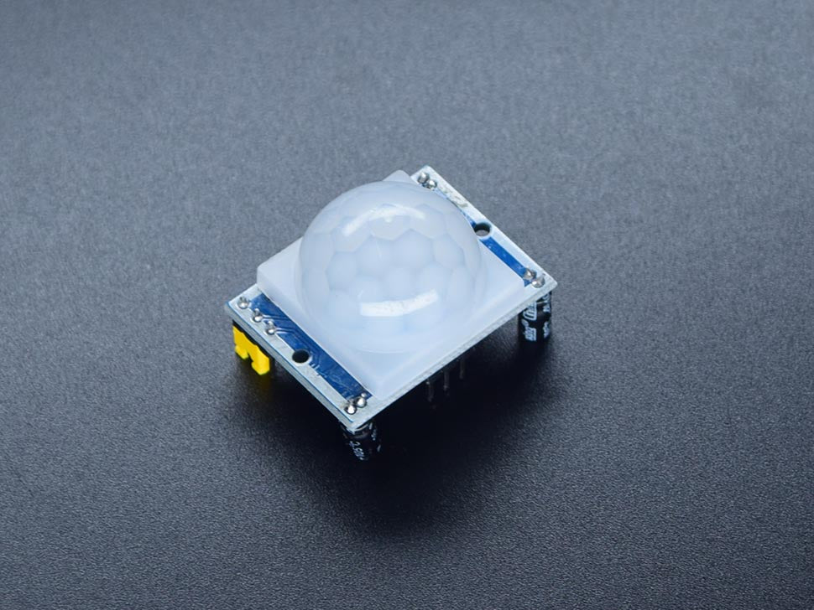
Note. Image from Circuitrocks (n.d.-c).
The HC-SR501 is a passive infrared (PIR) sensor. It detects the modulation of infrared light as a warm body passes in front of its white dome lens and its output pin will be "high" when motion is detected. The sensitivity and output high time is determined by two trimmers on the board.
It is used by Smart-Bin to determine when someone approaches the bin. When the output on IO27 is high and the bin is available for opening, the bin beeps and the servo raise the lid and the user never has to touch it. The lid will close 5 seconds (user definable length) after movement ceases. During COLLECT mode motion sensing is suppressed and the lid remains open while the collector is operating.
Figure 47
BME680 Environmental Sensor
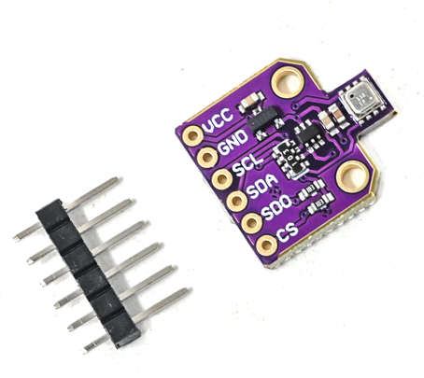
Note. Image from Robu.in (n.d.).
The BME680 is a single chip sensor for measuring temperature, humidity, VOC (volatile organic gases) and air pressure. Based on the gas reading, an estimated indoor air quality (IAQ) rating can be obtained. It is powered by 3.3V and communicates via I2C.
In Smart-Bin it monitors the air within the bin. When the temperature, humidity or estimated air quality goes over its limit, the firmware sounds an alarm and sends an alert, even if the bin isn't full yet, because a high temperature may mean a fire or hot material. It is located at I2C address 0x76 (SDO tied to ground).
The purpose of this is using the combination of temperature, humidity, and gas reading (IAQ) in order to determine by the collector or operator how much rotting trash is in the Smart-Bin for smell-sensitive areas. The IAQ value is an estimate from the gas reading, and it needs about 5 minutes after power-up to settle.
Figure 48
BMI160 Six-Axis Inertial Measurement Unit
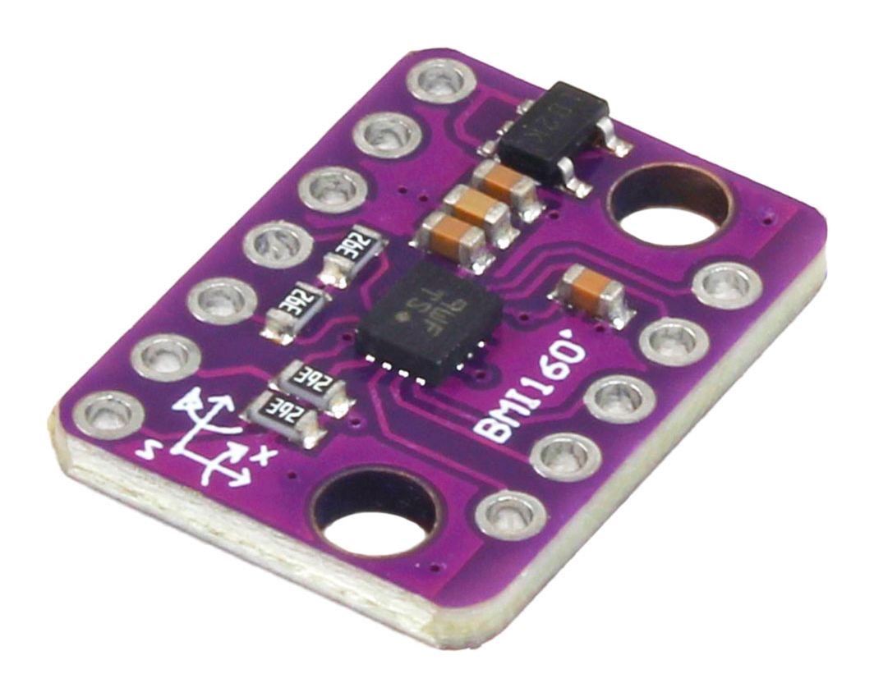
Note. Image from ElectroPeak (n.d.).
BMI160 is a 3-axis accelerometer and 3-axis gyroscopes integrated onto one chip. It is an I2C acceleration and rotation sensor that operates on 3.3V.
It is used by Smart-Bin for tamper detection. If the bin is tilted, the readings exceed the range limits and the firmware sets the Tamper alarm, activates the buzzer and prevents the lid opening. It is on the same I2C bus as the BME680 with the address 0x68 by shorting out SA0 to ground. The tamper check is paused during COLLECT mode.
Figure 49
HX711 Load Cell Amplifier and 5kg Load Cell
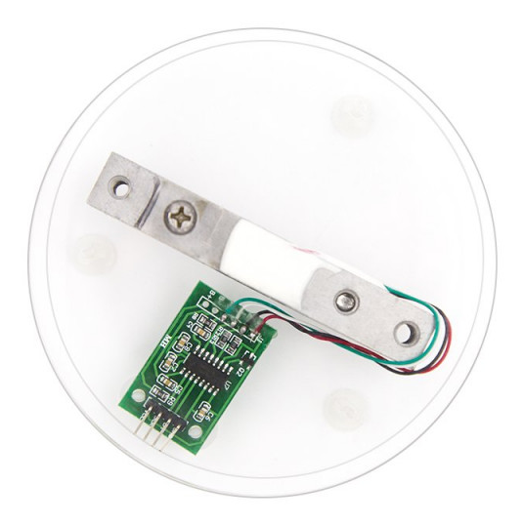
Note. The HX711 board and the 5kg load cell are shown on a display base. Image from ElectronicsComp.com (n.d.).
A load cell is a metal bar with strain gauges designed so that as the load is applied, the bar's resistance varies slightly. The bar here is a 5kg model, and has a very small voltage output, which is amplified and converted in the HX711 board by a 24 bit analog to digital converter. The result is read by the ESP32 using two pins: DT (IO32) and SCK (IO14).
The two together measure the garbage. Weight is a second check on the fill level: wet waste can be heavy before the bin is full, and a bin full of light waste can be tall without being heavy. The weight is displayed on the dashboard and the app, and stored to the cloud with every measurement.
Figure 50
SG90 Micro Servo Motor
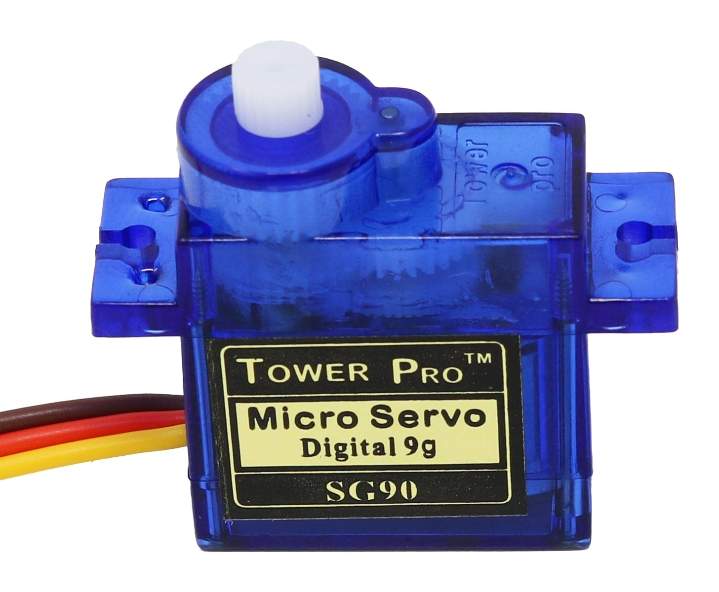
Note. Image from The Pi Hut (n.d.).
The SG90 is a small hobby servo which will rotate its output arm to a specific angle (roughly 180 degrees) depending on the width of a PWM pulse. Operates on approximately 5V and can be attached directly to the bin.
Servo is used to open and close the bin lid. It is managed by ESP32, it will open when it is detected people, or when the collector taps COLLECT, it will close after 5s (user settable) when people are not detected or the collector taps DONE. When the bin is locked, full or flagged for tampering, the firmware keeps the servo in the closed position.
Figure 51
2.4-in. TFT Touchscreen (ILI9341 With XPT2046 Touch Controller)
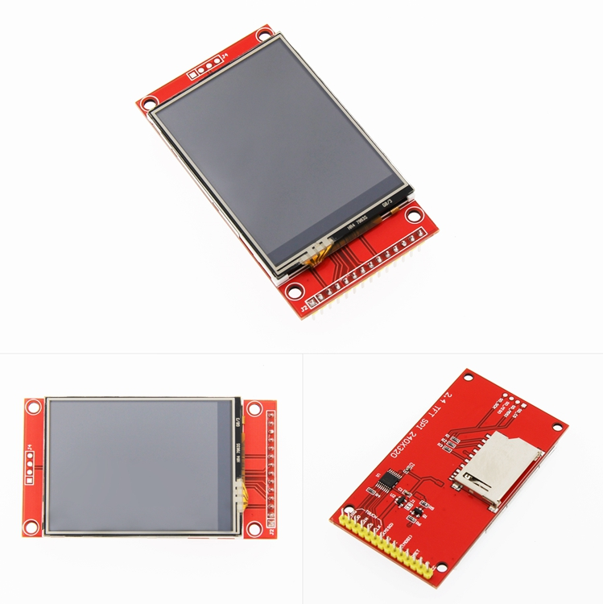
Note. Front, back, and angled views of the module. Image from LCDWIKI (n.d.).
This module is a 2.4 in., 240 × 320 color display driven by the ILI9341 controller over SPI. The same SPI bus also has a separate XPT2046 controller for the resistive touch layer on top. There is also an SD card slot on the board, which isn't used by Smart-Bin.
The bin's local screen is the display. It indicates the fill level, sensor readings and the bin status (LOCKED and TAMPER). The touch layer provides the collector with the buttons COLLECT, PIN and DONE, making it possible to empty a bin without the app.
Figure 52
KY-016 RGB LED Module
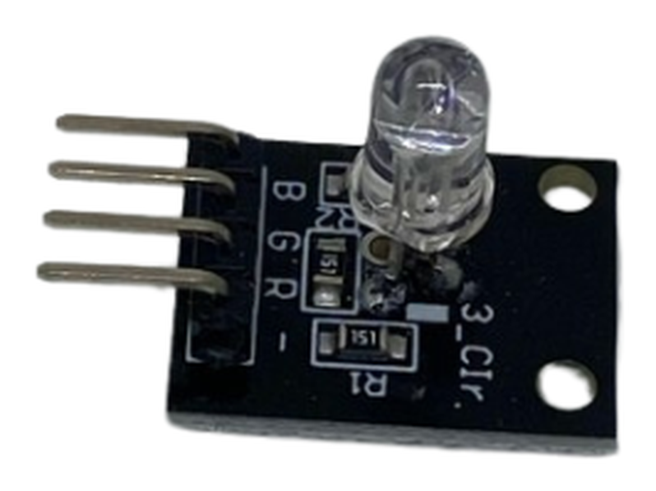
Note. Image from Circuitrocks (n.d.-d).
The KY-016 is a small board with a common-cathode RGB LED, a small package containing the red, green and blue chips. When the three colors are combined, other colors are created such as amber (red + green). A 1kΩ resistor is used for each colour to control the current.
The fill level is indicated on the LED, green if there is room in the bin, amber when it is filling up and red when the bin is full or a warning is triggered. It is driven from IO25, IO26 and IO33 and turns green again after the collector taps DONE.
Figure 53
Passive Buzzer Module (MH-FMD)
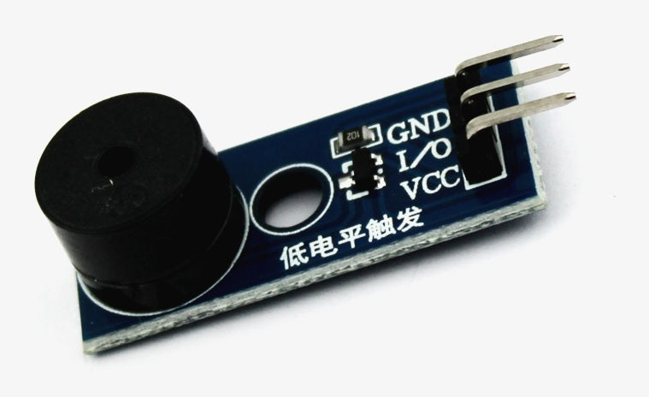
Note. Image from QuartzComponents (n.d.).
Passive buzzer: No built-in oscillator so it only buzzes if it is pulsed by the controller with a changing signal. This will allow the firmware to produce various tones and patterns, rather than just a single beep.
It is used by Smart-Bin for sound feedback from IO4. It beeps when lid is opened, alerts user if the BME680 senses high temp or humidity or poor air quality, and activates the siren if BMI160 senses tampering. It remains quiet while in COLLECT mode.
Figure 54
18650-Battery Shields for Bin A (4-Cell) and Bin B (2-Cell)
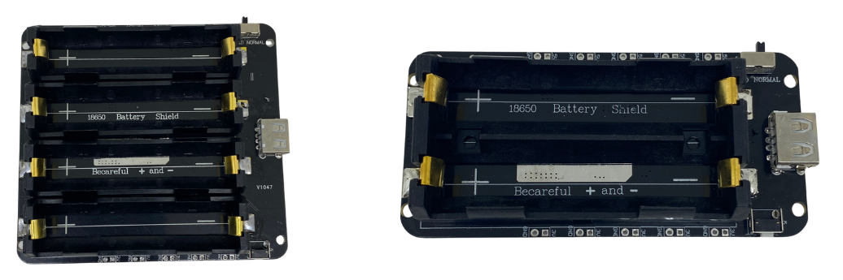
Note. Left: four-cell shield used in Bin A (Circuitrocks, n.d.-b). Right: two-cell shield used in Bin B (Circuitrocks, n.d.-a).
The 18650-battery shield comprises lithium-ion 18650 cells which will provide the electricity needed and convert its voltage to a regulated 5V output. It also features a charging USB port for the cells. Bin A are equipped with a four-cell V9 shield (5V/3A), while Bin B are equipped with a two-cell shield.
The shield supplies power to the entire bin, without the need for a wall outlet, which allows a bin to be set anywhere that Wi-Fi is available. It is placed in a closed compartment and connected to the 5V of the ESP32 which provides 3.3V for the sensors. As mentioned in the schematic, the battery should not be connected during code upload via USB.

III. TESTING, RESULTS, AND CONCLUSION

3.1 Test Cases
[Introduce the test cases here. Each specific objective is tested below.]

Specific Objective 1: Sensor Monitoring and Detection
[Insert test cases TC1.1 to TC1.6 here.]

Specific Objective 2: Real-Time Monitoring and Alerts
[Insert test cases TC2.1 to TC2.6 here.]

Specific Objective 3: Bin Control and Collection Prioritization
[Insert test cases TC3.1 to TC3.6 here.]

3.2 Results and Discussion
[Present and discuss the test results here.]

3.3 Conclusion
[Write the conclusion here.]

3.4 Recommendations
[Write the recommendations here.]

REFERENCES
Aasish, V. G., Mari Shankar, C., & Shanmugasundaram, M. (2025). FreeRTOS based smart waste management system. In 2025 Innovations in Power and Advanced Computing Technologies (i-PACT) (pp. 1–7). IEEE. https://doi.org/10.1109/i-PACT65952.2025.11307820
Abdullahi, A., Mohammed, A., Bonet, M. U., El-Suleiman, A., Ahmad, R. B., & Chollom, T. D. (2024). Development of a smart waste management system with automatic bin lid control for smart city environment. EAI Endorsed Transactions on Smart Cities, 7(3). https://doi.org/10.4108/eetsc.4385
Alnanih, R., Elrefaei, L., & Al-Ahwal, A. (2025). Advancing sustainability through an IoT-driven smart waste management system with software engineering integration. Sustainability, 17(21), Article 9803. https://doi.org/10.3390/su17219803
Alnuaimi, A. N., Aydin, R., & Al-Shihabi, S. (2024). Optimizing municipal solid waste collection using smart bins: A case study in United Arab Emirates. In 2024 IEEE International Conference on Technology Management, Operations and Decisions (ICTMOD) (pp. 1–6). IEEE. https://doi.org/10.1109/ICTMOD63116.2024.10878234
Alourani, A., Ashraf, M. U., & Aloraini, M. (2025). Smart waste management and classification system using advanced IoT and AI technologies. PeerJ Computer Science, 11, Article e2777. https://doi.org/10.7717/peerj-cs.2777
Asido, D. (2024, January 19). Baguio students develop smart garbage bins. The Post. https://thepost.net.ph/news/campus/baguio-students-develop-smart-garbage-bins/
Awotayo, M. M., & Dodo, U. A. (2026). Design and implementation of an IoT-based smart bin for real-time fill level monitoring. Journal of Science Technology and Education, 14(1), 344–351. https://www.researchgate.net/publication/400748751
Ayyanagoudar, A., Mohankar, A., Gharte, J., Pasnsare, P., Ainapure, B., & Appasani, B. (2024). A smart bin with real-time monitoring and garbage level tracking using IoT. In 2024 11th International Conference on Reliability, Infocom Technologies and Optimization (Trends and Future Directions) (ICRITO) (pp. 1–7). IEEE. https://doi.org/10.1109/ICRITO61523.2024.10522263
Azmi, A. Z., Sahar, N. M., & Islam, M. T. (2024). Smart waste management system using LoRa technology. E3S Web of Conferences, 599, Article 04007. https://doi.org/10.1051/e3sconf/202459904007
Bahga, A., & Madisetti, V. (2014). Internet of things: A hands-on approach.
Balachandran, N., & Talavera, O. (2023). Apparatus and method for waste monitoring and analysis (U.S. Patent No. 11,788,877). U.S. Patent and Trademark Office. https://patents.google.com/patent/US11788877B2
Banciu, C., Florea, A., & Popa, M. (2025). IoT-enabled waste collection: Route optimization and environmental impact reduction using smart technologies. In 2025 29th International Conference on System Theory, Control and Computing (ICSTCC) (pp. 782–788). IEEE. https://doi.org/10.1109/ICSTCC66753.2025.11240462
Bigbelly. (n.d.). CLEAN software. Retrieved October 19, 2026, from https://bigbelly.com/products/clean-software
Bosch Sensortec. (n.d.). BME680 gas sensor (Document No. BST-BME680-DS001) [Data sheet]. Retrieved October 19, 2026, from https://www.bosch-sensortec.com/media/boschsensortec/downloads/datasheets/bst-bme680-ds001.pdf
Brown, W. J. (2006). Compactor service and monitoring system (U.S. Patent No. 7,145,450). U.S. Patent and Trademark Office. https://patents.google.com/patent/US7145450B2
Circuitrocks. (n.d.-a). 2 channel 18650-battery holder protection board. Retrieved October 15, 2026, from https://circuit.rocks/products/2-channel-18650-battery-holder-protection-board
Circuitrocks. (n.d.-b). 4 channel 18650-battery holder protection board. Retrieved October 15, 2026, from https://circuit.rocks/products/4-channel-18650-battery-holder-protection-board
Circuitrocks. (n.d.-c). HC-SR501 PIR motion sensor module. Retrieved October 15, 2026, from https://circuit.rocks/products/pir-motion-sensor-module-digital
Circuitrocks. (n.d.-d). KY-016 RGB 3 color full-color LED module. Retrieved October 15, 2026, from https://circuit.rocks/products/ky-016-rgb-3-color-full-color-led-module
Compology. (n.d.). Image-based container monitoring built for waste. Retrieved October 19, 2026, from https://compology.com/
Devitt, S., & Walsh, B. (2021). Techniques for optimally sensing full containers (U.S. Patent No. 11,054,545). U.S. Patent and Trademark Office. https://patents.google.com/patent/US11054545B2
Di Giugno, M., Giovanelli, F., Tiraboschi, S., & Villa, P. (2016). Measuring device, container means and system for monitoring and managing container means (European Patent No. 2516974). European Patent Office. https://patents.google.com/patent/EP2516974B1
Ecological Solid Waste Management Act of 2000, Republic Act No. 9003 (2001). https://lawphil.net/statutes/repacts/ra2001/ra_9003_2001.html
Ecube Labs. (n.d.). Waste analytics platform: CleanCityNetworks (CCN). Retrieved October 19, 2026, from https://www.ecubelabs.com/waste-analytics-platform/
ElectronicsComp.com. (n.d.). 5 kg load cell with HX711 module shell and 4P DuPont wire kit. Retrieved October 15, 2026, from https://www.electronicscomp.com/5-kg-load-cell-with-hx711-module-shell-and-4p-dupont-wire-kit
ElectroPeak. (n.d.). GY-BMI160 module 6DOF 6 axis angular velocity. Retrieved October 15, 2026, from https://electropeak.com/gy-bmi160-module-6dof-6-axis-angular-velocity
Enache, B.-A., Banica, C.-K., & Bogdan, A. G. (2024). Intelligent trash level detection for sustainable urban waste management. The Scientific Bulletin of Electrical Engineering Faculty, 24(1), 56–59. https://doi.org/10.2478/sbeef-2024-0010
Evreka. (2020). Fill level sensor. Retrieved October 19, 2026, from https://evreka.co/solutions/fill-level-sensor/
Gajula, R., Karanam, M., Vakkapatla, D. C., Endrapu, K. R., Raju, V. V. R., Reddy, S. B., Aljanabi, S. O., Koli, S., & Mahajan, S. (2025). Sustainable waste management solution: ESP32-powered smart bin. AIP Conference Proceedings, 3263(1), Article 140006. https://doi.org/10.1063/5.0261359
González, G. E., Escobar, E. R., Carvajal, I. I., & Bento, A. C. (2024). Smart trash bins: Integration of IoT with AI for efficient waste management. In 2024 IEEE International Humanitarian Technologies Conference (IHTC) (pp. 1–6). IEEE. https://doi.org/10.1109/IHTC61819.2024.10855147
Greenwalt, M. (2020, June 2). Bin-e creates contactless smart bin. Waste360. https://www.waste360.com/recycling/bin-e-creates-contactless-smart-bin
Gupta, S., Gautam, R., & Muneer, A. (2025). IoT-based e-tracking system for waste management. In 2025 12th International Conference on Reliability, Infocom Technologies and Optimization (Trends and Future Directions) (ICRITO) (pp. 1–6). IEEE. https://doi.org/10.1109/ICRITO66076.2025.11241930
Ishaq, A., Mohammad, S. J., Bello, A. D., Wada, S. A., Adebayo, A., & Jagun, Z. T. (2025). Smart waste bin monitoring using IoT for sustainable biomedical waste management. Environmental Science and Pollution Research, 32(32), 19434–19449. https://doi.org/10.1007/s11356-023-30240-1
Karthi, S. P., Aravind, A., Dharineesh, V., Dhayanidhi, J. V., & Dinesh Kumar, J. R. (2025). IoT enabled smart dustbin with RFID-based access control and Blynk integration. In 2025 IEEE First International Conference on Innovations in Engineering and Next-Generation Technologies for Sustainability (ICINVENTS). IEEE. https://doi.org/10.1109/ICINVENTS64613.2025.11402326
Kekäläinen, F. (2018). Method and system for monitoring and communicating fill rate of container (U.S. Patent No. 9,930,429). U.S. Patent and Trademark Office. https://patents.google.com/patent/US9930429B2
Kekalainen, F., & Engstrom, J. (2014). Smart waste collection system and method (International Patent Application Publication No. WO 2014/079586 A1). World Intellectual Property Organization. https://patents.google.com/patent/WO2014079586A1
Kekalainen, F., & Engstrom, J. (2018). Sensor device for smart waste collection systems and method (U.S. Patent No. 9,927,278). U.S. Patent and Trademark Office. https://patents.google.com/patent/US9927278B2
Keller, J. R., Redmond, M. O., & Mirza, S. A. (2024). System and method for measuring the fill level of a trash can using a sensor (U.S. Patent No. 12,125,361). U.S. Patent and Trademark Office. https://patents.google.com/patent/US12125361B2
Kumar, K. R., Pavan, O. S., Azeez, S. A., Suresh, C. V., Sree, K. R., & Reddy, P. U. (2025). IoT enabled route optimization for smart waste management using machine learning. i-manager's Journal on IoT and Smart Automation, 3(2), 11-23. https://doi.org/10.26634/jiot.3.2.21684
Kurani, H. B. (2023). Smart waste bin sensor device and methods for waste management system (U.S. Patent No. 11,702,280). U.S. Patent and Trademark Office. https://patents.google.com/patent/US11702280B2
Kuzhin, M. F., Joshi, A., Mittal, V., Khatkar, M., & Guven, U. (2024). Optimizing waste management through IoT and analytics: A case study using the Waste Management Optimization Test. BIO Web of Conferences, 86, Article 01090. https://doi.org/10.1051/bioconf/20248601090
LCDWIKI. (n.d.). 2.4inch SPI module ILI9341 SKU:MSP2402. Retrieved October 15, 2026, from https://www.lcdwiki.com/2.4inch_SPI_Module_ILI9341_SKU:MSP2402
Leones, J. R. (2025, March 3). Philippines ministerial statement [Paper presentation]. High-Level 12th Regional 3R and Circular Economy Forum in Asia and the Pacific, Jaipur, India. https://uncrd.un.org/sites/uncrd.un.org/files/12th3r_ps1-philippines.pdf
Maulida, A., Fayzalmi, C. S., Anaam, F. A. C., Ardiansyah, D., Gunawan, M. A., & Ridwan, N. (2025). Design of IoT-based smart trash bin monitoring using ESP32 and Firebase. Jurnal Komputer, Teknologi Informasi dan Sistem Informasi (JUKTISI), 4(2), 420-428. https://doi.org/10.62712/juktisi.v4i2.420
Mehta, H., Deriya, V., Sankhe, D., Kanani, P., Pandya, G., & Shelke, V. (2025). Smart bins, smarter cities: IoT-driven waste collection with real-time sensing and methane mapping. Mathematical Modelling of Engineering Problems, 12(6), 2110–2122. https://doi.org/10.18280/mmep.120626
Mehta, S., & Rathour, A. (2024). Innovative waste management: The efficiency of IoT-enabled smart bins. In 2024 7th International Conference on Circuit Power and Computing Technologies (ICCPCT) (pp. 467–471). IEEE. https://doi.org/10.1109/ICCPCT61902.2024.10672653
Mugaruka, O. M., Kala, J. R., Ndikumagenge, J., van Schadewijk, R., & Nibitanga, R. (2026). Design of an IoT sensor-based network architecture for waste collection in Bukavu city (DRC). Discover Internet of Things, 6(1), Article 168. https://doi.org/10.1007/s43926-026-00479-4
Mullaney, G. (2016). Refuse container with weight indicator and danger alerting (U.S. Patent No. 9,347,821). U.S. Patent and Trademark Office. https://patents.google.com/patent/US9347821B1
Muthukumar, K., Siddarth, T., Udhayakumar, K., & Saratha, M. (2024). Smart bin: AI-based waste segregation with monitoring system. International Journal of Innovative Research in Technology, 11(6), 1293–1298. https://ijirt.org/Article?manuscript=169606
Neumann, R. H., & Allison, C. B. (1991). Automated trash management system (U.S. Patent No. 5,016,197). U.S. Patent and Trademark Office. https://patents.google.com/patent/US5016197A
Nordsense. (n.d.). Intelligent routing. Retrieved October 19, 2026, from https://nordsense.com/intelligent-routing/
Philippine Statistics Authority. (2026). Highlights of the Compendium of Philippine Environment Statistics 2016–2025, Component 3: Residuals. https://psa.gov.ph/statistics/environment-statistics/highlights/component-3-residuals
Poss, J., Satwicz, J., Richmond, B., & Taylor, M. (2006). Solar powered compaction apparatus (U.S. Patent No. 7,124,680). U.S. Patent and Trademark Office. https://patents.google.com/patent/US7124680B2
QuartzComponents. (n.d.). Passive buzzer module with PCB. Retrieved October 15, 2026, from https://quartzcomponents.com/products/passive-buzzer-module
Rathnayake, R. M. P. M. D., Chanaka, T. M. M., Dabare, P. T. R., & Hewagamage, K. P. (2024). IoT-enabled dual-sensing smart waste management system: Enhancing urban cleanliness and sustainability in smart cities. In 2024 8th SLAAI International Conference on Artificial Intelligence (SLAAI-ICAI). IEEE. https://doi.org/10.1109/SLAAI-ICAI63667.2024.10844960
Robu.in. (n.d.). BME680 digital temperature humidity pressure sensor CJMCU-680 high altitude sensor module development board. Retrieved October 15, 2026, from https://robu.in/product/bme680-digital-temperature-humidity-pressure-sensor-cjmcu-680-high-altitude-sensor-module-development-board/
Saad, A. M., Jul, B. O., Basalamah, A., & Sayuti, S. (2023). IoT-based smart dustbin prototype. PROtek: Jurnal Ilmiah Teknik Elektro, 10(2), 120–125. https://doi.org/10.33387/protk.v10i2.6035
Sadikin, F. R., Hikmawati, E., & Aulia, S. (2025). TrashTrack: A smart waste monitoring system with constraint-based greedy algorithm for optimized collection routes. In 2025 IEEE International Conference on Artificial Intelligence for Learning and Optimization (ICoAILO) (pp. 262–268). IEEE. https://doi.org/10.1109/ICoAILO66760.2025.11155998
Sait, S., Aliyu, F. M., Bukar, S., Maina, B. S., & Lawal, D. U. (2025). Waste bin collection and monitoring method using waste bin sensors (U.S. Patent No. 12,450,575). U.S. Patent and Trademark Office. https://patents.google.com/patent/US12450575B1
Salleh, A., Mohamad, N. R., & Hashim, N. M. Z. (2024). Optimizing waste collection efficiency by NodeMCU enabled ultrasonic trash can surveillance and ThingSpeak dashboards. International Journal of Latest Technology in Engineering, Management & Applied Science, 12(12), 19-26. https://doi.org/10.51583/ijltemas.2023.121202
Sensoneo. (n.d.). Waste management system. Retrieved October 19, 2026, from https://www.sensoneo.com/products/waste-management-system/
Shahabdeen, J. A. (2016). Smart garbage bin (U.S. Patent Application Publication No. 2016/0176630 A1). U.S. Patent and Trademark Office. https://patents.google.com/patent/US20160176630A1
Shaharil, M. H. F., & Po’ad, F. A. (2024). Arduino-based smart dustbin with ultrasonic sensor for efficient waste management. Evolution in Electrical and Electronic Engineering, 5(2), 92–97. https://periodical.uthm.edu.my/index.php/eeee/article/view/17147
Shahibollah, R. A., Fadzal, N., Fadzal, A. N., Omar, S., Jaafar, A. N., & Ahmad, N. (2025). IoT-enabled smart dustbin for real-time waste monitoring and scalable hygiene management. In 2025 IEEE 16th Control and System Graduate Research Colloquium (ICSGRC) (pp. 75–80). IEEE. https://doi.org/10.1109/ICSGRC65918.2025.11159745
Shin, H. (2016). Inputting device for quantity and weight loss of food garbage container (Korean Patent No. 10-1581944). Korean Intellectual Property Office. https://patents.google.com/patent/KR101581944B1
Sigmanortec. (n.d.). ESP32-DevKitC ESP32-WROOM-32D WiFi BT 38P development board. Retrieved October 15, 2026, from https://sigmanortec.ro/en/esp32-devkitc-development-board-esp32-wroom-32d-38p
SparkFun Electronics. (n.d.). Ultrasonic distance sensor - 5V (HC-SR04). Retrieved October 15, 2026, from https://www.sparkfun.com/ultrasonic-distance-sensor-hc-sr04.html
Thangam, S., Gurupriya, M., Yadav, C. S. K., Harshith, M., & Kumar, M. S. (2024). A smart waste management system using ESP8266. In 2024 4th International Conference on Sustainable Expert Systems (ICSES) (pp. 1–5). IEEE. https://doi.org/10.1109/ICSES63445.2024.10762967
The Pi Hut. (n.d.). TowerPro servo motor - SG90 analog. Retrieved October 15, 2026, from https://thepihut.com/products/towerpro-servo-motor-sg90-analog
United Nations Department of Economic and Social Affairs. (n.d.). Goal 11: Make cities and human settlements inclusive, safe, resilient and sustainable. https://sdgs.un.org/goals/goal11
Wang, X., Chen, J., & Lin, Z. (2020). Trash can having sensing flip lid having settable sensing distance and control method therefor (European Patent No. 3 620 405 A1). European Patent Office. https://patents.google.com/patent/EP3620405A1
Wang, X., Zhang, Y., & Wang, Z. (2020). Garbage bin intelligent control ware and garbage bin supervisory systems (Chinese Patent No. CN111559590A). China National Intellectual Property Administration. https://patents.google.com/patent/CN111559590A
World Bank. (2022). An assessment of municipal solid waste plans, collection, recycling and disposal of Metro Manila (East Asia and Pacific Region: Marine Plastics Series). https://documents1.worldbank.org/curated/en/099125007222250938/pdf/P170994059e8e308c0a3ec02e0c4f57778b.pdf
Yan, S., & Chen, J. (2021). Smart city garbage management system (Chinese Patent No. CN 109324552 B). China National Intellectual Property Administration. https://patents.google.com/patent/CN109324552B
Yang, F., & Sandor, J. (2010). Trash can with power operated lid (U.S. Patent No. 7,781,995). U.S. Patent and Trademark Office. https://patents.google.com/patent/US7781995B2
Yang, S., Liao, D., Li, R., & Yu, Y. (2020). Capacity automated inspection garbage bin with infrared induction function (Chinese Patent No. CN 210504152 U). China National Intellectual Property Administration. https://patents.google.com/patent/CN210504152U
Yogesh, H. M., Shivalingappa, Suman, M., Vinodh, B., & Malini, V. L. (2025). IoT-enhanced smart dustbin with real-time weight and level monitoring using ESP32. International Journal of Advanced Research in Science, Communication and Technology, 5(10), 227-231. https://doi.org/10.48175/ijarsct-28841

APPENDICES

Appendix A
Gantt Chart
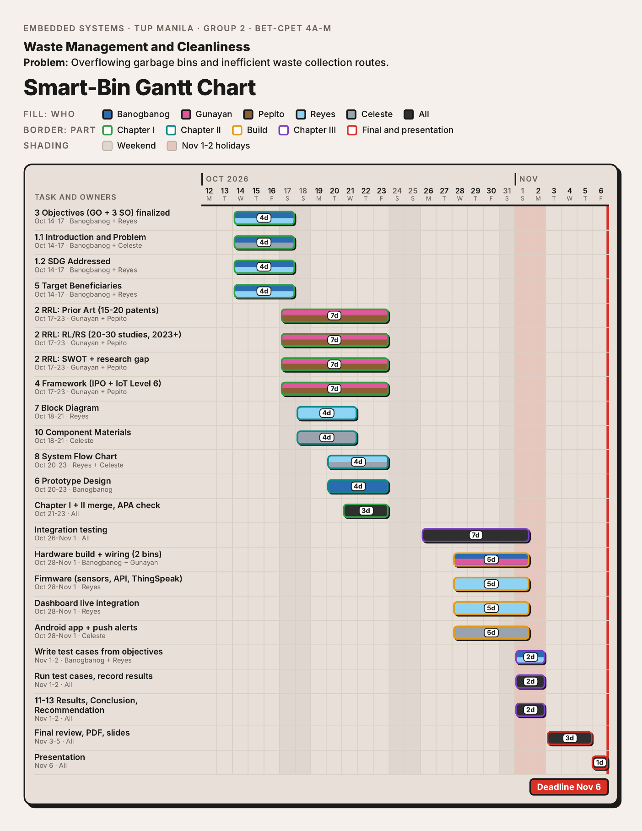

Appendix B
Bill of Materials of the Smart-Bin Prototype
Component | Qty | Unit price | Amount
ESP32 DevKit V1 (38-pin, WROOM-32D) | 2 | ₱250.00 | ₱500.00
HC-SR04 ultrasonic sensor | 2 | ₱45.00 | ₱90.00
HC-SR501 PIR motion sensor | 2 | ₱55.00 | ₱110.00
SG90 micro servo motor (180°) | 2 | ₱65.00 | ₱130.00
2.4-in. TFT touch display (ILI9341 + XPT2046) | 2 | ₱280.00 | ₱560.00
BMI160 six-axis inertial sensor module | 2 | ₱80.00 | ₱160.00
BME680 environmental sensor | 2 | ₱400.00 | ₱800.00
HX711 load cell amplifier board | 2 | ₱60.00 | ₱120.00
5kg straight bar load cell | 2 | ₱120.00 | ₱240.00
KY-016 RGB LED module (common cathode) | 2 | ₱8.00 | ₱16.00
MH-FMD passive buzzer module | 2 | ₱12.00 | ₱24.00
18650 battery shield, 4-cell (Bin A) | 1 | ₱310.00 | ₱310.00
18650 battery shield, 2-cell (Bin B) | 1 | ₱206.00 | ₱206.00
18650 Li-ion cell, 3.7V 2500mAh | 6 | ₱203.00 | ₱1,218.00
Ceramic capacitor 100nF (pack of 10) | 2 | ₱75.00 | ₱150.00
Electrolytic capacitor 10µF (pack of 10) | 1 | ₱39.00 | ₱39.00
Electrolytic capacitor 1000µF (pack of 10) | 1 | ₱165.00 | ₱165.00
Resistor 1kΩ (pack of 10) | 1 | ₱19.00 | ₱19.00
Resistor 2.2kΩ (pack of 10) | 1 | ₱19.00 | ₱19.00
Resistor 10kΩ (pack of 10) | 1 | ₱19.00 | ₱19.00
Total |  |  | ₱4,895.00
Note. Quantities apply to both bins. The prices from the ESP32 to the buzzer are the market prices of the group as of their check in October 2026.

Appendix C
User Interface Screens
[Include images of the touchscreen, Web dashboard and Android app here. Number them Figure C1, Figure C2 and so on, with the bold label and the italic title above each image.]

Appendix D
Source Code
[Insert the source code for the firmware, or a link to the repository here.]

